CMPE 273

ENTERPRISE DISTRIBUTIVE SYSTEMS

TEAM PROJECT

FANDANGO PROTOTYPE

PROJECT GROUP 6

**GROUP - 6**

Pranith Kiran Kouda - 012411971

Vishal Vannada - 012417054

Rishith Rayal - 011926746

Sathish Kumar Gollaprolu- 011821615

Mandipsinh Gohil - 012169612

Mangesh Tak - 012429521

**Contents**

## **Fandango Prototype**

We are developing a replica of a website [www.fandango.com](http://www.fandango.com) which is very popular for selling movie tickets through their website and mobile application. The site provides movie details and other movie related information. Fandango has tie up with many movie halls so that you can directly book ticket from site.

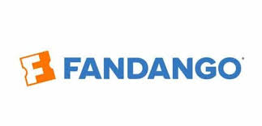

FANDANGO was founded in 2000 by NBC Universal and Warner bros. It is particularly used as search engine for searching, booking movies. Fandango servers around 36 million users per month.

We developed our application using distributed systems concepts, the front end is developed in React, HTML5, Bootstrap and CSS. After successful login, user gets various options like search movies, book a ticket for movie, submit review for movie. All these functionalities provided are sent over to the server where RESTful APIs are written to handle the requests. Server is designed using Node.js and Express.js.

We have used Kafka for messaging queue where all requests are sent from RESTful API. Exact logic for data handling is present ay Kafka back end.

# **PURPOSE OF THE SYSTEM**

Fandango application is used to search tickets, movie halls, book tickets. This application consists of various modules. The purpose of each module is as follows:

The client will be an application that allows a user to do the following:

## User Module/Service:

* Create a new User (Reference Fandango websites for fields information)
* Delete an existing User
* Change a user’s information (name, address, profile image etc) – *This function must support the ability to change ALL attributes*
* Display information about a User.
* Search listing for different categories
* Search Movies / Halls

o Filter based on Price and Ratings

* Book a Movie
* Add Review/Rating to Movie.
* Make Payment
* View Past/Current purchases

## Movie Hall Module/Service:

* Allow only the authorized user to access this module
* Add movie information like time etc.
* Search for listing and edit it.
* Get revenue by each movie and cancel the booking by user.

## Admin Module/Service:

* Allow only the authorized (admin user) to access Admin Module
* Add Movie hall to the system.
* Search for Movies and/or Halls and edit it.
* View/Modify user/hall account
* Search for a Bill based on attributes (fetch all bills By date, By months)
* Display information about a Bill.
* Display revenue by movie and Movie hall

# **CONTRIBUTION**

## Vishal Vannada

* User Module:
* Set up Git repository and base project structure
* Movies – Initial Data,
* Movies – Searches term,
* Front End, Movie Overview, Movie Review, Save Review, Navigation Bar, Conditional Rendering, Payment Module – Front End
* Movie Hall Module:
* Conditional Rendering, UI Fix, Heading Bar.
* Admin Module:
* Admin Module – Sign In, Conditional Rendering, UI Fix.
* Movie Searches, Update, Save
* MongoDB Connection Pooling
* Mongo Hosting

## Rishith Rayal

* Developed APIs for profile page in frontend as well as backend.
* Movies listing and API development for admin section.
* Report creation.
* Created Sign Up, Dashboard, Past Purchases, User Profile Edit, Admin Add Movie Hall Form, User Viewed Pages mapping frontend.
* Developed API’s for Created Sign Up, Genre Search
* Bug Fixing and part of documentation
* Movie Genre Search

## Mangesh Tak

* Movies listing and API development for admin section.
* Search and Edit Movies
* Search and Edit Movie Hall
* Search Customer’s Bill
* Analytics charts and user tracking in admin section.
* Listing and API development of Billing section in admin side.
* Redis setup and integration for API cache
* Result sorting in each type of listings on user side.

## Pranith Kiran Kouda

* Developed API’s to fetch data for Movie Search, Movie Hall Listing and User Transactions.
* Implemented Functionality to handle transactions and cross Database updates during Transaction Approval and Transaction Cancellation
* Add Movies listing and API development for Movie module section.
* Movies Listing Editing and Movie Hall Admin editing were implemented
* Designed the Mongo DB structure and made improvements for Performance tuning.
* JMeter load testing along with Mocha testing for Movie Module.
* Bug fixing and UI testing as we progress.
* Admin’s user listing module with search.
* Search and Filters functionality across client and admin module.
* Handling complex queries which involved nested updating for billing and booking module.
* Movie booking frontend and billing interface. User past booking module

## Mandipsinh Jaydipsinh Gohil

* Design the responsive Admin Module
* Admin Module include Count of Total Revenue, Total Movies, Total sold tickets and Total Registered User.
* Dashboard contain more than 6 visual statistics that help admin to improve the business.
* Tables that shows revenue per movie and movie hall.
* User tracking
* Less seen area by the users by logging every click of the users.

1. Satish Kumar

* Created the Signin functionality for the Users using passport for authetication and with Sequelize ORM using Mysql as database.
* Used the expression-session store to store the user sessions in mongo database.
* Created the Signin functionalities for MovieHallOwners and Admin for logging into the website.
* Created the Backend calls for User Dashboard, User profile including change basic info, change email, password in Kafka-node and server.
* Developed the Front end and Backend functionalities for Admin to Edit the user information and delete the users.
* Developed the Front end and Back end functionalities for Admin to search movie hall users Edit and delete their accounts.
* Developed the purchase history functionality for the user account to see the last transactions and tickets purchased.
* Developed the module the visualize the movie revenue for movie halls using Barcharts.
* Developed the search functionalities for finding users and moviehall users in the admin module.

# **ABOUT THE PROJECT**

## **Object Management Policy**

Fandango clone application consists of various functionalities like searching movie details, booking a movie ticket, submit a review, searching, sorting, movies and movie halls. Admin Module has functionality like Movie and Movie Hall search and edit, searching bills and user, graphs with so much of details. It also provides admin functionalities like add movie, add movie hall, delete movie hall. Because of all these multiple offerings, we made the application modular and distributed.

Application’s architecture is as follows:

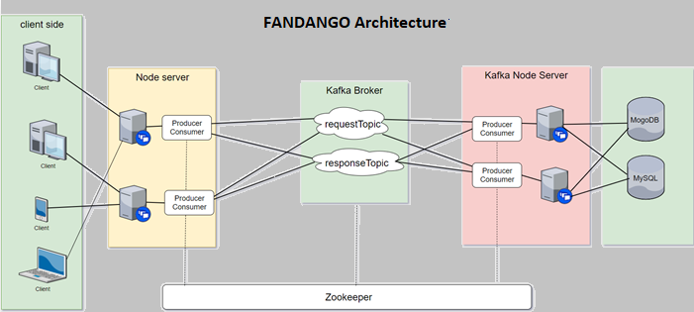

**System Design:**

Kayak Application is built on top of the following:

* Node.js - Application Server
* Express.js - Node.js Web Framework
* MongoDb and MySQL - Database Storage
* Twitter Bootstrap and Material UI - UI Component & Layout Library
* Kafka – communication between frontend and backend- Distributed architecture

**Object Management Policy:**

In this project, we have implemented the following objects:

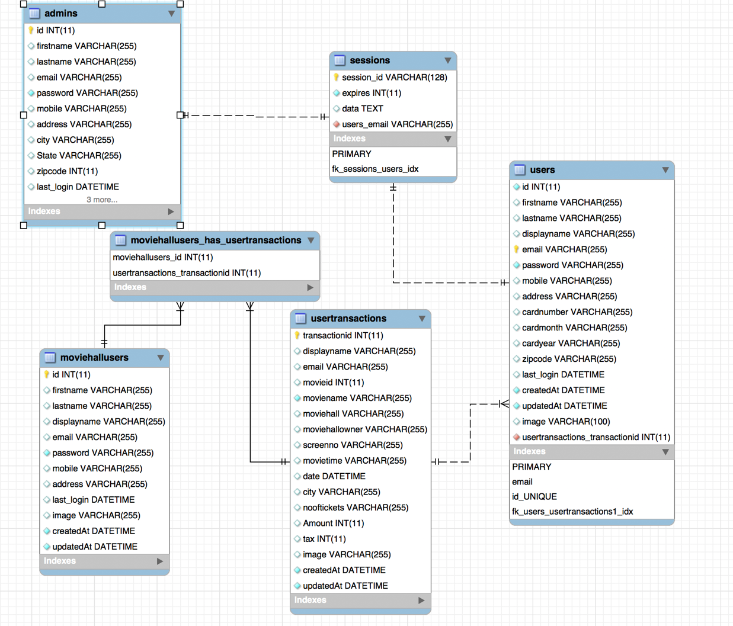

**Heavy -Weight Resource Handling:**

We have employed the following in handling heavy-weight resources:

**Database Connection Pooling:**Connection Pooling is implemented on both the databases (MongoDB and MySQL) which is the crucial part in object management policy. The objects in connection pooling represent physical database connections that is used by an application which connects it to a database. Once a request is done using a connection to database, connection used is returned and it can be reused for another connection. This increases the scalability of the system. If no connection is found, a new connection will be created.

**SQL Query Optimization:**

Query streamlining is the way toward choosing the most productive methods for executing a SQL statement. The database optimizes each SQL statement in view of insights gathered about the data obtained. The optimizer decides the ideal plan for a SQL statement by looking at various access methods, for example, full table scan or index filters, diverse join strategies, for example, nested loops and hash joins, distinctive join orders, and conceivable changes.

It was critical for us to know how data is utilized and the recurrence of the data being utilized to make useful indexes. Making useful indexes can without much of a hard work accomplishing better query optimization. We made such indexes where there were more select queries and found that the execution better performance. Picking what to index and what not to, assumes a gigantic part in influencing the performance of the system.

For instance, a query may ask for data about particular movie or theater in a specific city. In the event that the optimizer measurements show that 80% of such movie or theater exist in city, at that point the optimizer may choose that a full table sweep is generally efficient. Nonetheless, if insights show that not very many movies or theater exists in city, at that point perusing a index took after by a table access by id might be more productive than a full table search. Since the database has numerous internal statistics and tools available to its disposal, the optimizer will perform better.  
**Redis Caching:**

‘Redis is a data structure store based on a key value model which stores the data in the RAM which makes it super useful as a caching layer. It is very powerful and flexible than most of the caching techniques.

Redis allowed us to gain control over data eviction and gives the user great deal of liberty to select from six different eviction policies and the user can choose to delete the data only when new data is to be added. It also allowed a large storage which can go up to 512 MB for every object and the user has choice to select from 5 primary data structures. Redis has optimized tasks in our project not only for caching but also when user wants data to be always available and consistent as Redis Hash allows us to store the object using a single key which leads to lower resource consumption. It can withstand failures as it has a feature of data replication and hence, data lost can easily be recovered.’

**Admin module:**

The most important module of the application, which can be accessed only with admin privileges. Admin has authority to control all the system data which is going to be displayed on website. Admin can add movies, movie theaters, modify user details, delete movie, drop movie theaters, check bill, revenue.

The most important functionality of admin is the whole analytics of the website. Analytics provides analysis of stored data which shows how the website is being used. Analytics page take help of graphs, pie charts, user tracking with number of click in each pages and also shows us the less used area by the users. Admin Module can also give the information about the revenue per city, movies, movie hall. Admin also have access to user profiles and he can change or delete any profile anytime.

**Client Module (Front-end):**

The client frontend is the actual web application which will be used by the end user. After landing on the home page, the user will have options to search for movies as it Movie Ticket Booking Website. While searching we provide suggestions of the cities of USA according to entered string in input box. The results will be displayed according to the user’s selection criteria. User can change filter criteria on the fly and new results will be displayed. User can also sort the results (ascending/descending) based on price, rating, stars.

After selecting a Movie, the user will be redirected to the Movie details page where he can see the movie rating, actors in the movies, rating and review of the movies. After the if he/she wish to book the ticket, click on book the ticker will lead to them on booking pages. When they need to fill all the details like Number of tickets, Show time and date. Then they will redirected to billing information and payment.

User can also see his/her profile, past bookings and register payment methods. User also can update his/her person details and can also upload profile picture if want to. User also can register multiple payment methods which will be provided next while billing.

**Node Module (Back-end):**

The node backend server is responsible for handling all the requests made by the above two front end services. It is the first point of contact which routes all the API calls to its respective handler. The first thing after receiving a request from the front end is to check whether the request is from a validated user or not. All these requests are handled by passport. After validation, the requests are passed on to the Kafka node backend using Kafka topics.

**Kafka-end:**

The Kafka server maintains topics which are also known as messaging queues. All the requests are passed via the request topic and received via the response topic. All the requests sent in the topic are associated with a unique id for identification purpose. These requests are further sent to the Kafka node back end where the actual logic for data handling is present.

**Kafka Node Back-end:**

Once a request is received by the Kafka back end, we perform the desired operation or fetch the required data from databases such as MongoDB or MYSQL. The required data is then further sent to the node back end via Kafka server in response topic. Once the node back end receives the data, it sends the data back to the front end where the data is displayed to the user.

As it is known that performing queries on the database requires costly resources, it is very essential to limit these kinds of activities. We managed our resources in the following way to reduce data fetch time, keeping in mind the necessary security measures.

• All the user’s login information is stored in MySQL as it is more secured.

• Various other information like data related to booking, billing and analytics data is stored in MongoDB as it supports faster data retrieval and easy to store data in modular format with no relation.

• To get all the movies and trailers we used an api, to make it easy. With out having to store all the videos and images we used the api by youtube and the movie database.

• We used Redis to implement caching, so we need not to perform actual DB operation if we already found same in key in our cache. It gives better performance and less resource utilization.

• We implemented connection pooling, so form beginning we keep fix number of connection open so when heavy load comes we need not to open and close many connections. We just take one connection from pool, use it and then return it back to pool for reuse. It helps us to perform DB operation faster.

• For implementation of Kafka messaging queue, we created many topics for the batter distribution of the request. First set of topics are one is for sending message from node server to Kafka backend server and later one is for return flow to get response.

As we discussed above, that performing queries on the database requires costly resources, it is very essential to limit these kinds of activities. We followed a few policies which helped us keeping our databases optimized.

* No unnecessary data writing in the database. We only updated the database when a attribute is changed.
* We used SQL caching which helped us retrieving data faster for the most use API.
* We have created different API for different kind operations on each resource like GET, PUT, POST, DELETE. Because of this it helps us keep data integrity.
* We used MySQL for maintaining user login information, Transactions as MySQL is more secured.
* Other data of the movies and users like movie hall details, log details is stored in Mongo DB because Mongo DB is faster for data retrieval and security is not the actual need in this case.
* We also have many heavyweight images for user profile, Movie cover page images, actor’s images which we are directly saving on the cloud. This is done to avoid excessive data to be stored in the database which will also increase the hamper the performance.

**CUSTOMER APPLICATION**

## **Client Module**

Home page of Fandango

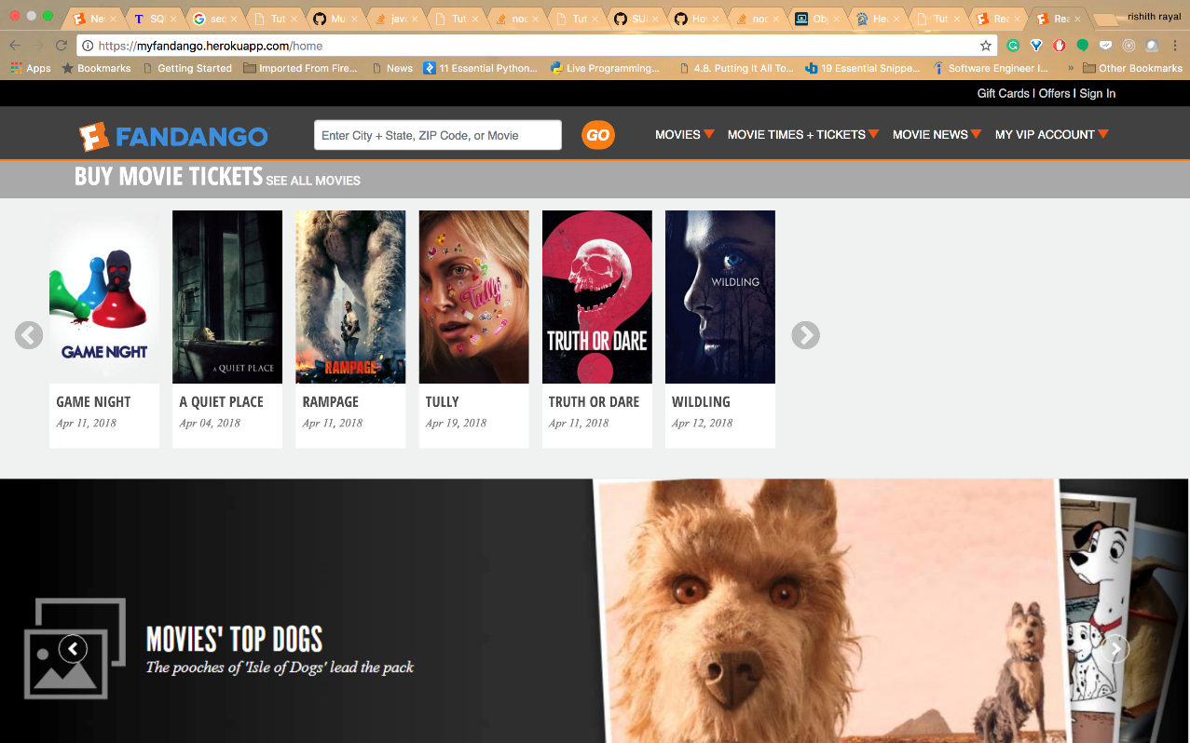

User Signup Page

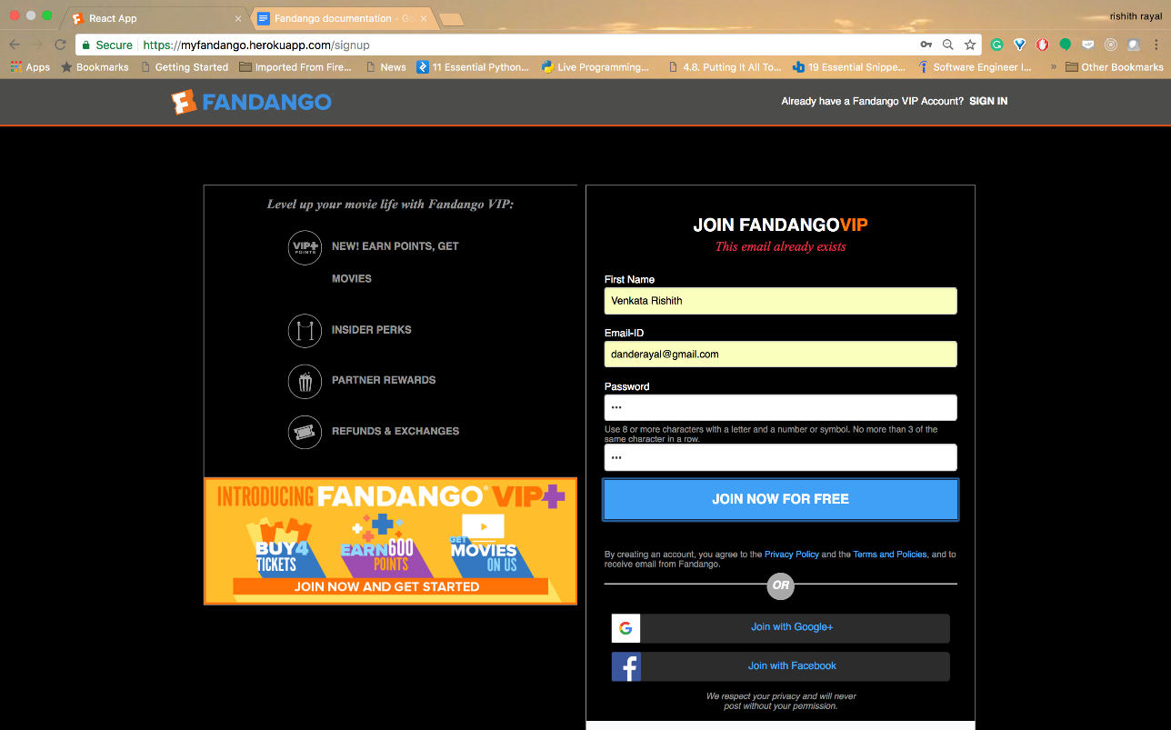

User Login Page

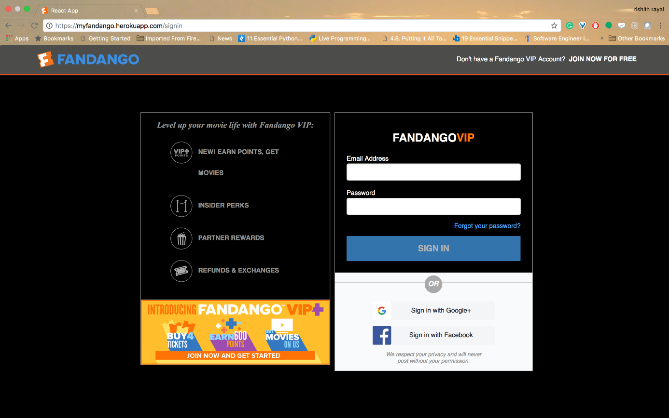

Validations in Login Page

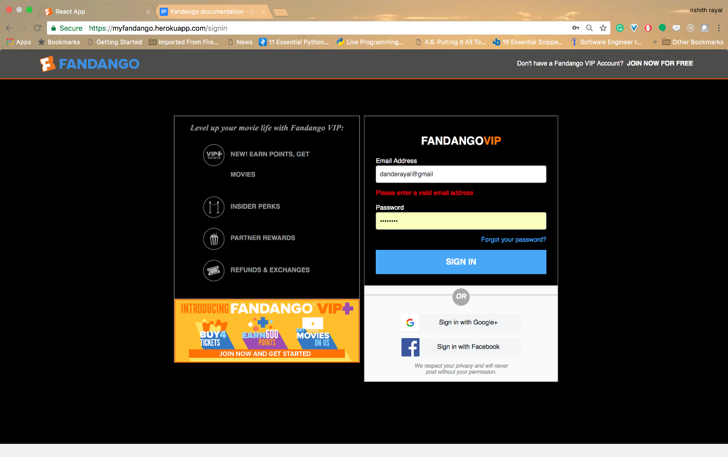

Validations in Login Page

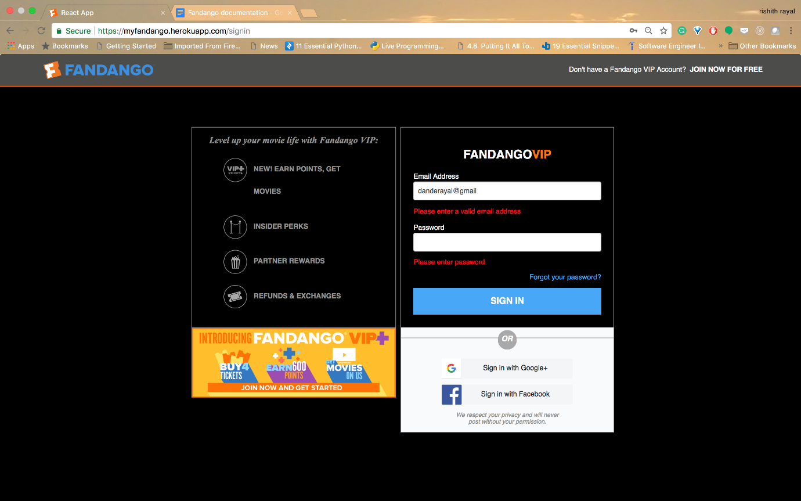

After Successful Sign In

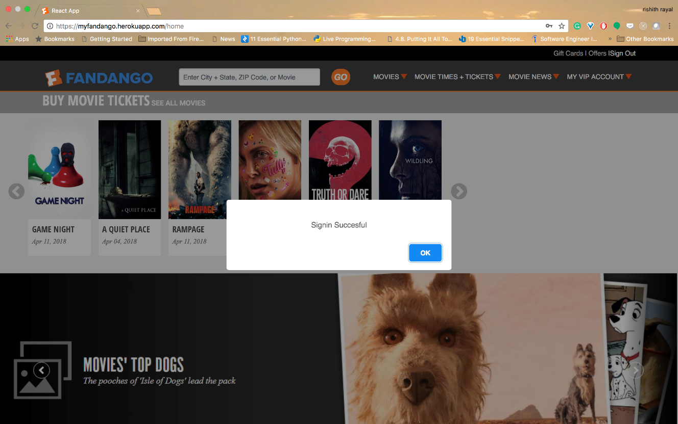

After Login Home Page

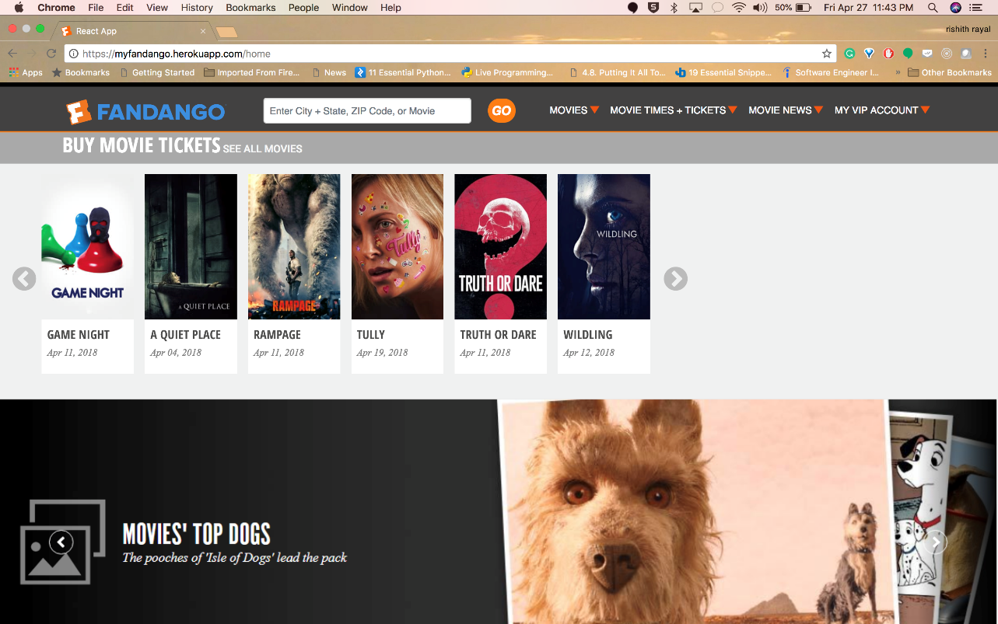

Search Movies by User

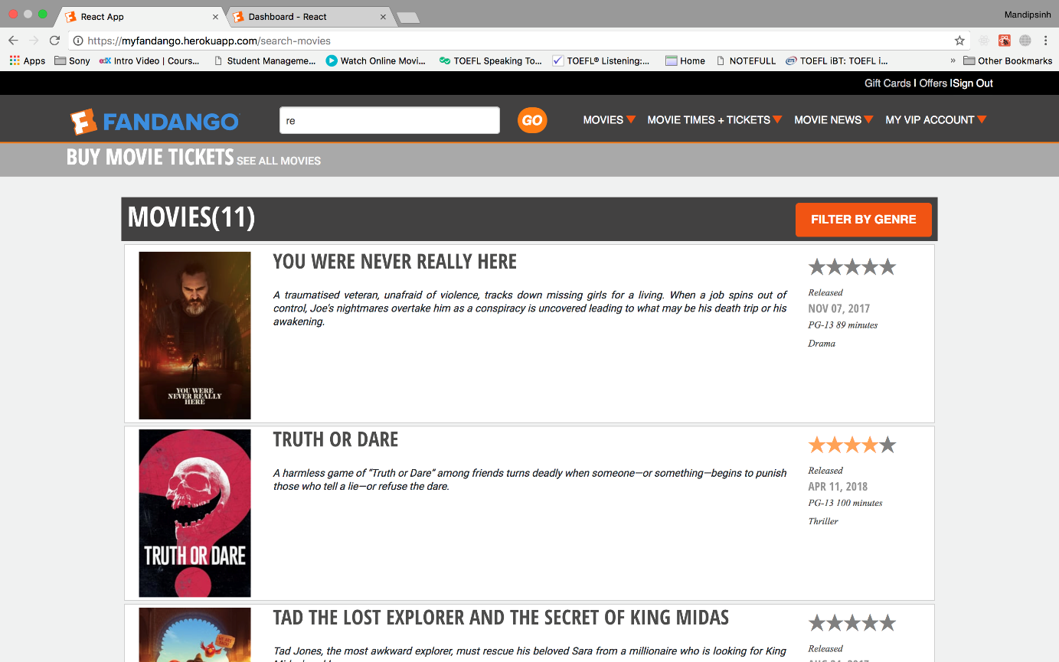

Filter Movies by Type Action

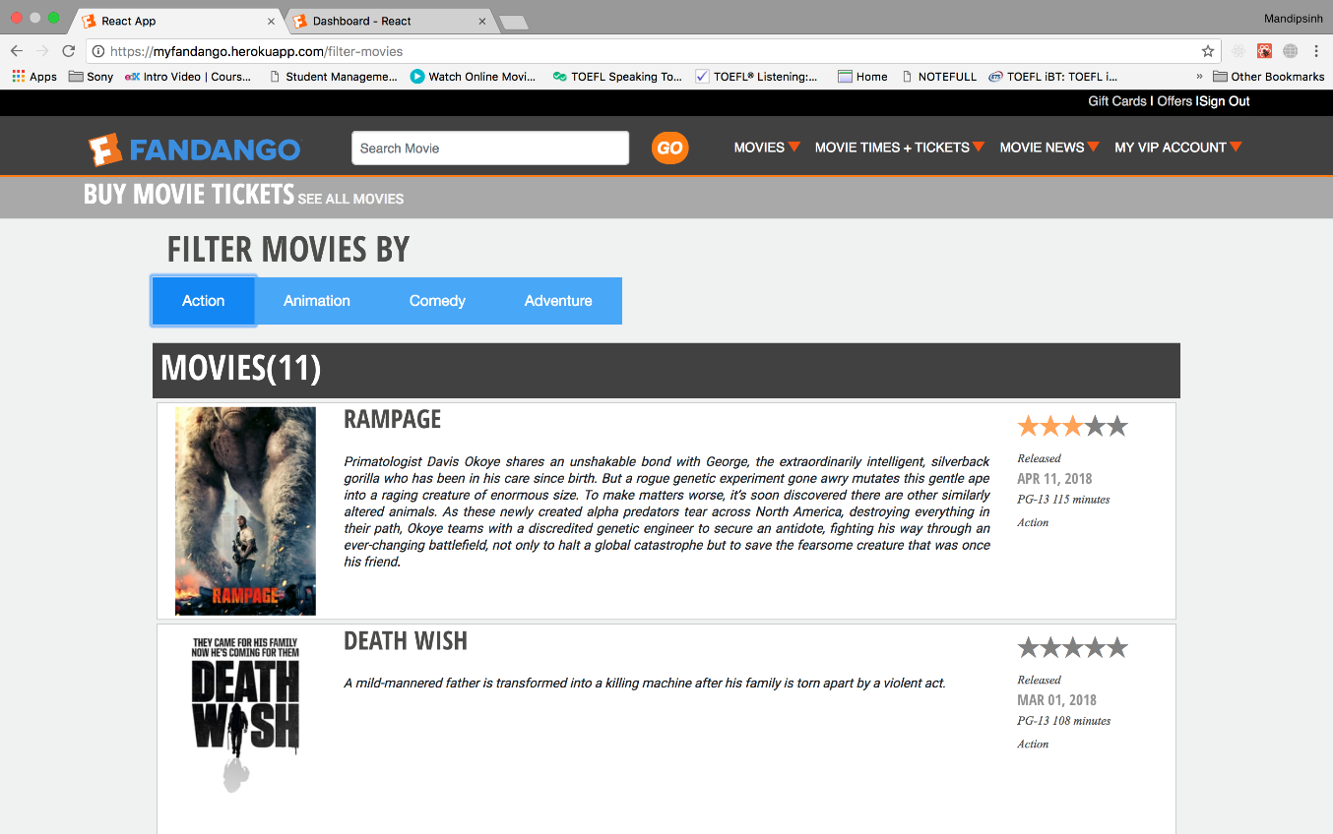

Filter Movies by Type Animation

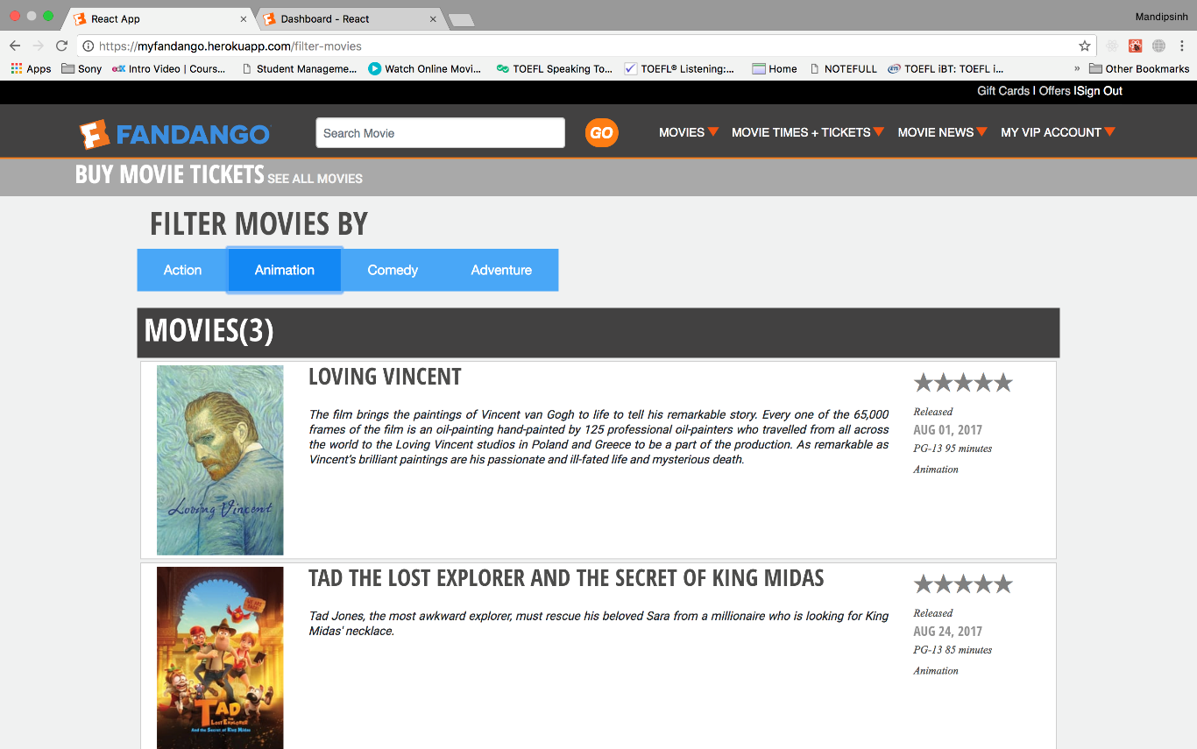

Filter Movies by Type Comedy

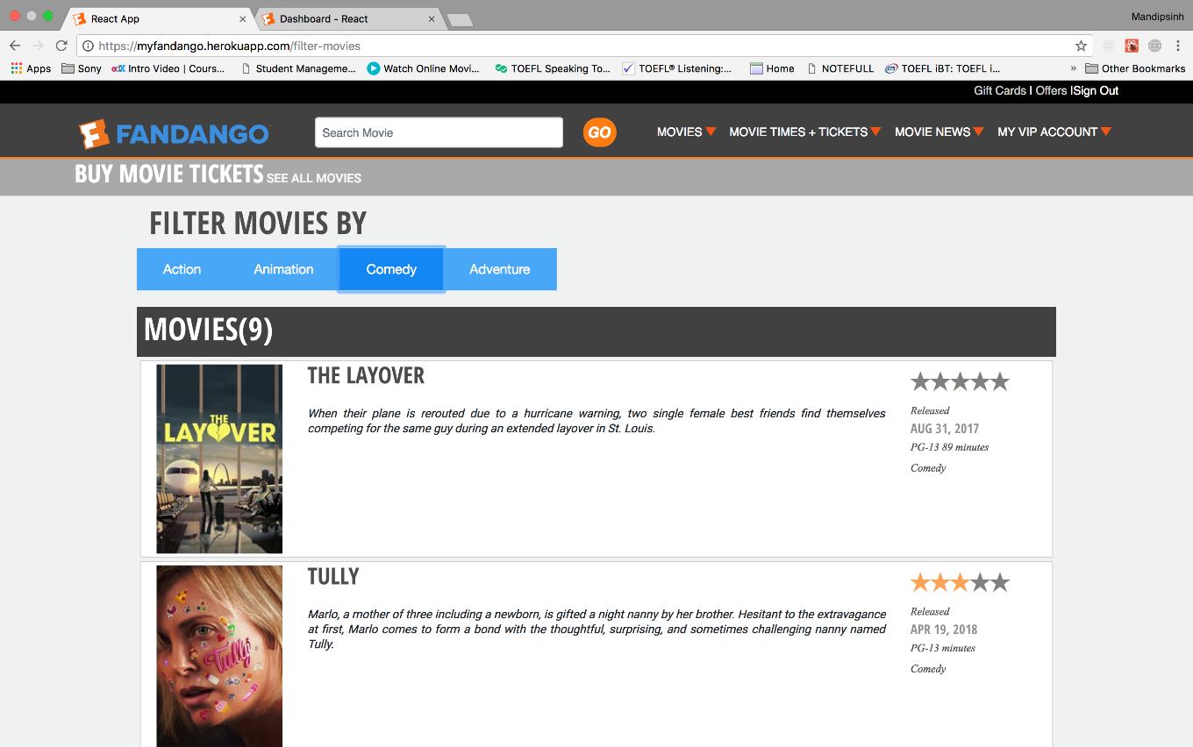

Filter Movies by Type Adventure

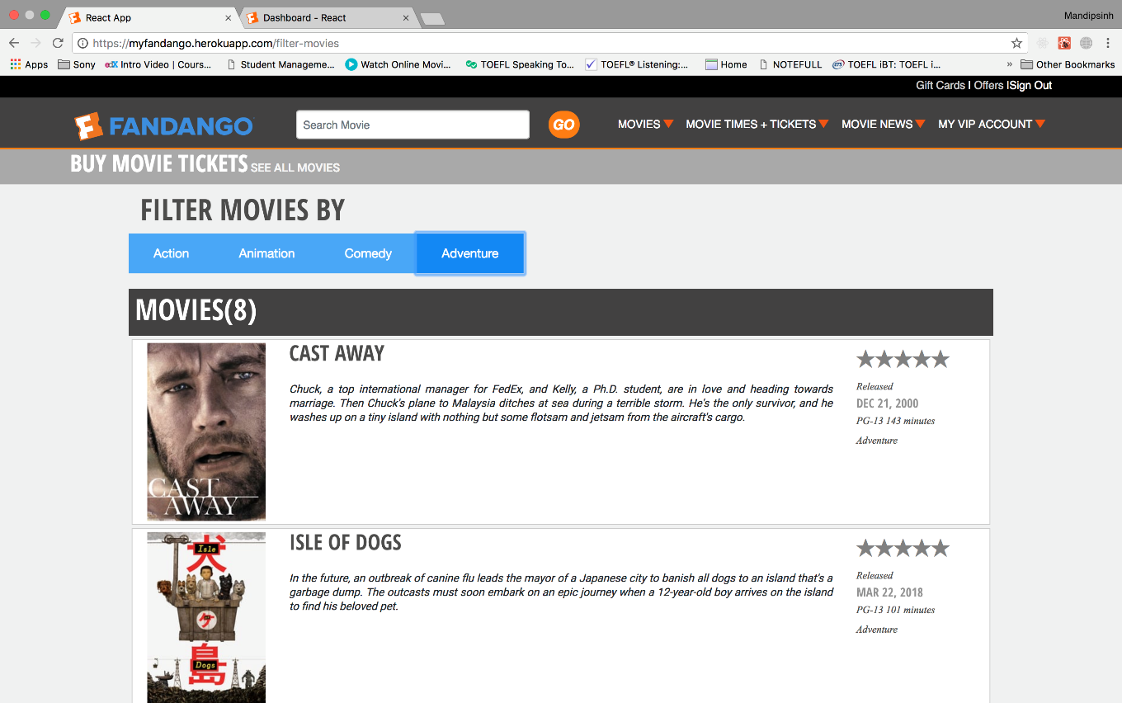

On Movie Click Detail View

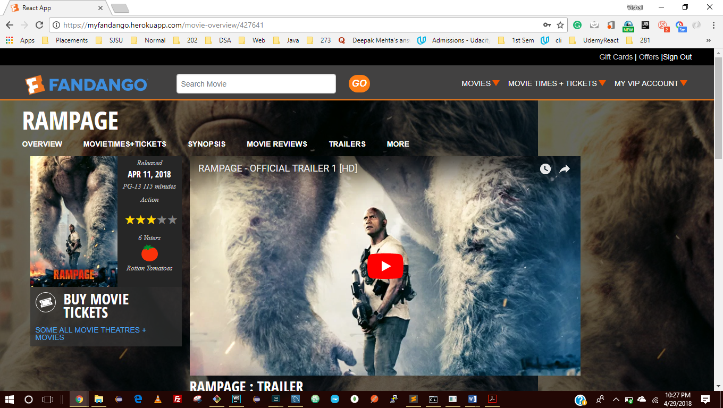

Movie Details View – Continues, Movie Details View Include Actors

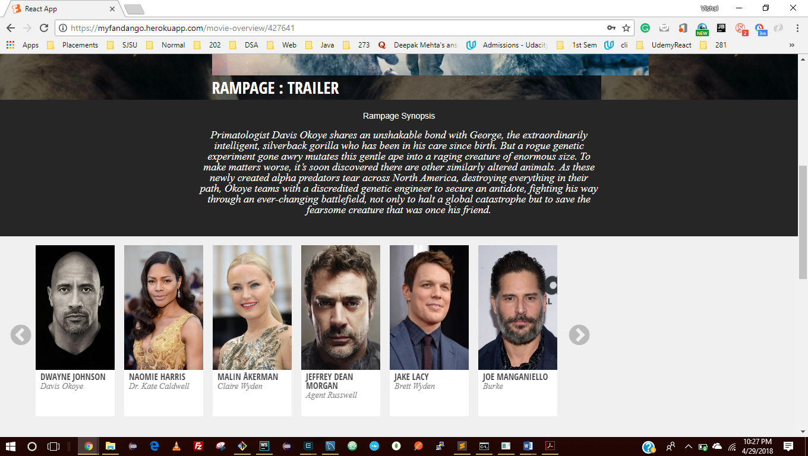

Existing Reviews

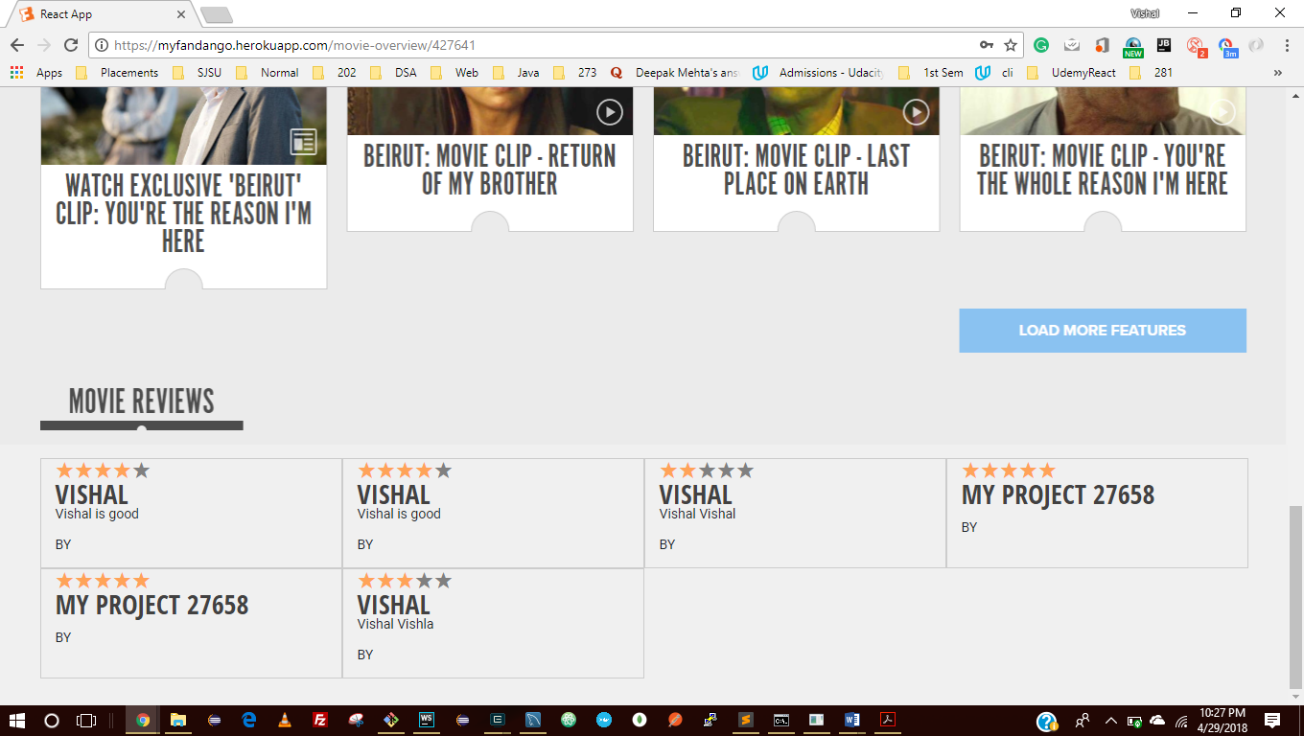

Validations

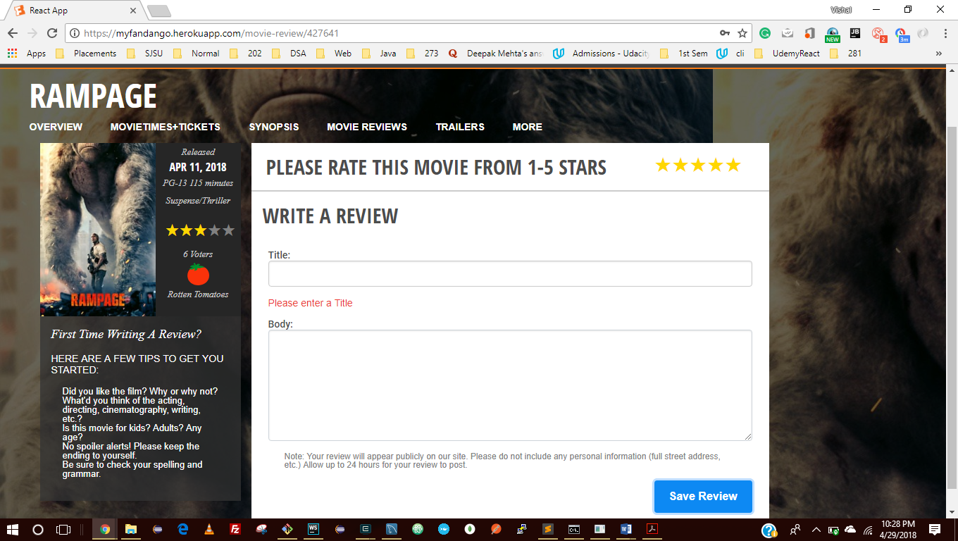

A Logged in User Can Write a Review

Write a Movie review

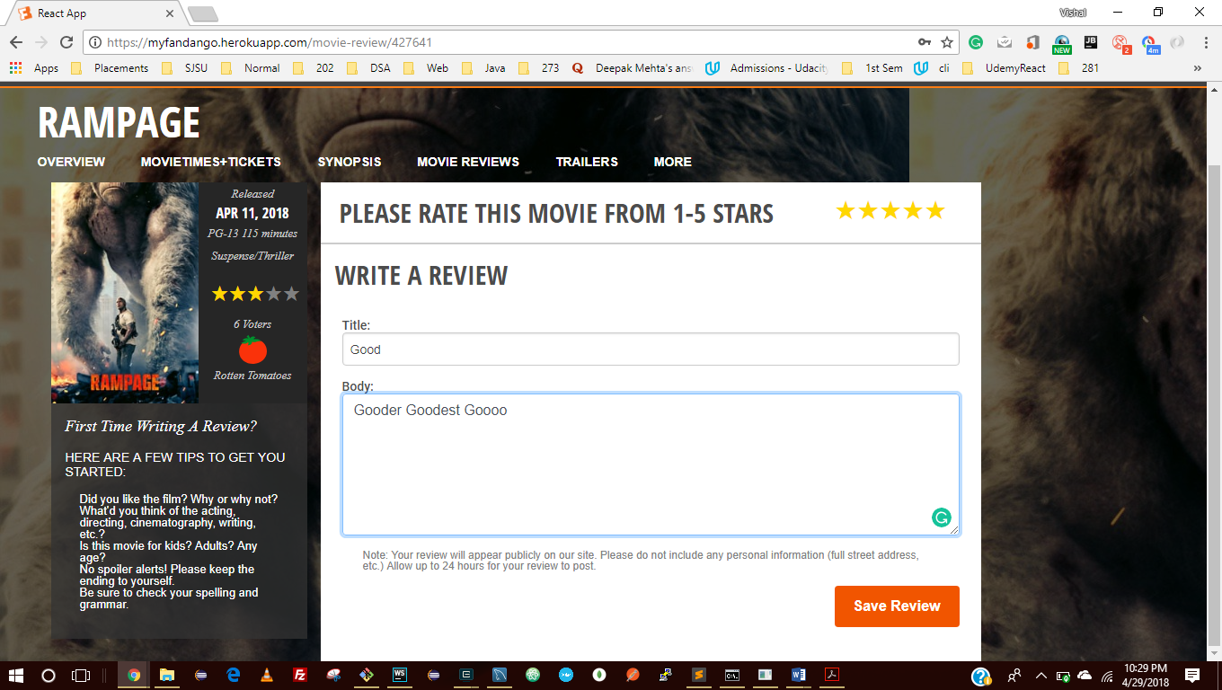

After Movie Review – Movie Details

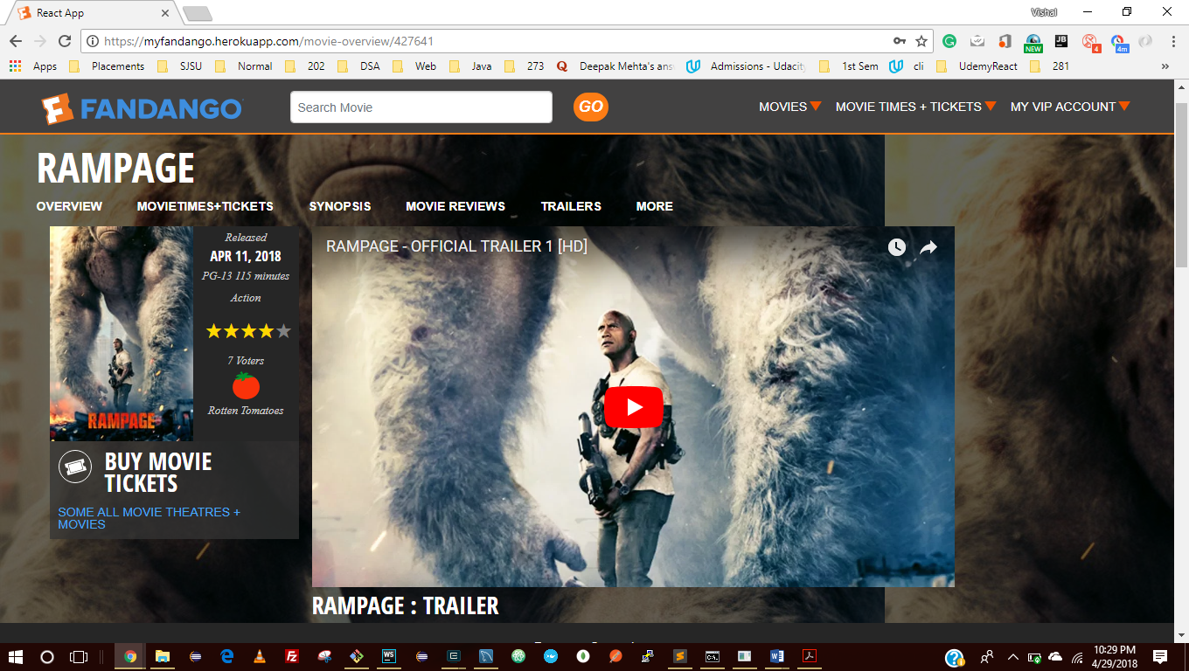

Reviews

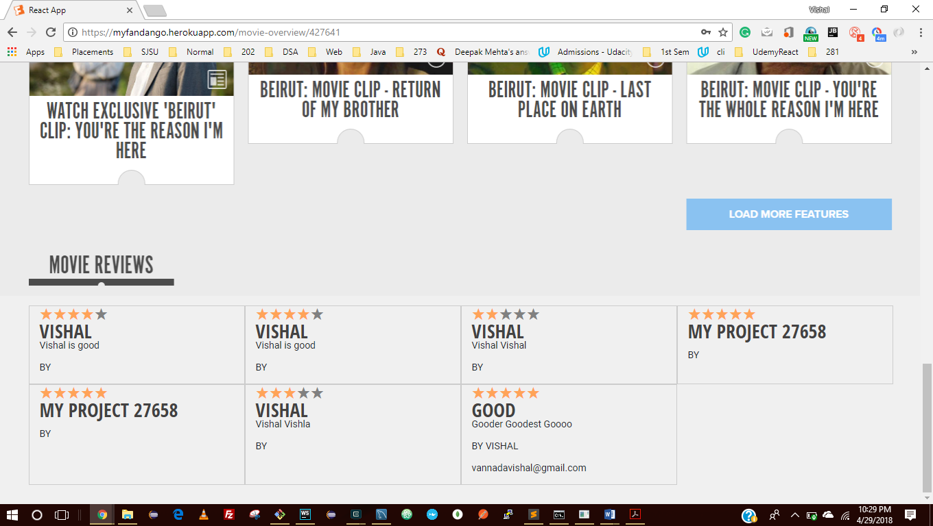

Ticket Booking for a Movie

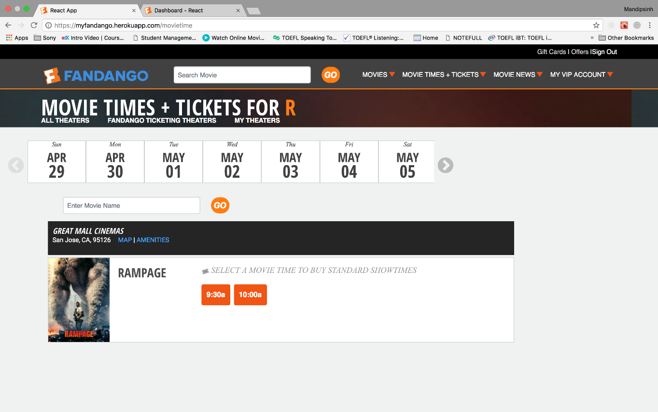

Movie Ticket Booking - Check Out

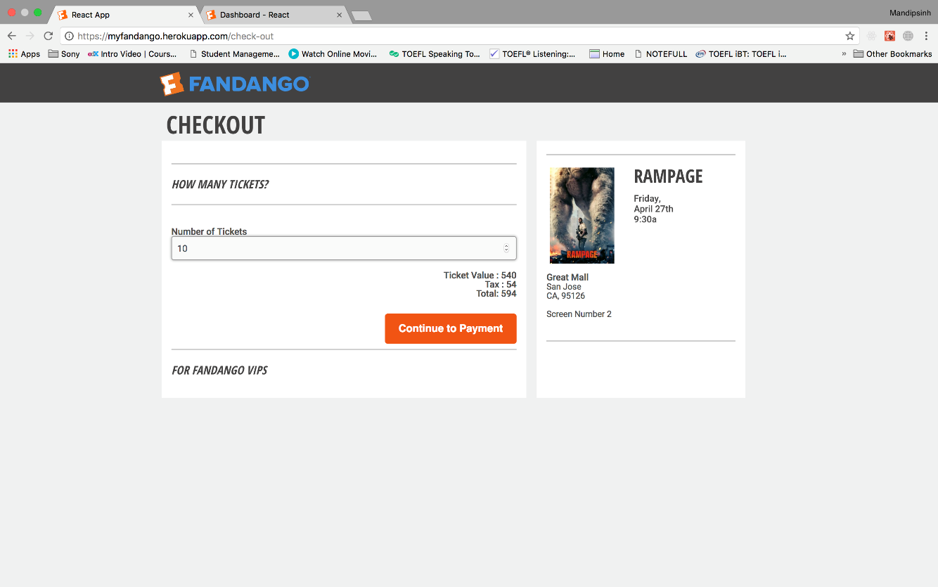

Enter Payment Details for Booking - Validation

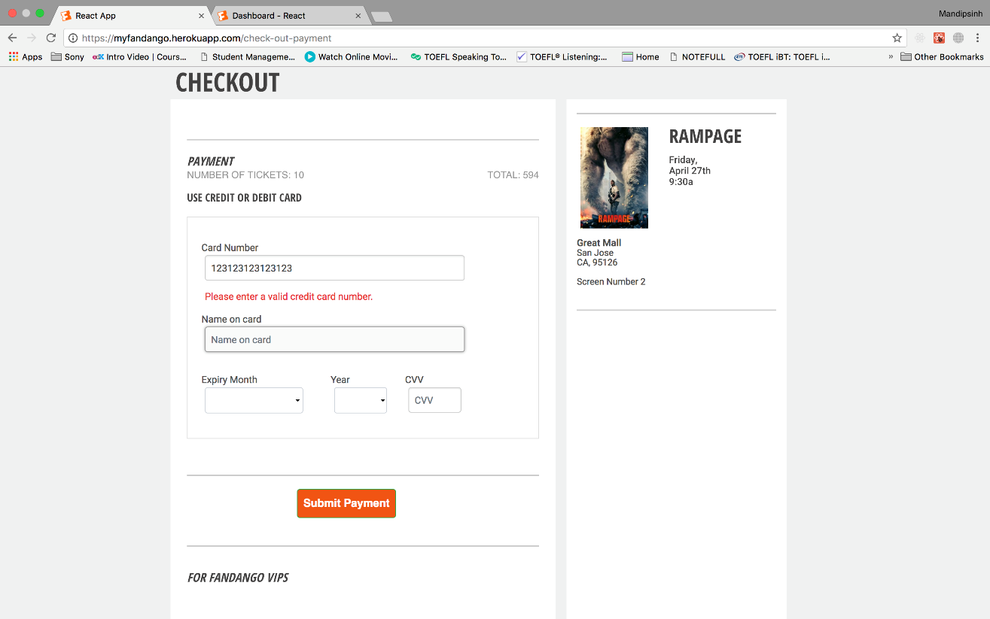

Enter valid Details for Payment

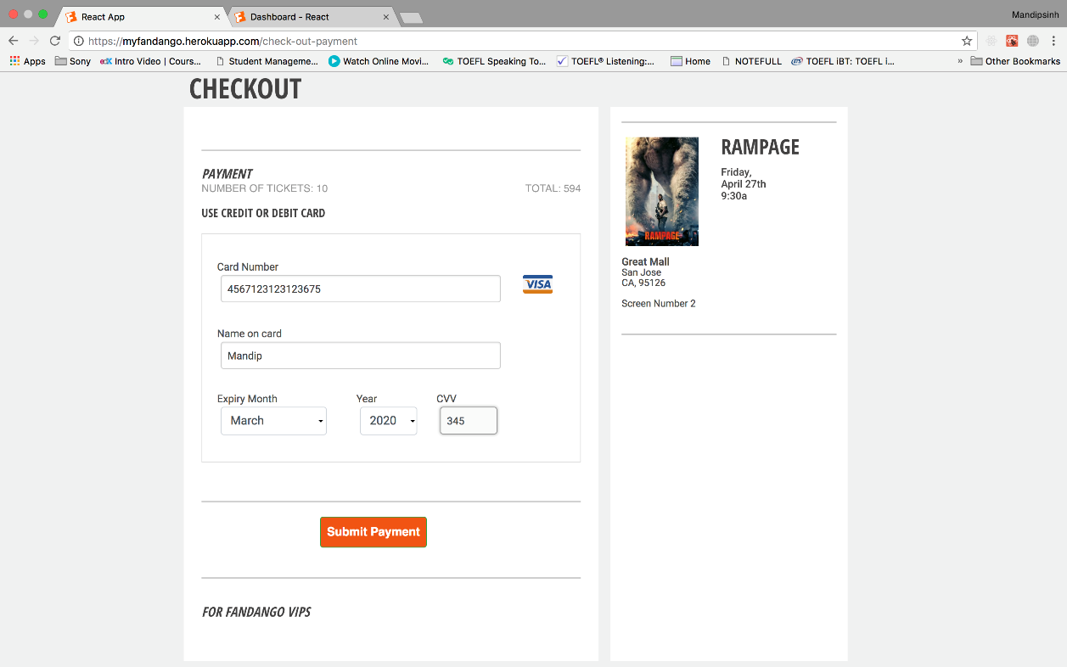

After Tickets Booked

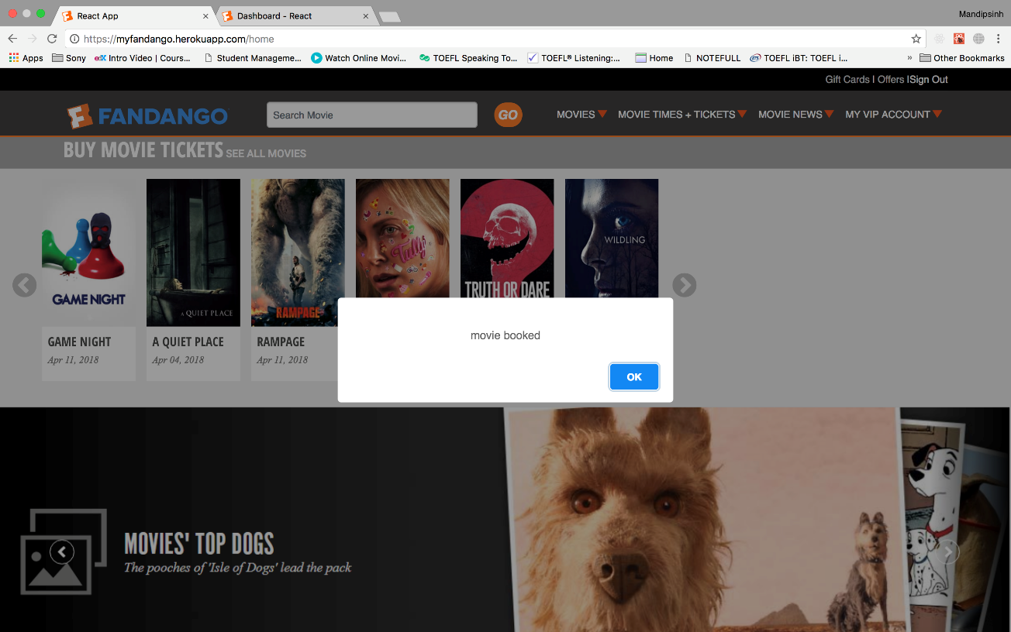

User Profile Details

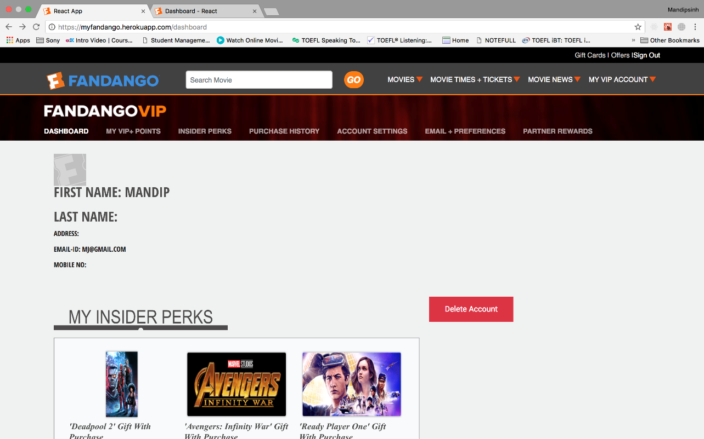

Recommendation for Users

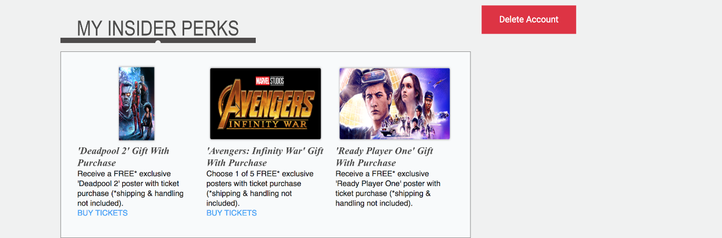

User Profile – Edit Profile

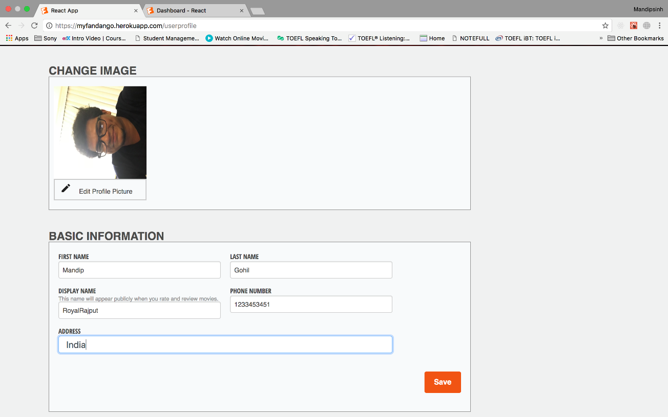

User Can Change Email

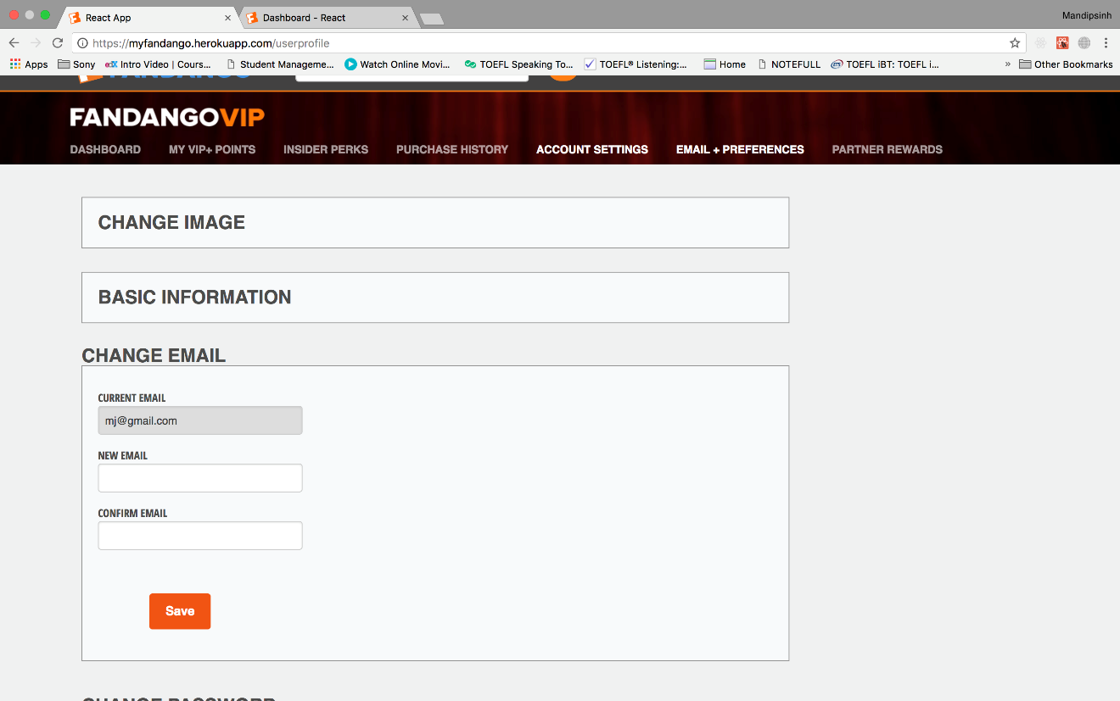

User Can Change Password

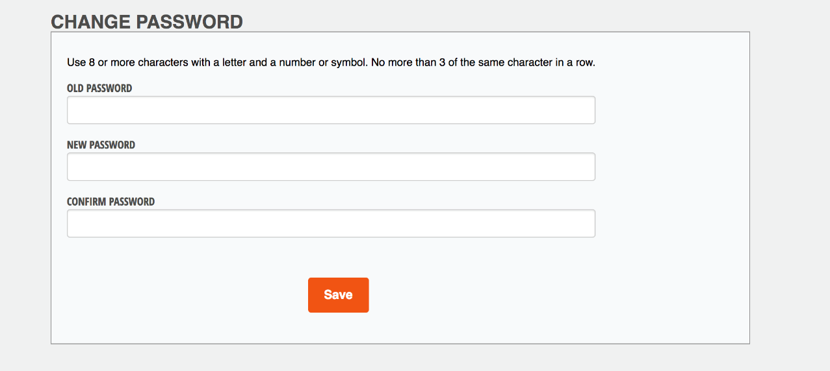

User can Add Payment Methods

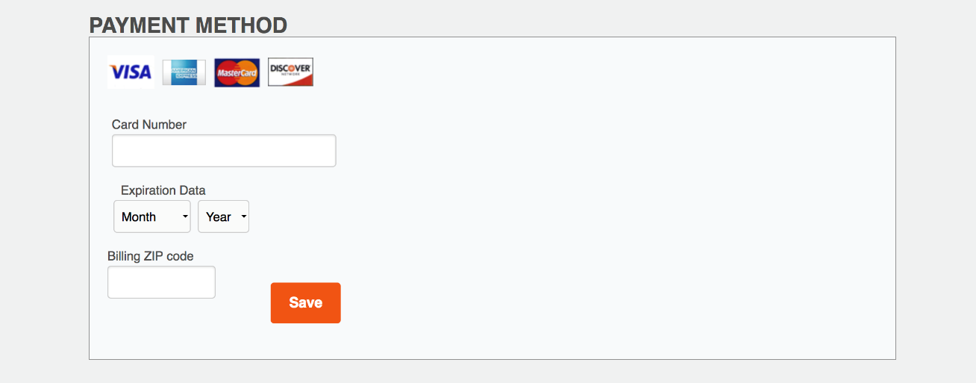

Purchase History of User

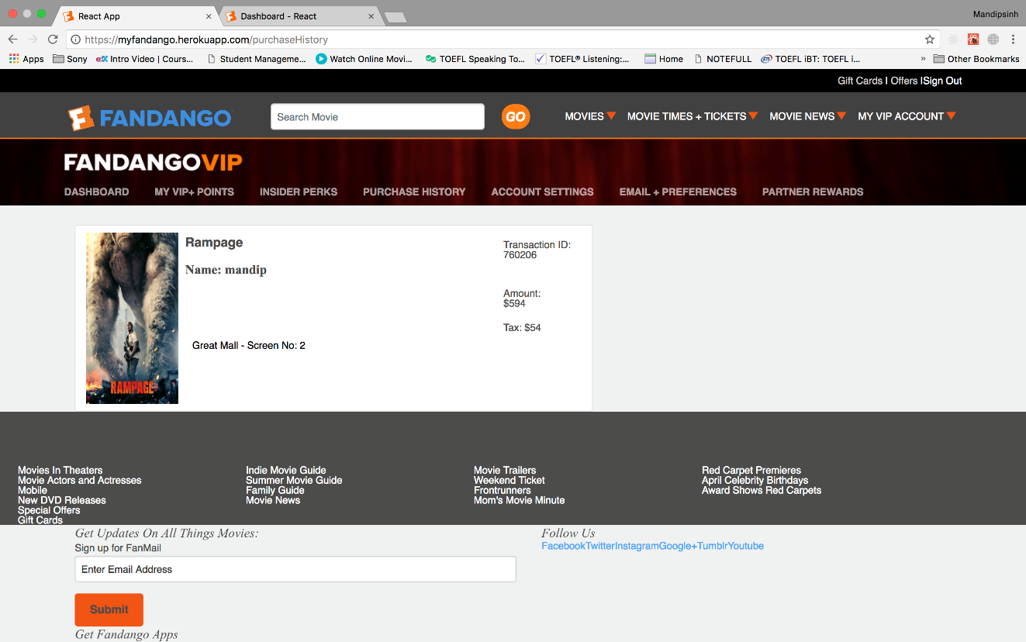

## **Admin Module**

## **Admin Login**

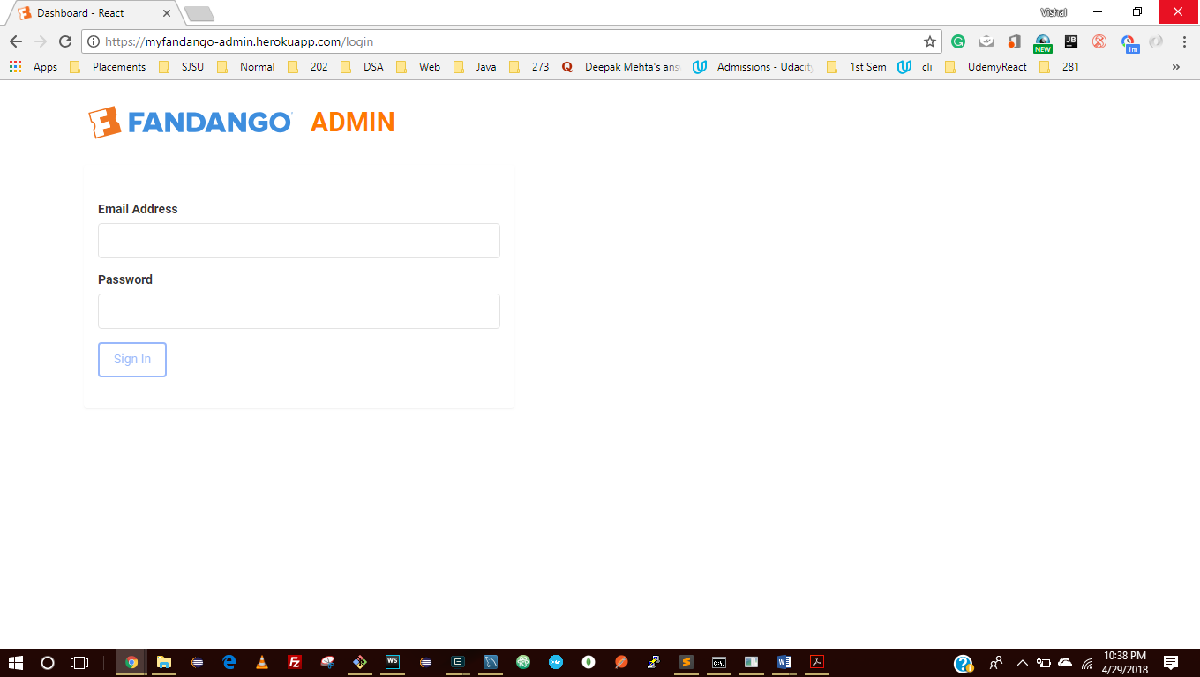

Disabled Button

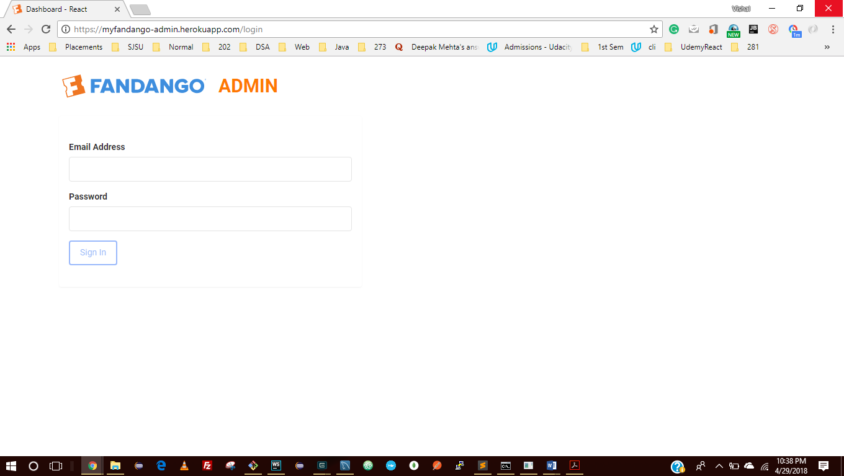

Validations

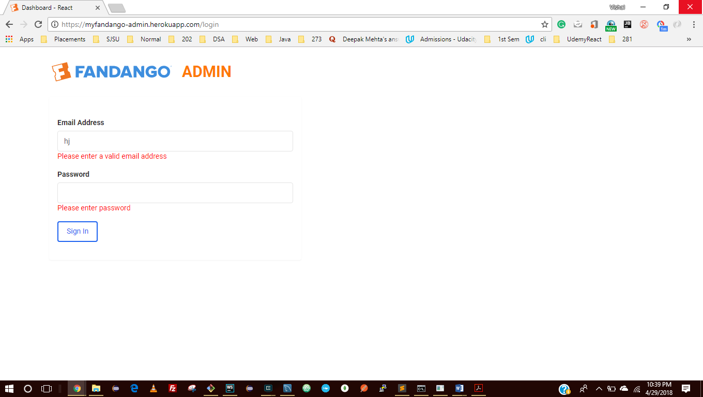

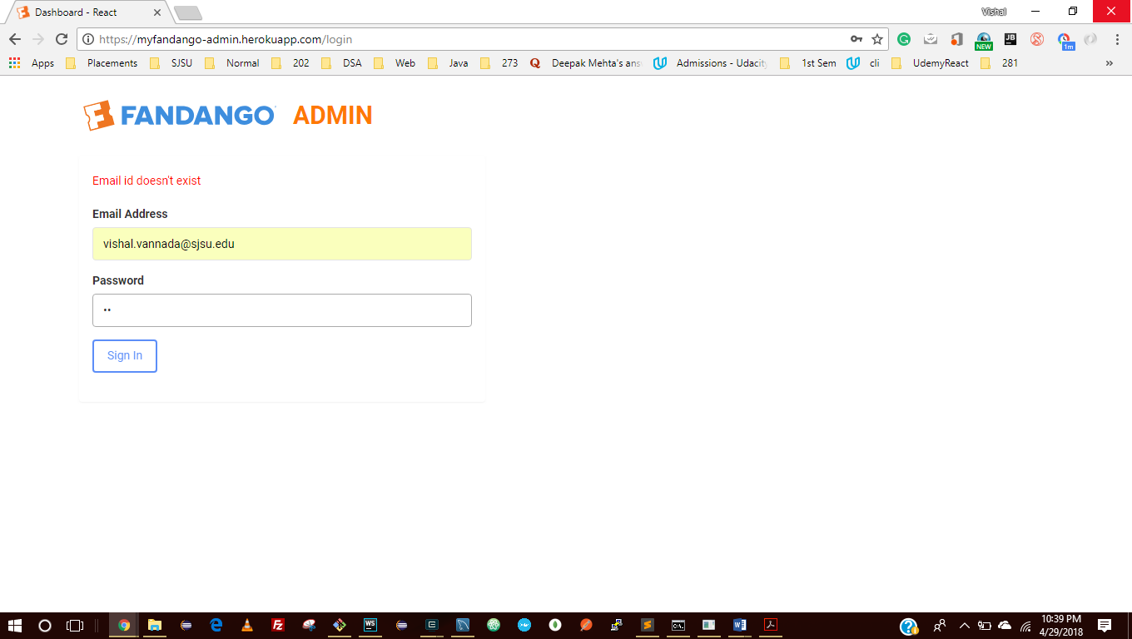

Successful Login

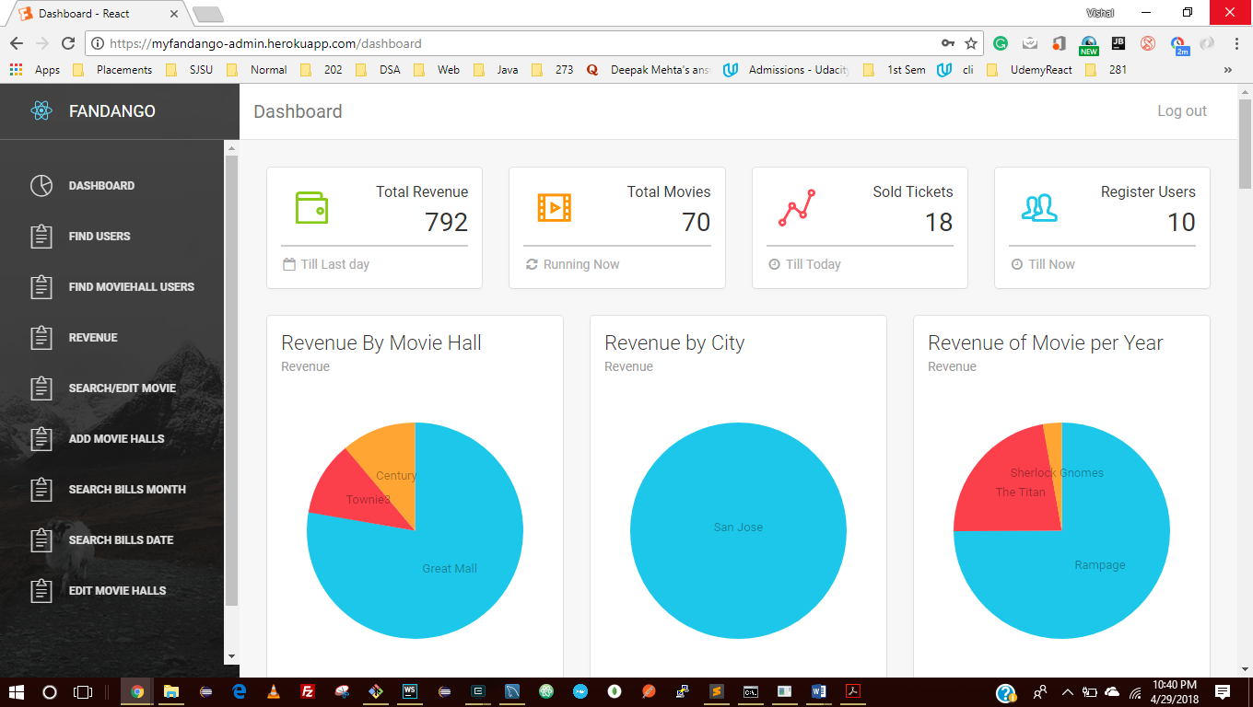

**Admin Dashboard**

Total Revenue, Total Movies, Sold Tickets, Total Register Users

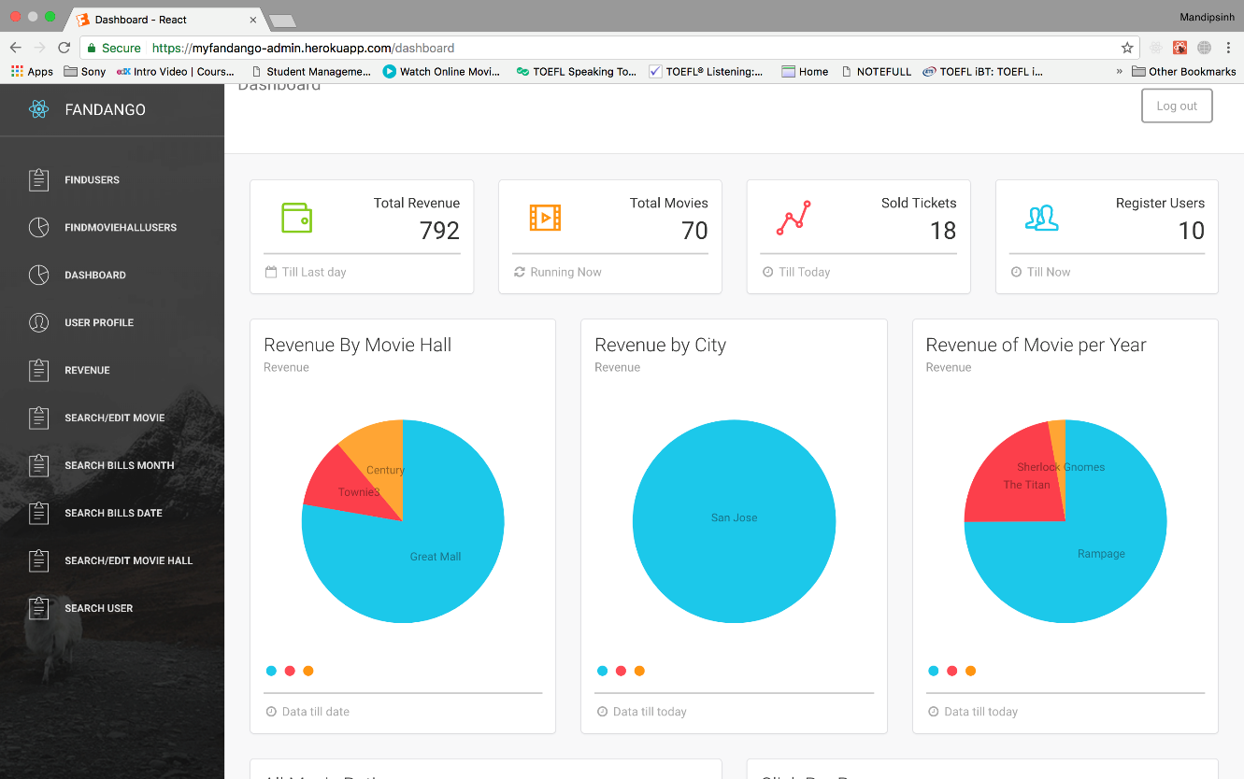

Graph – 1: Revenue by Movie Hall

Graph – 2: Revenue by City

Graph – 3: Revenue by Movie per Year

All Movies Rating Bar Graph

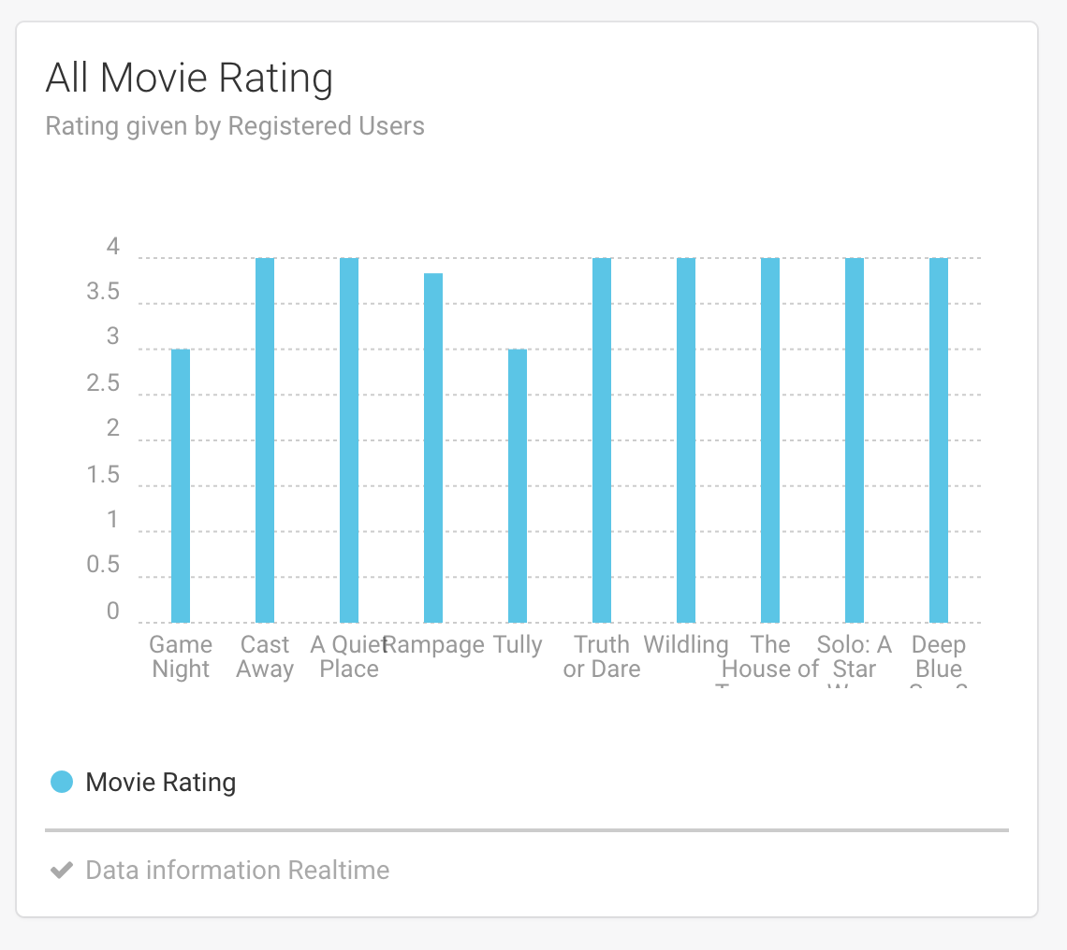

Click Per Pages Bar Graph

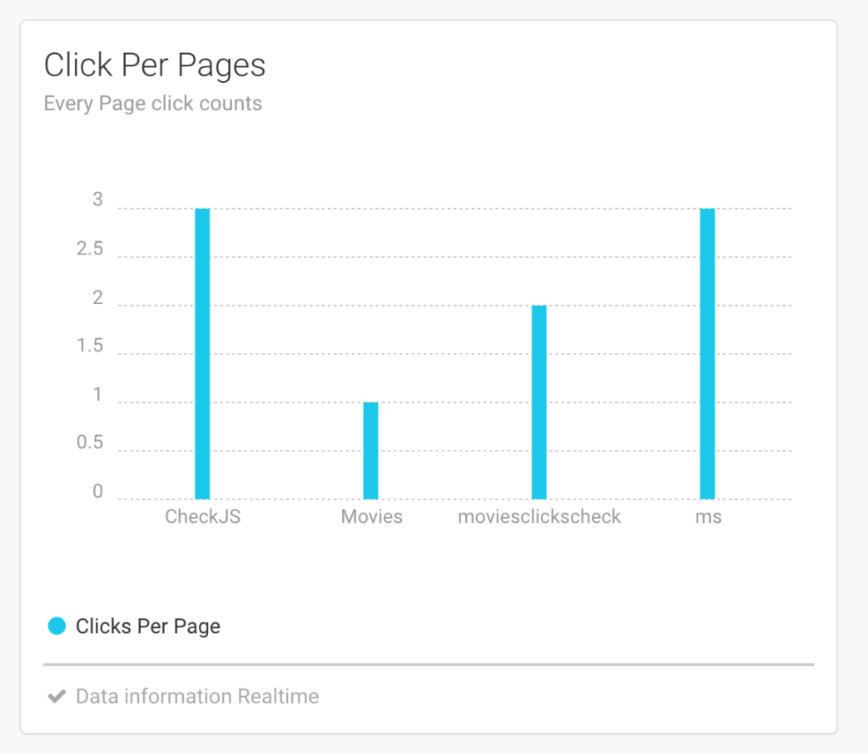

Click per Movies Bar Graph

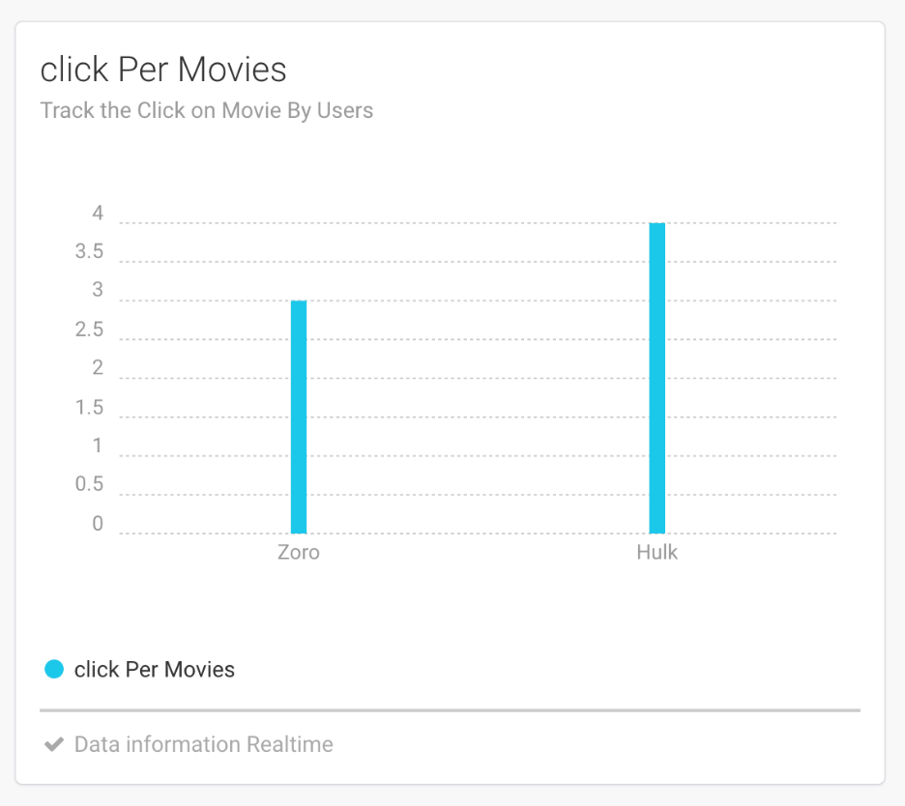

Less Seen Pages of the Website

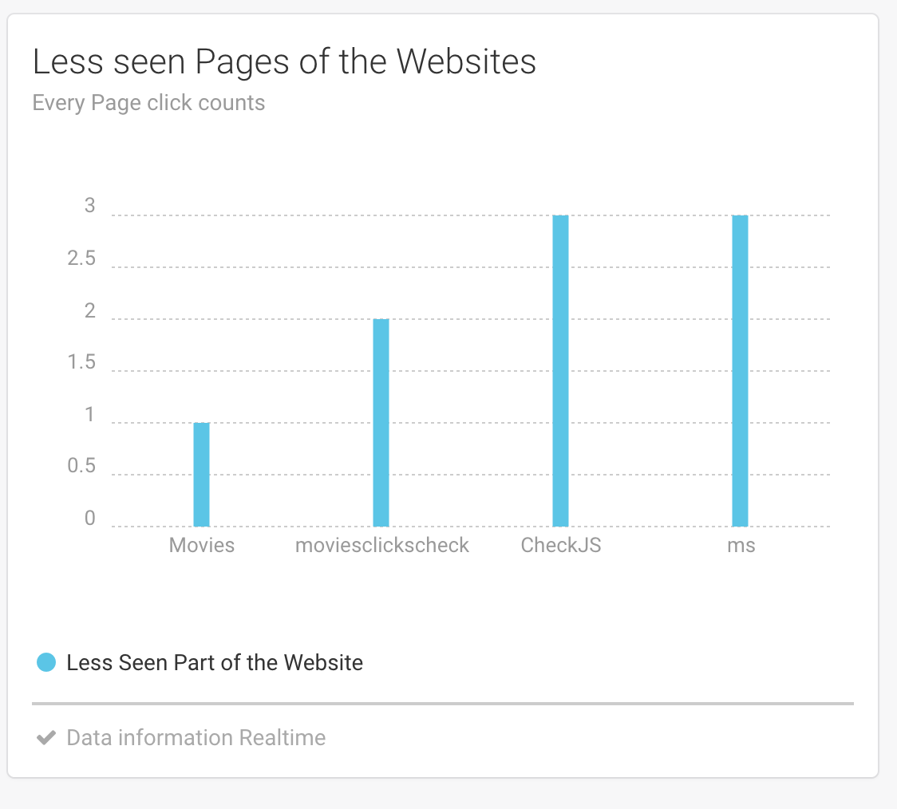

Admin can see the Tracking of Users

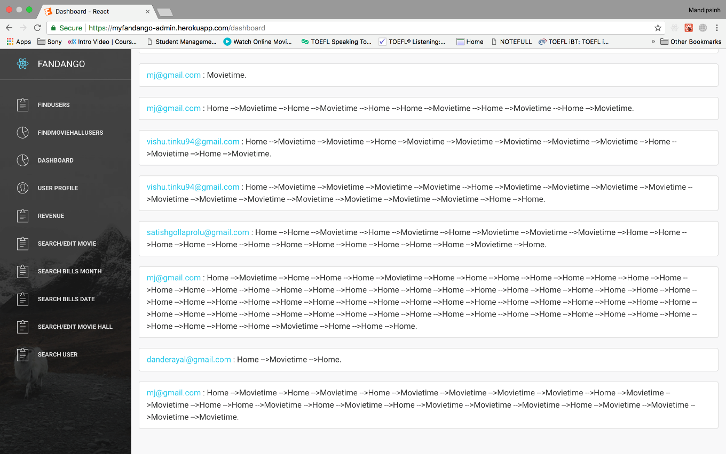

Details about Revenue per Movie / Movie Hall

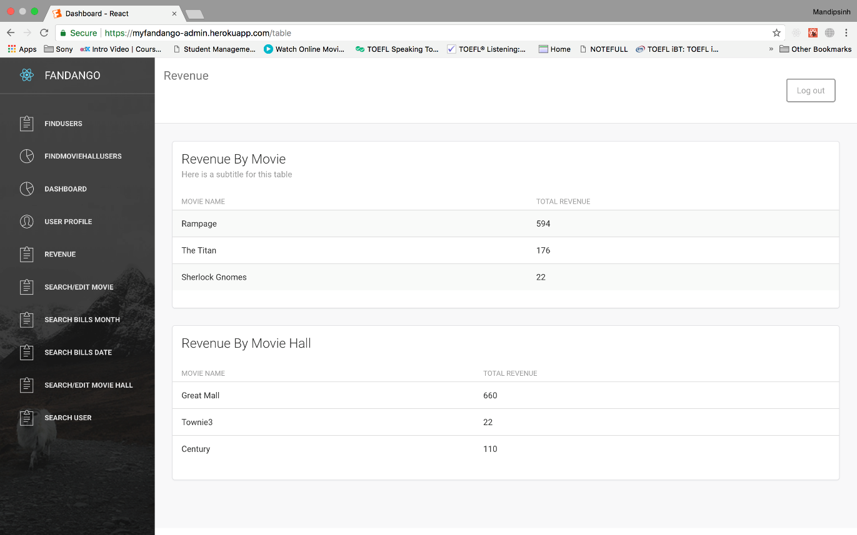

Search/Edit Users

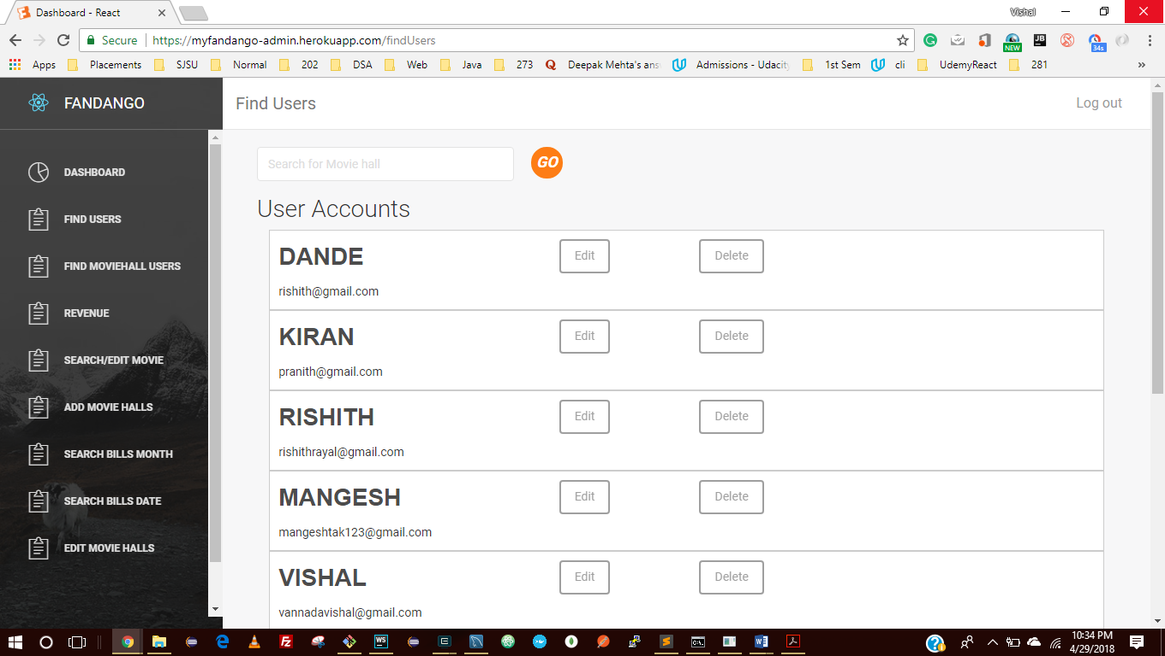

Search by Term

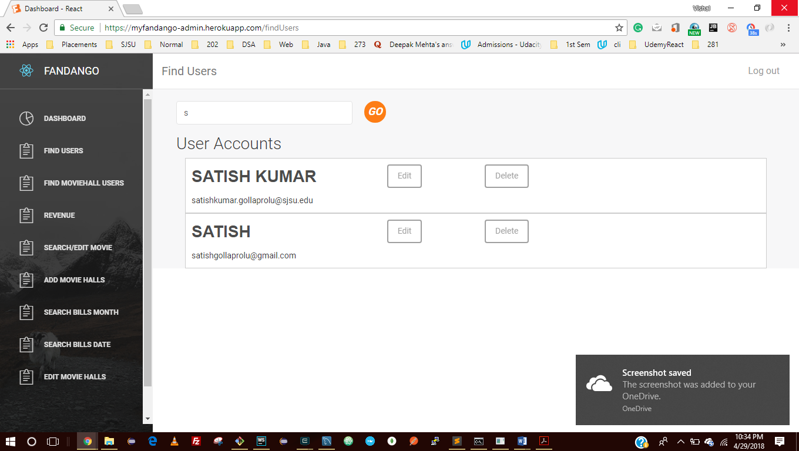

After Delete

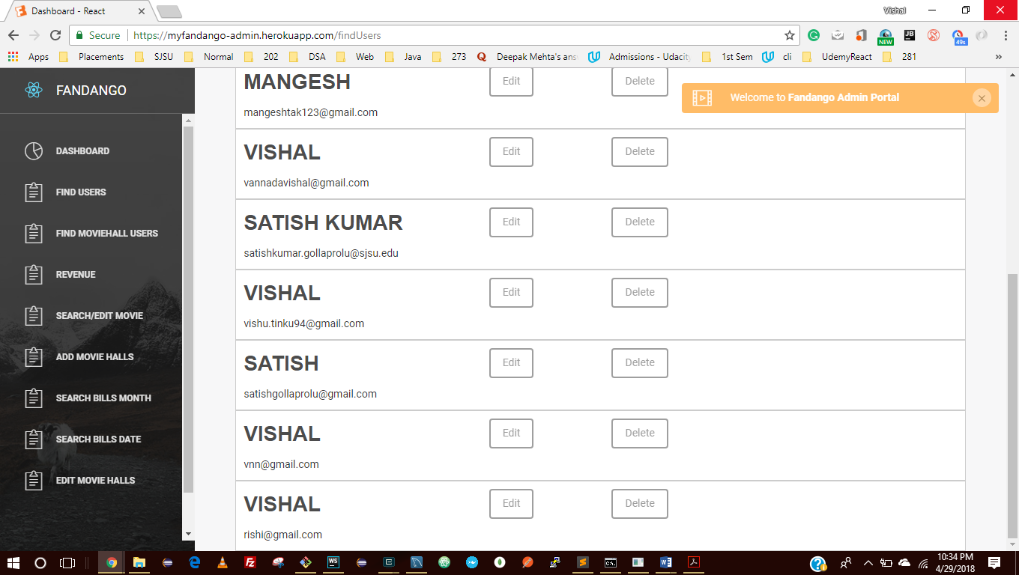

After Edit

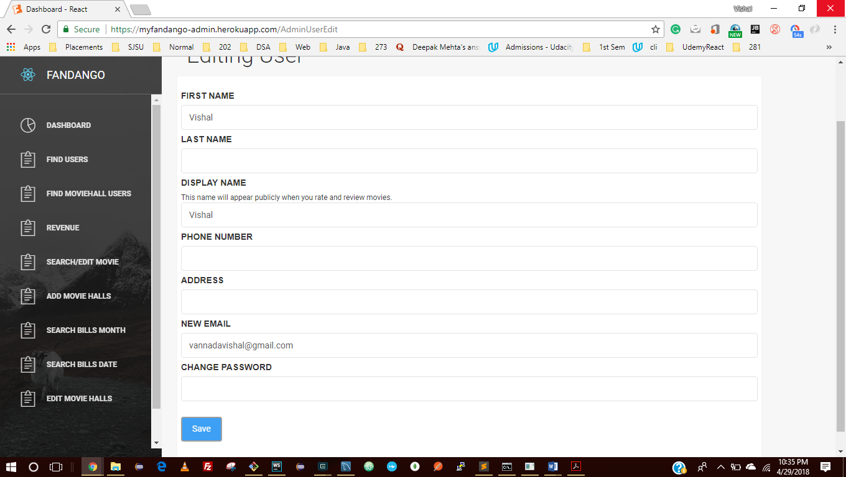

Search/ Edit Movie Hall User

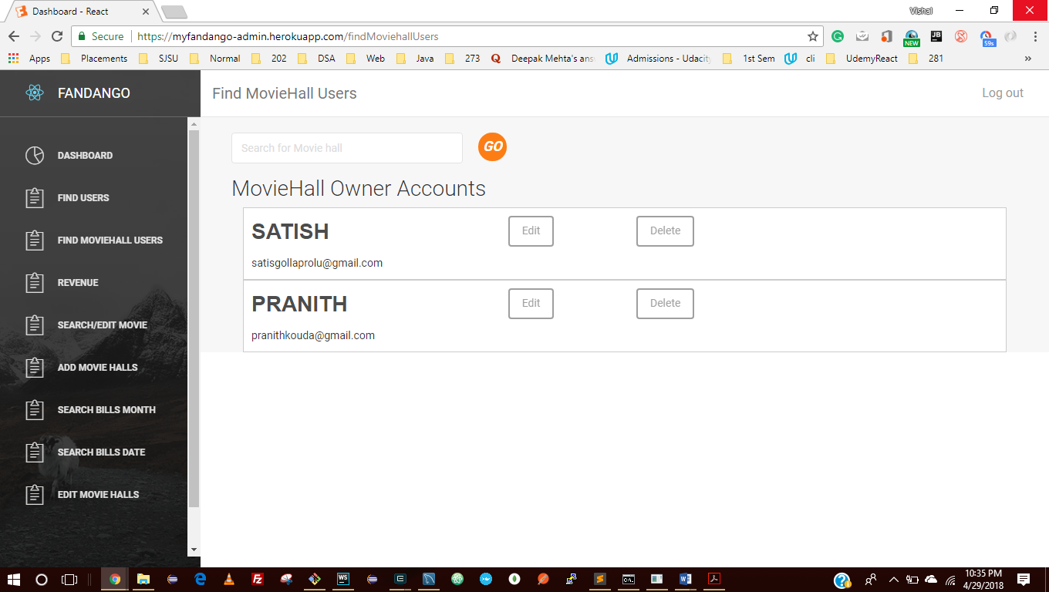

Editing

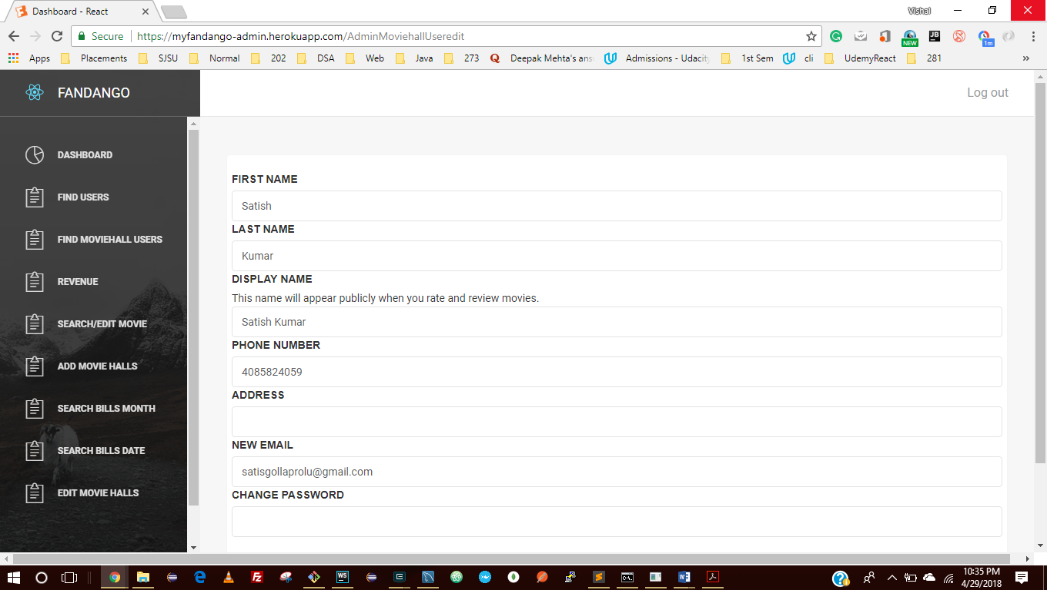

After Delete

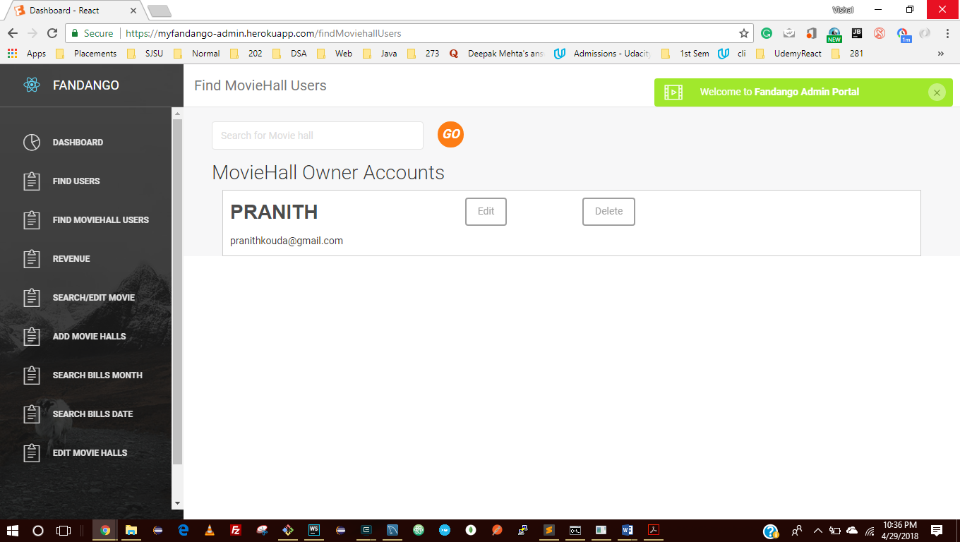

Search / Edit Movies

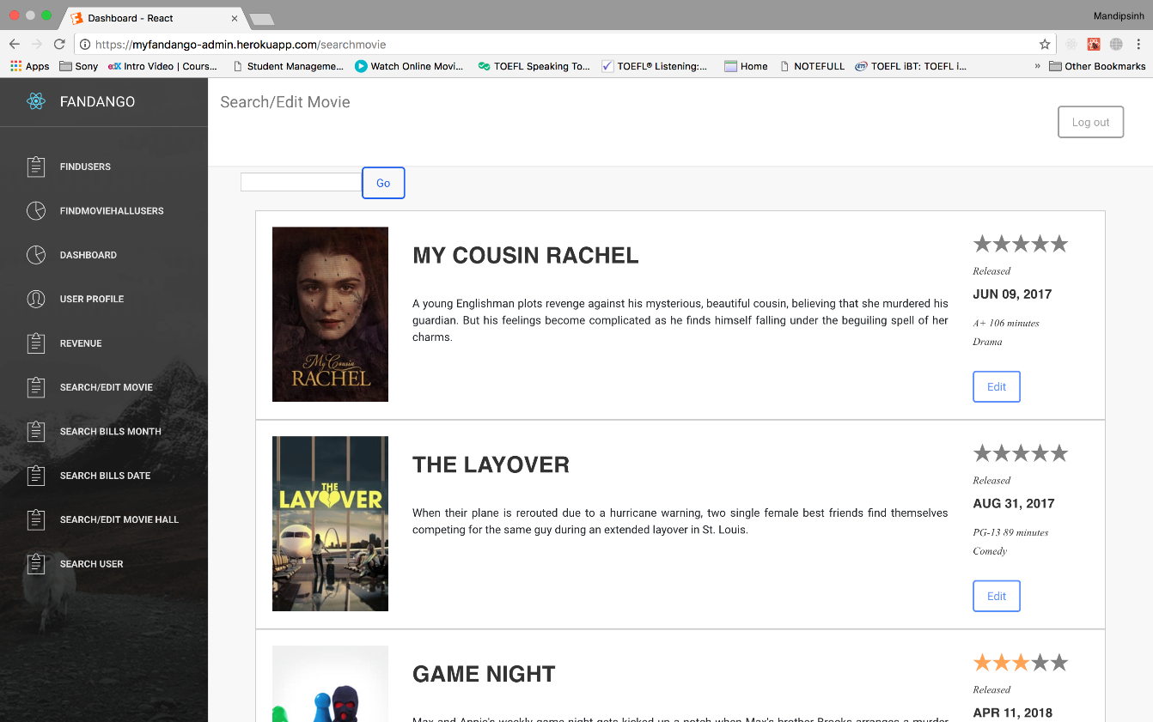

Search Movie by Name

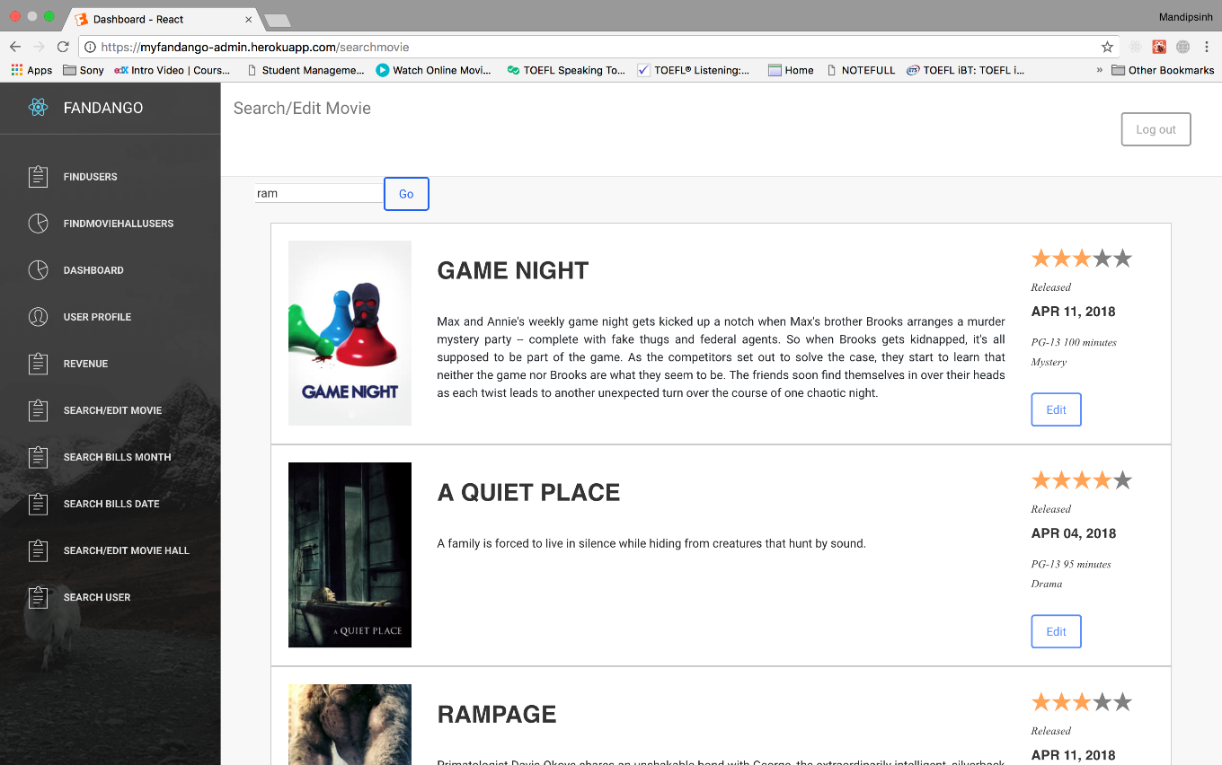

Edit Movie

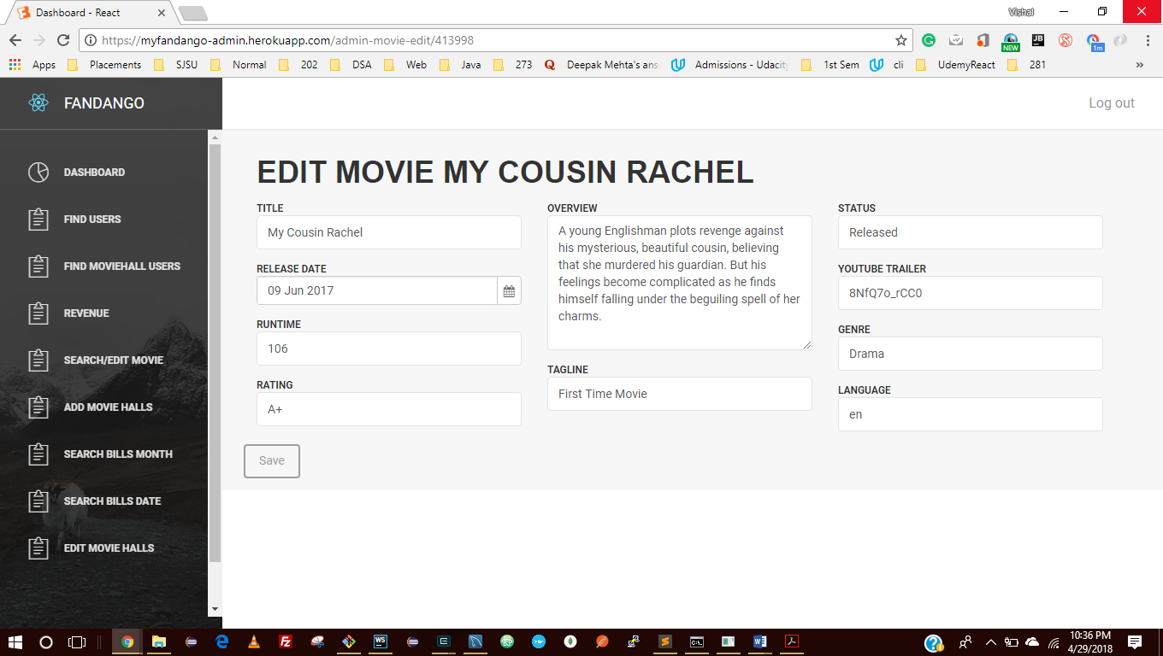

After Save

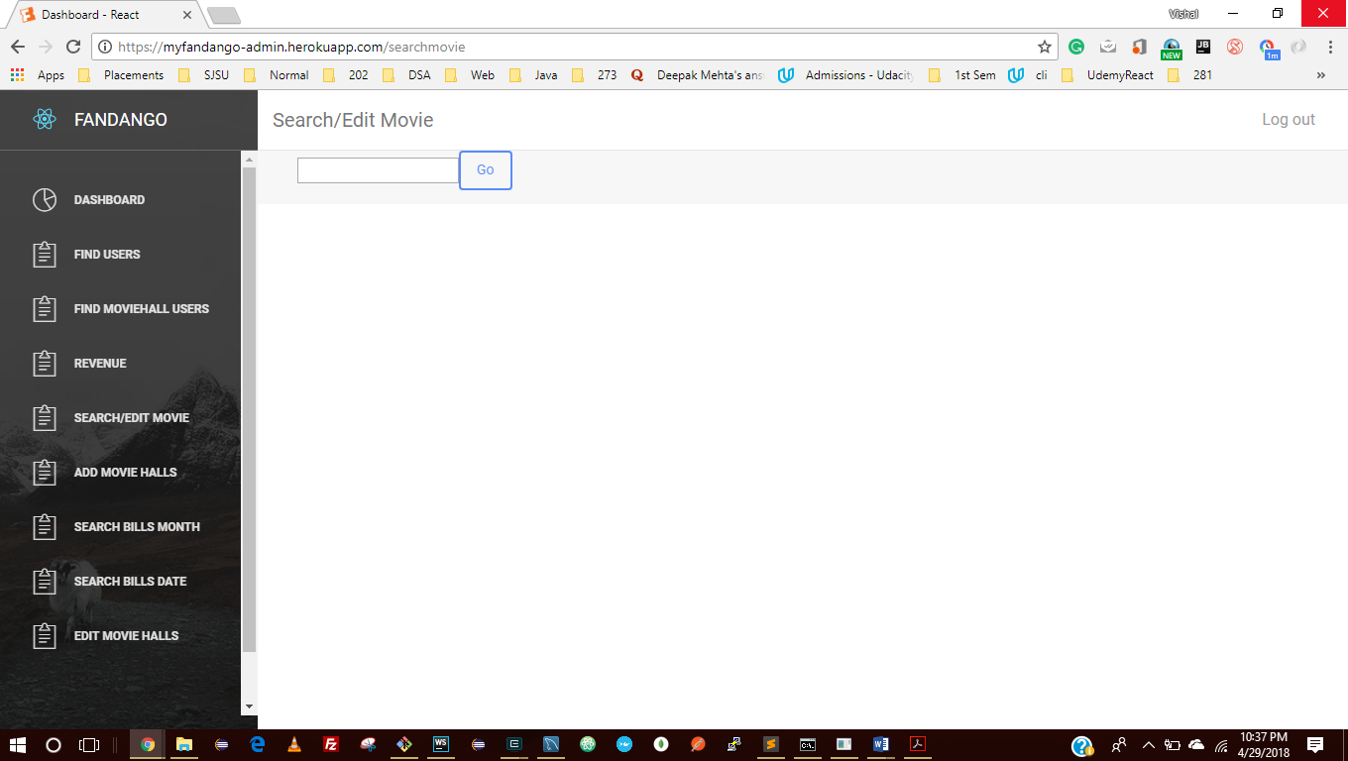

Search Bill by Month

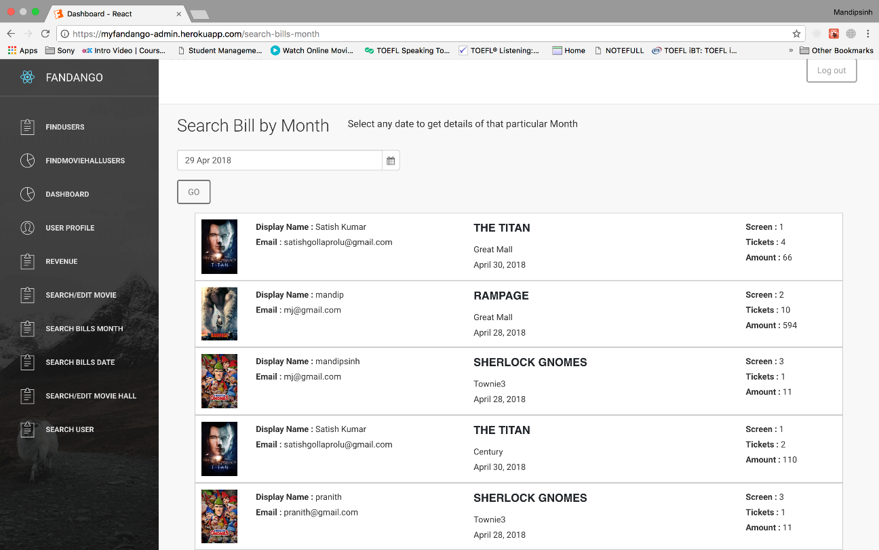

Search Bill by Date

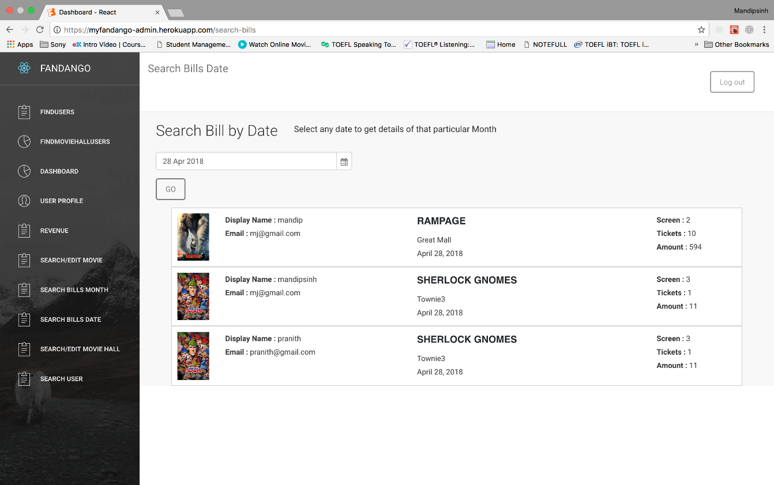

Admin Edit Movie Halls

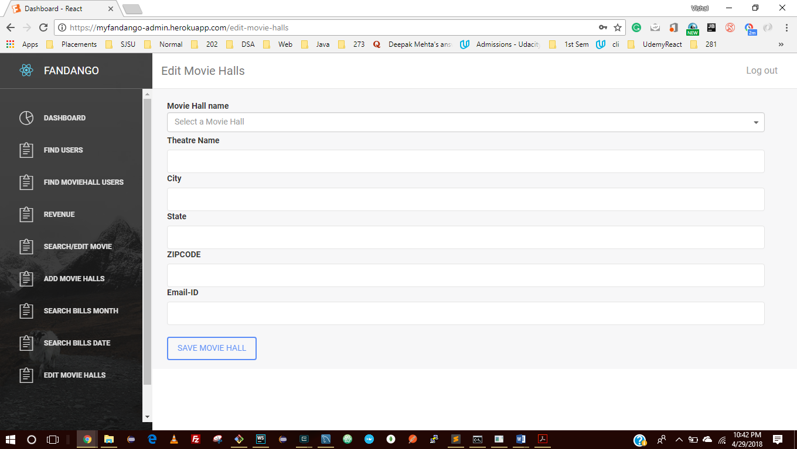

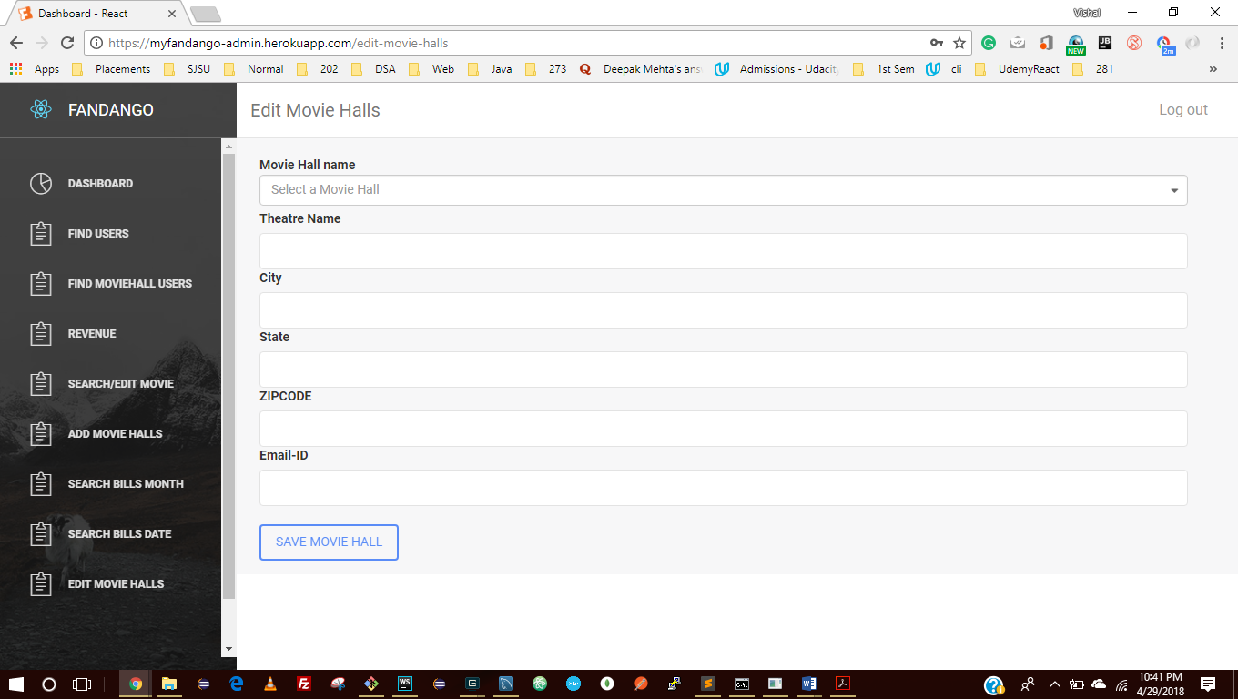

**Movie Hall Module**

Movie Hall Admin Login Page

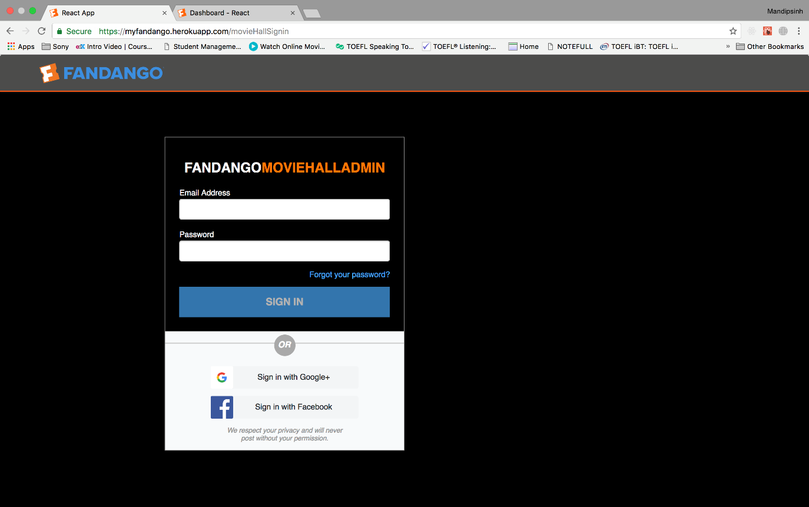

Validation in Movie Hall Login

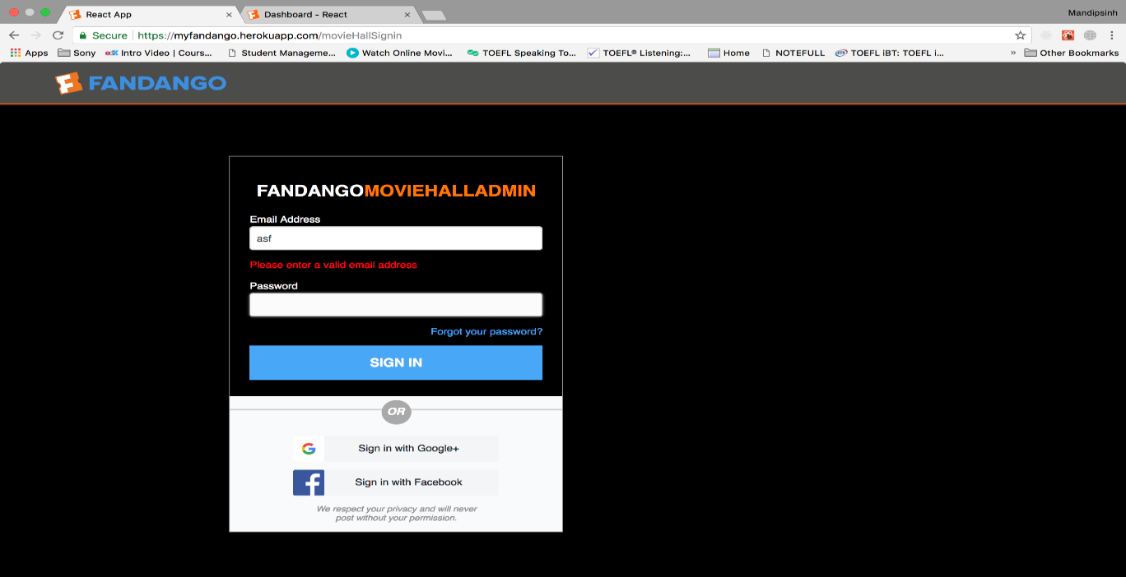

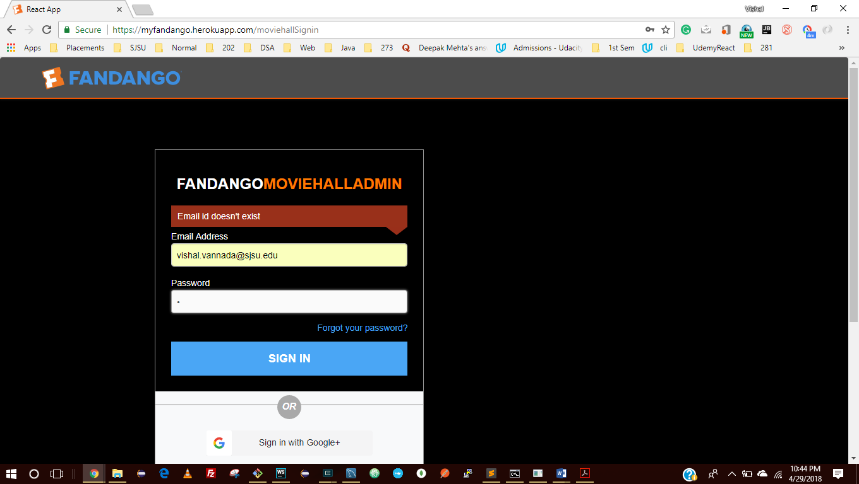

After Login in into Movie Hall Admin

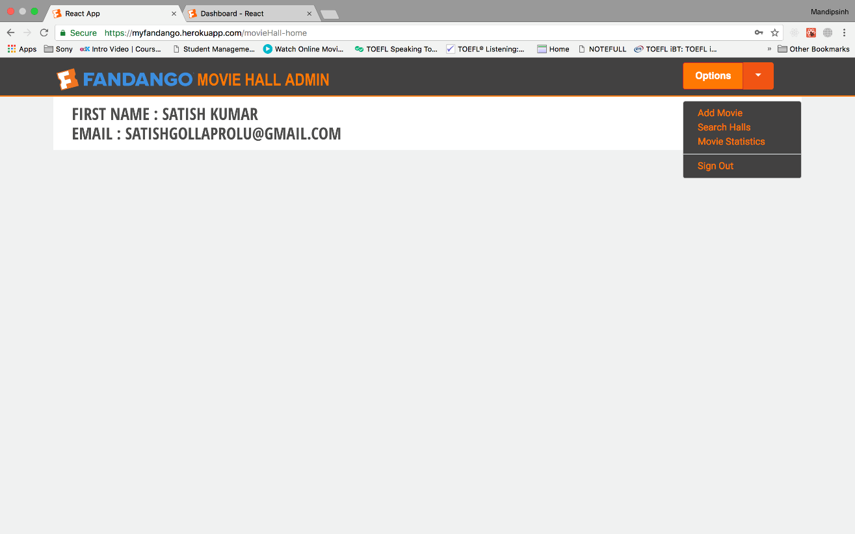

Add Movie to Movie Hall

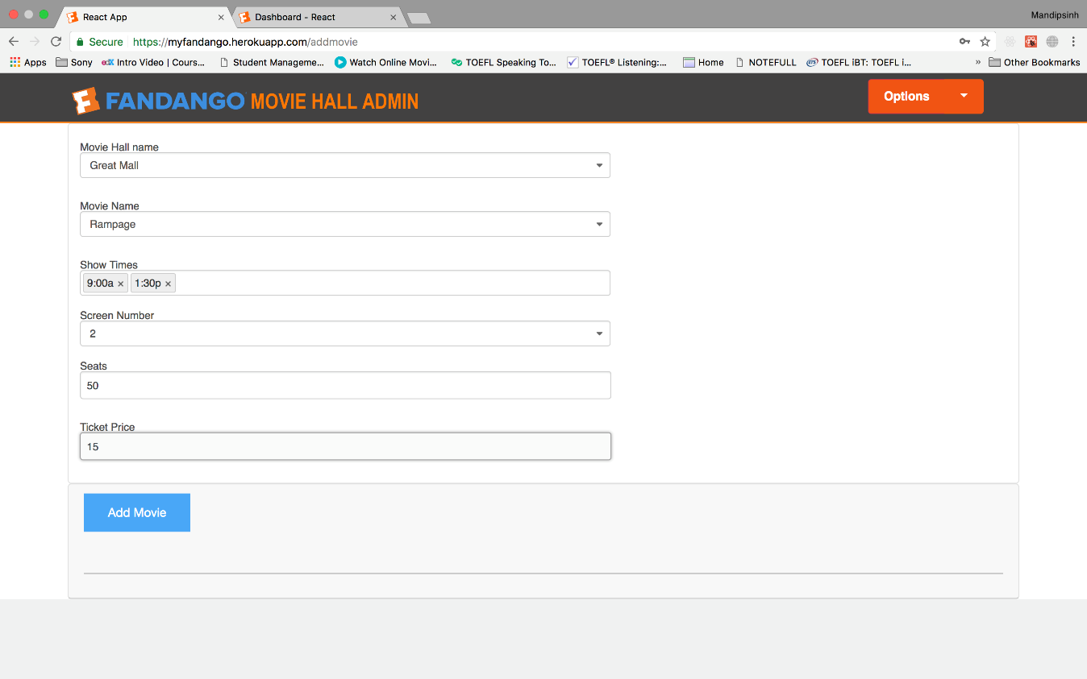

Add Movie to hall if it is Empty

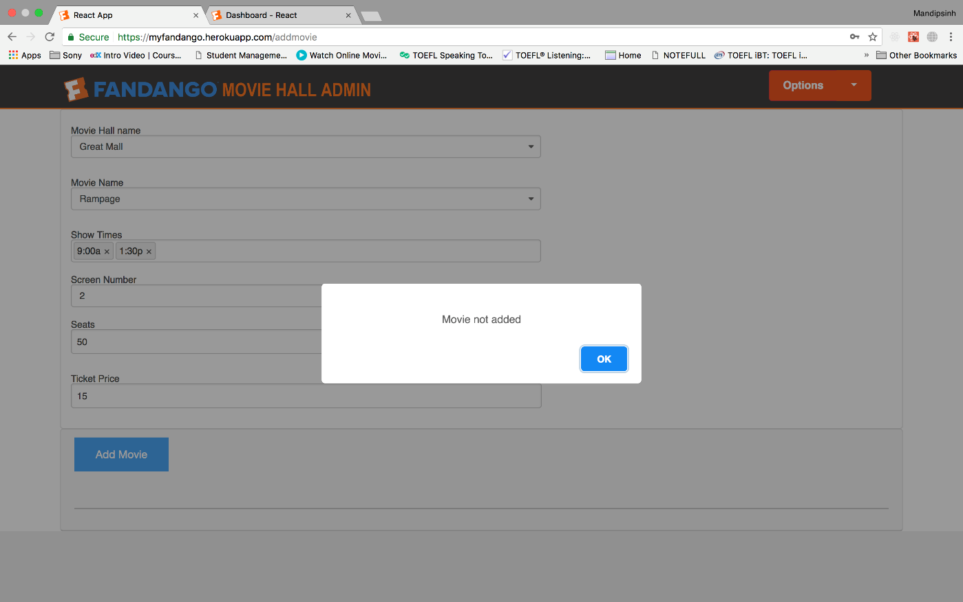

Add Movie to Hall successfully

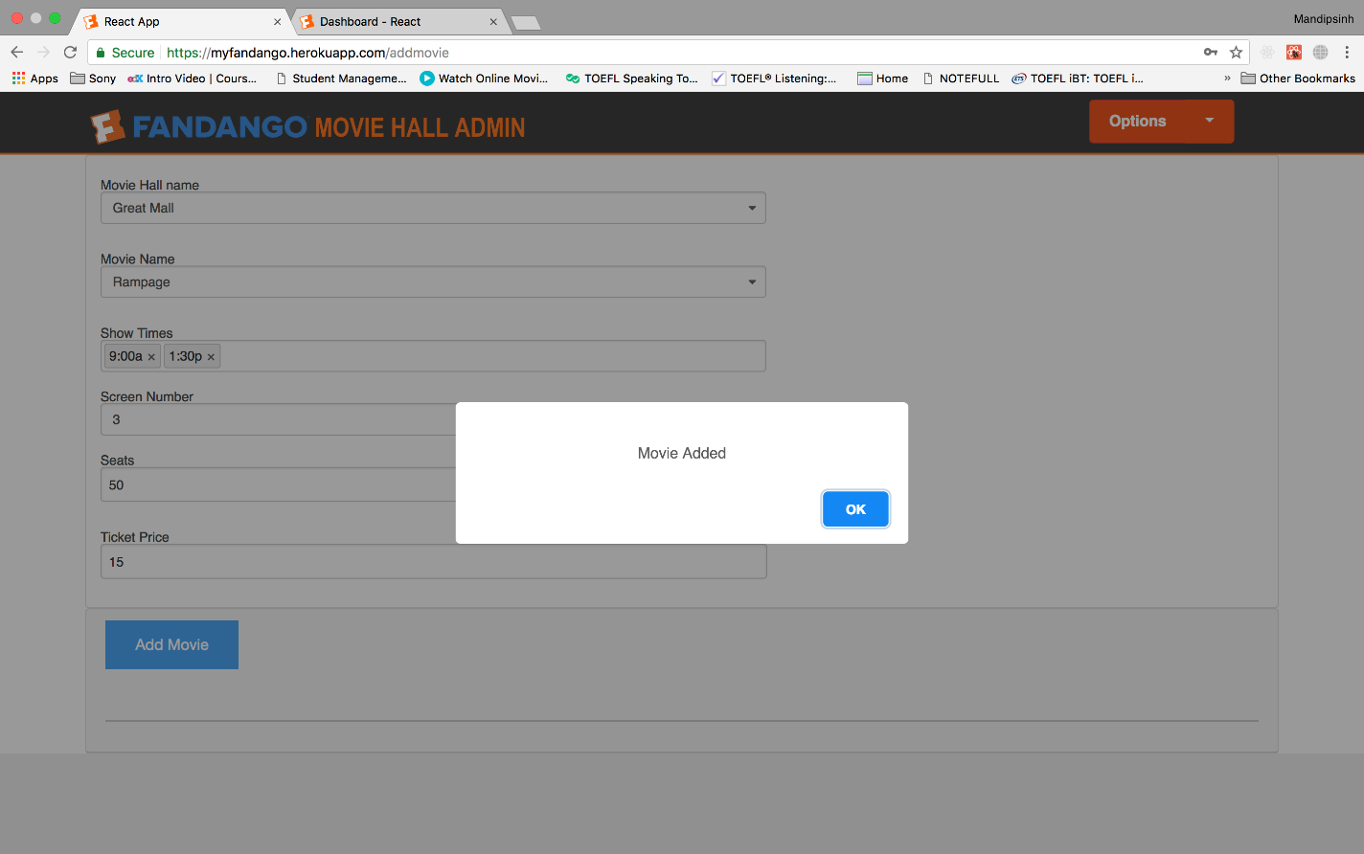

Search Movie Hall

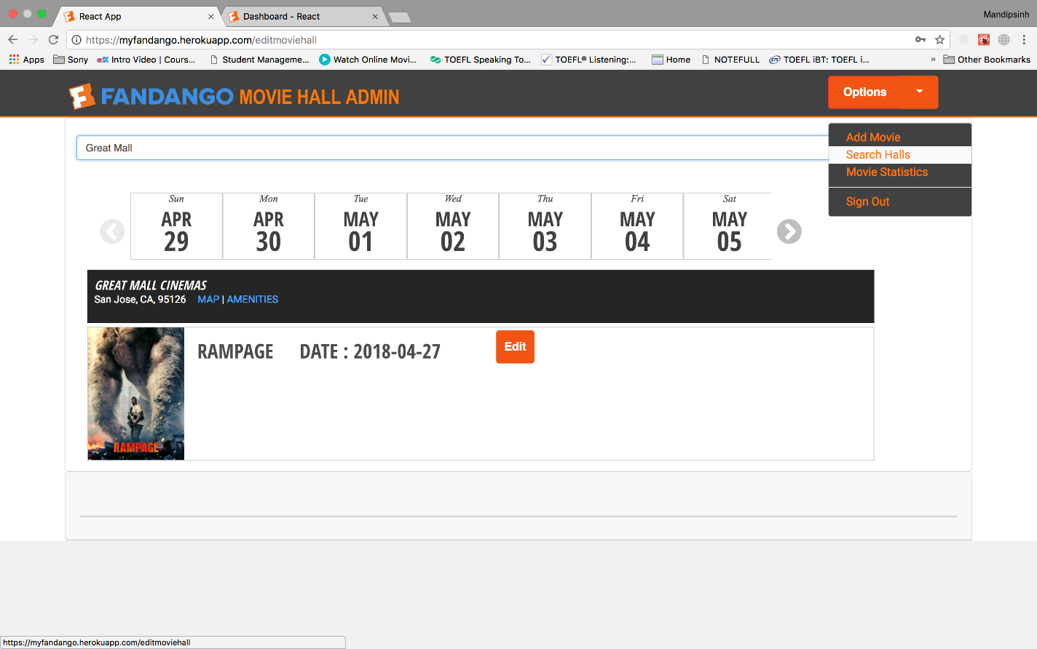

User can cancel the Movie Tickets

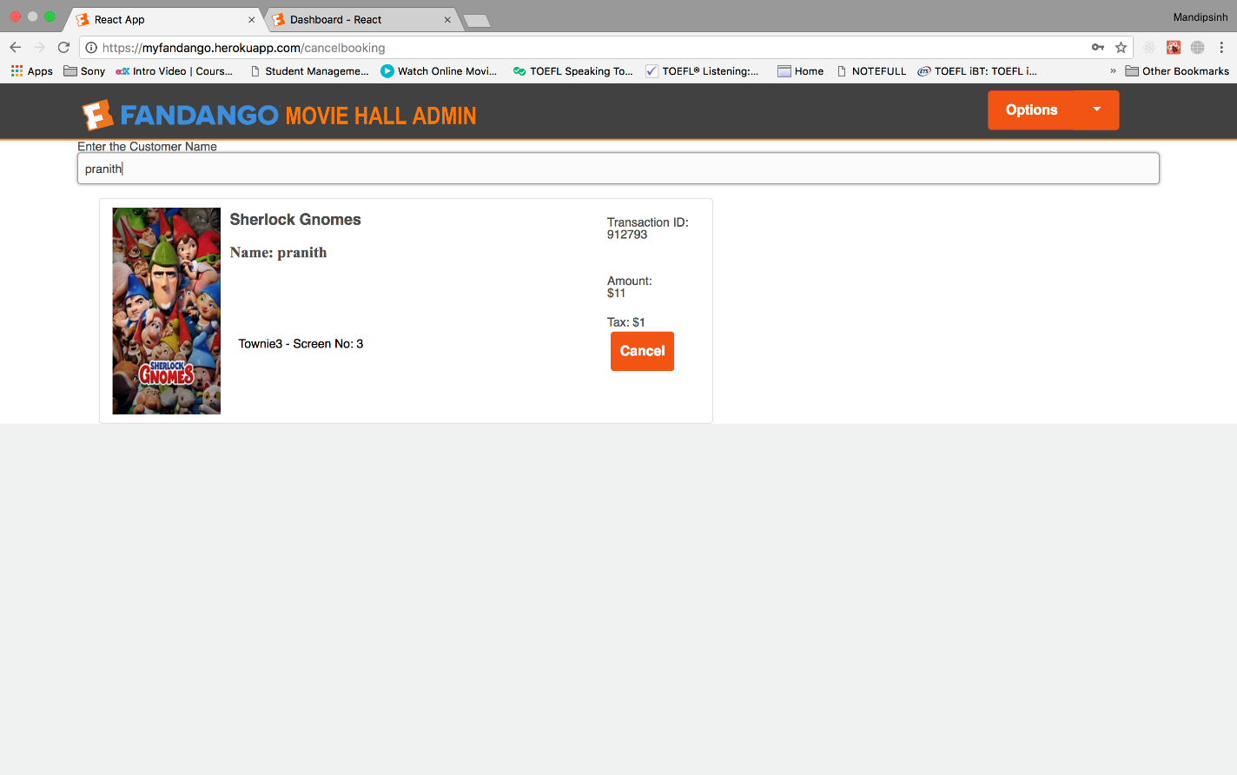

Search user Tickets

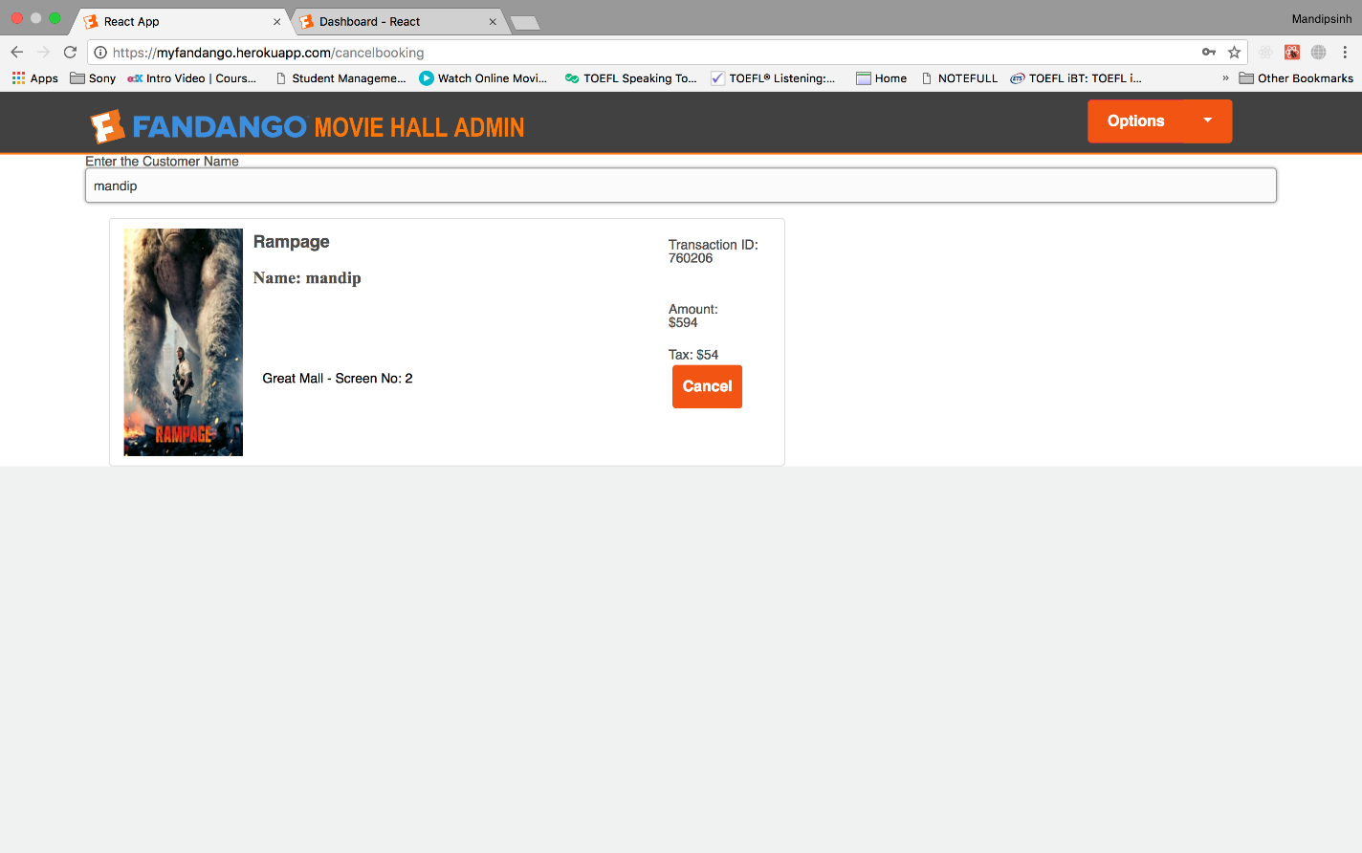

# **CODE LISTING**

## **Client Frontend**

## **Admin Frontend**

## **Node Backend**

## **Kafka Backend**

**Code Listing of Client**

**Code Listing of Server Entity Objects**

**Code Listing of Server Session Object**

**Code Listing of Main Server Code**

**Code Listing of Database Access Class**

**Code Listing of Test Class**

**SQL SCHEMA**

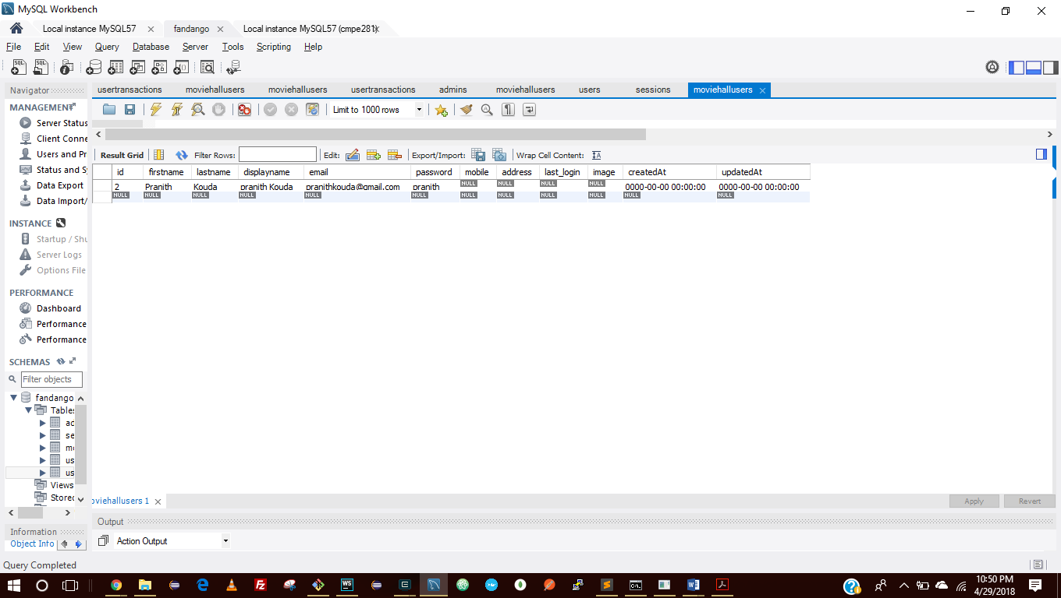

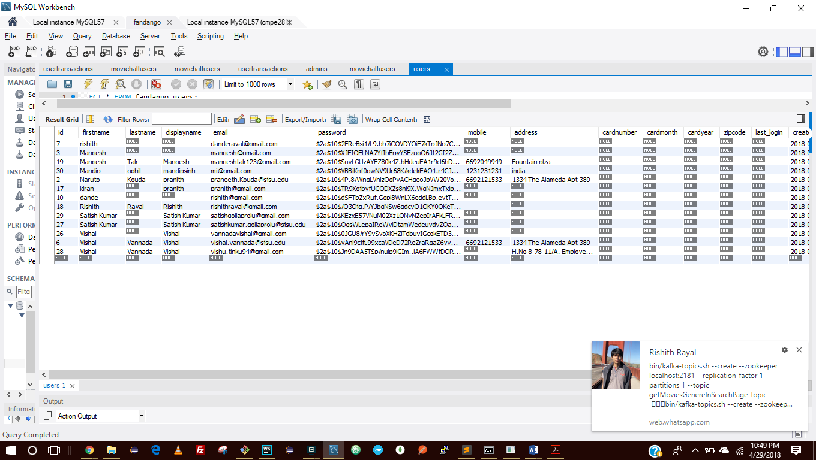

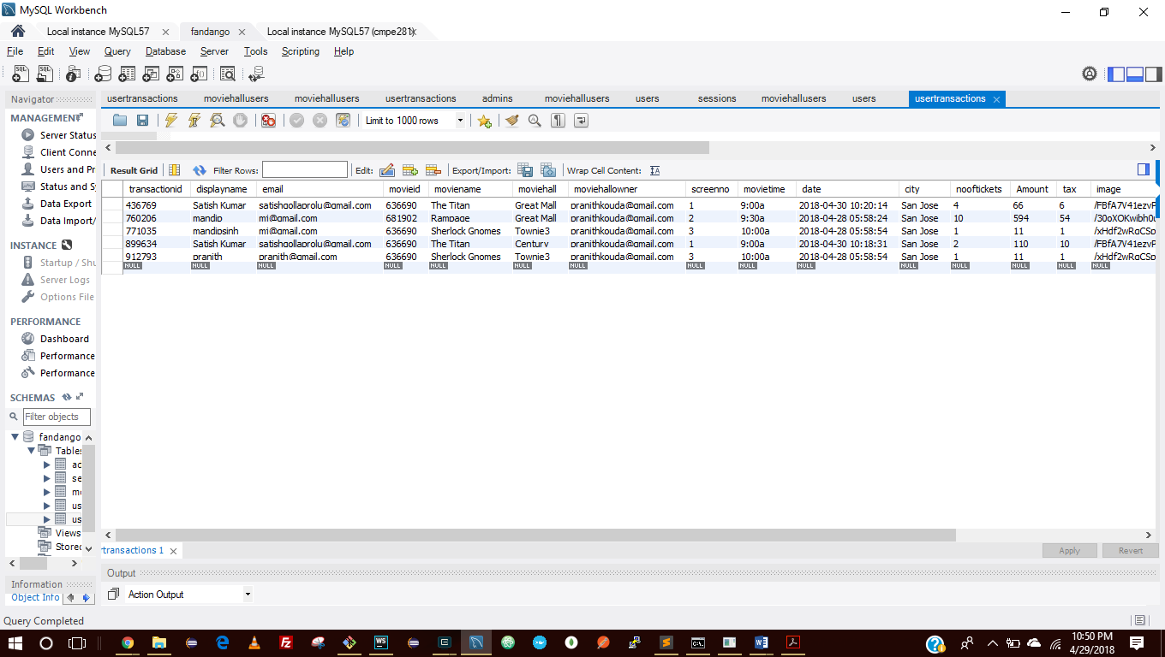

**Kafka Topics**

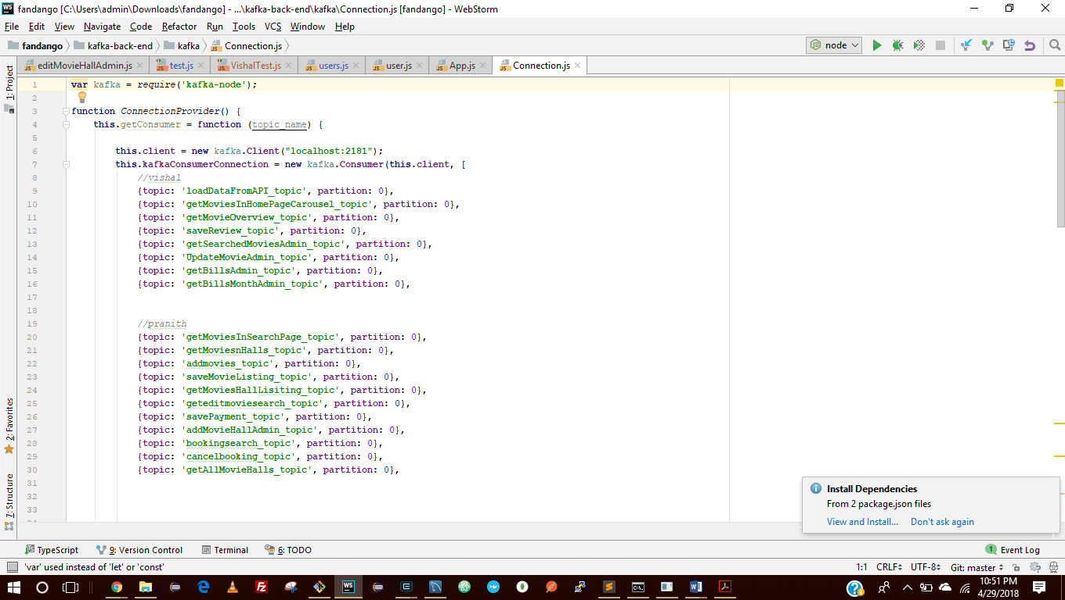

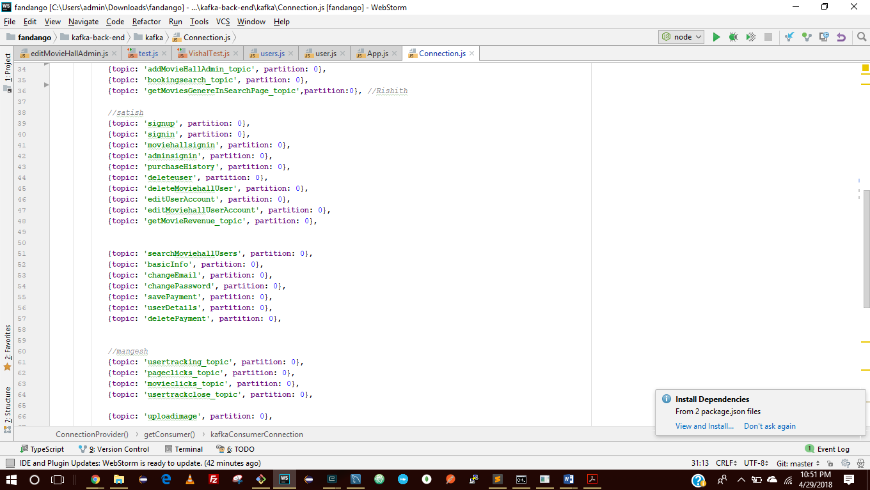

**Kafka Topics**

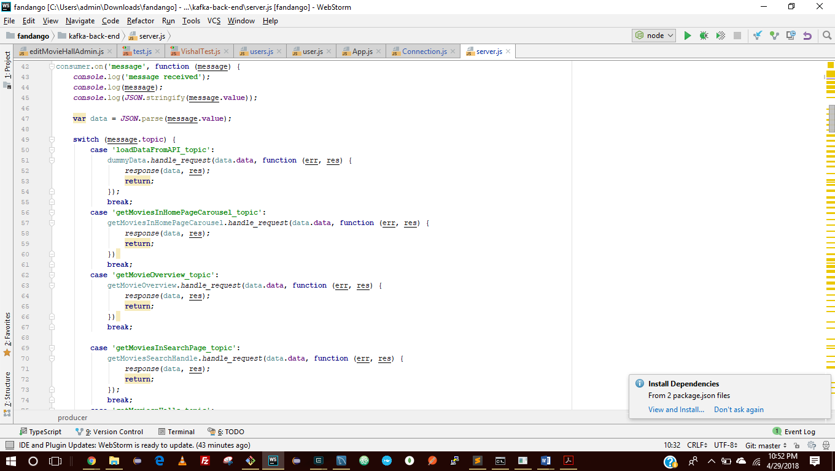

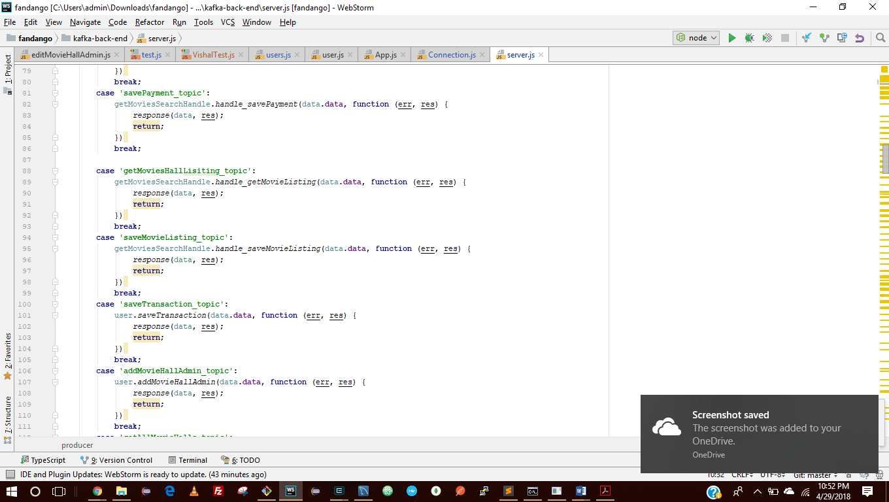

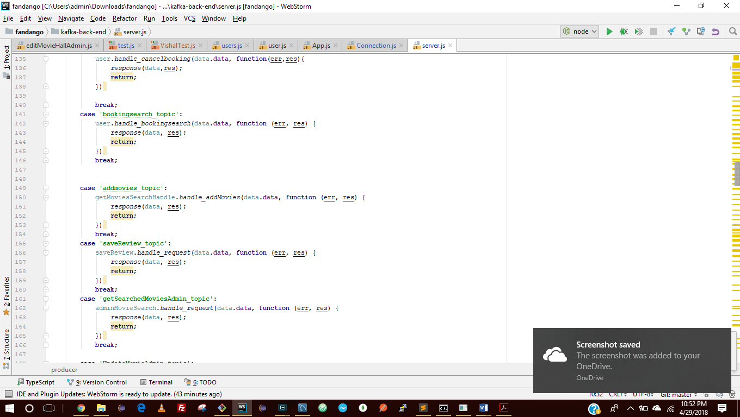

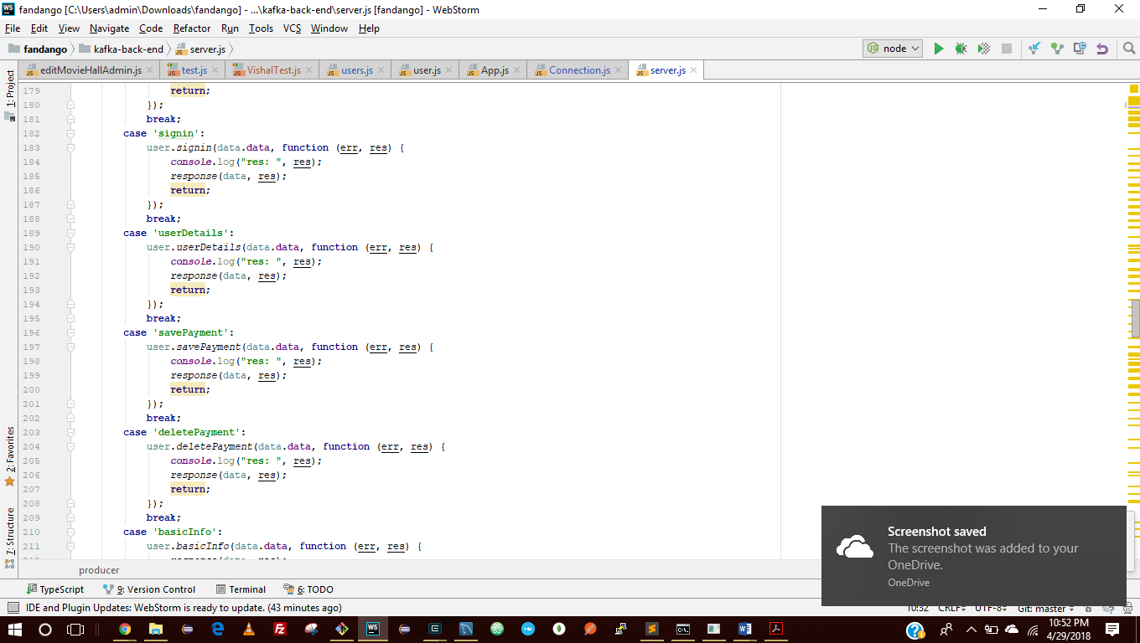

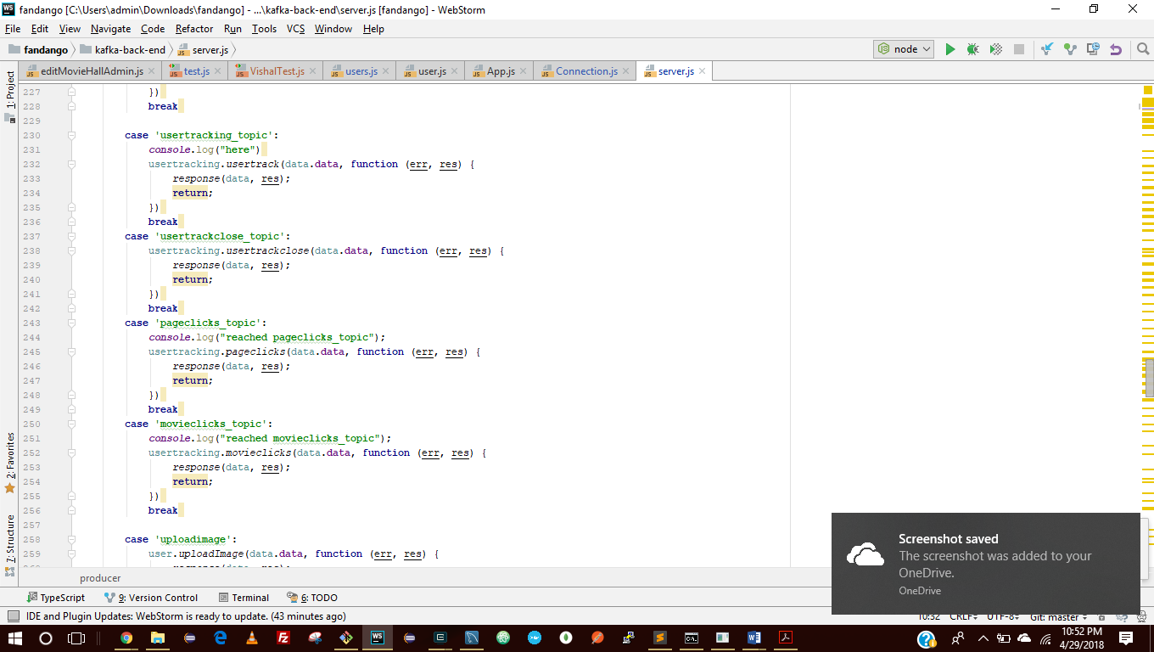

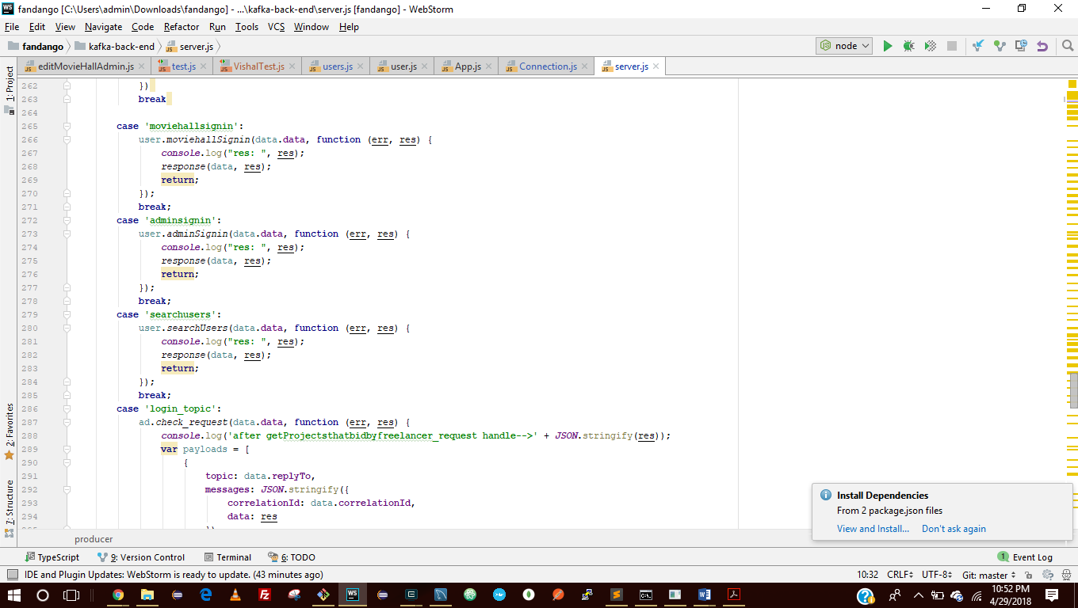

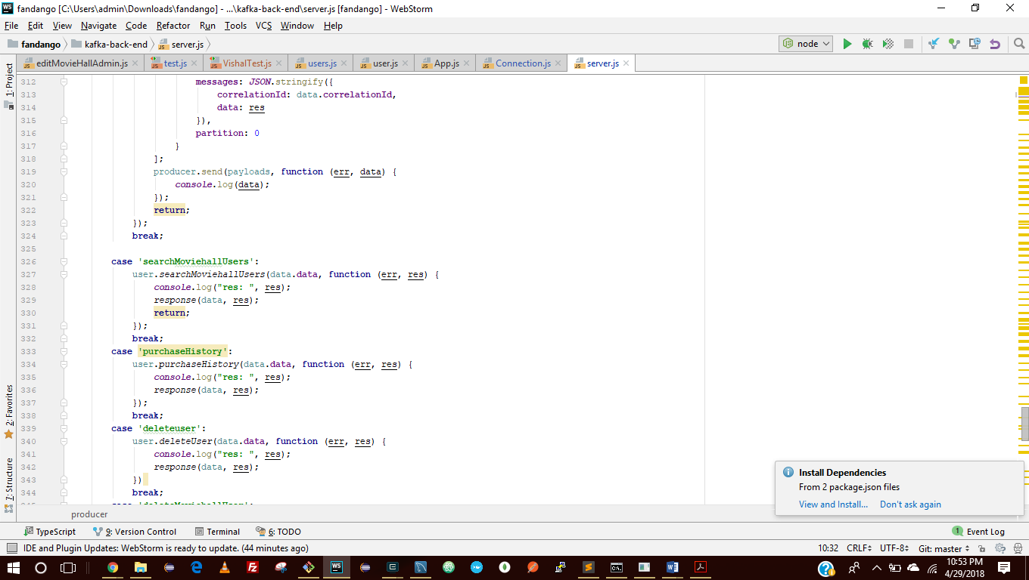

**Few server requests**

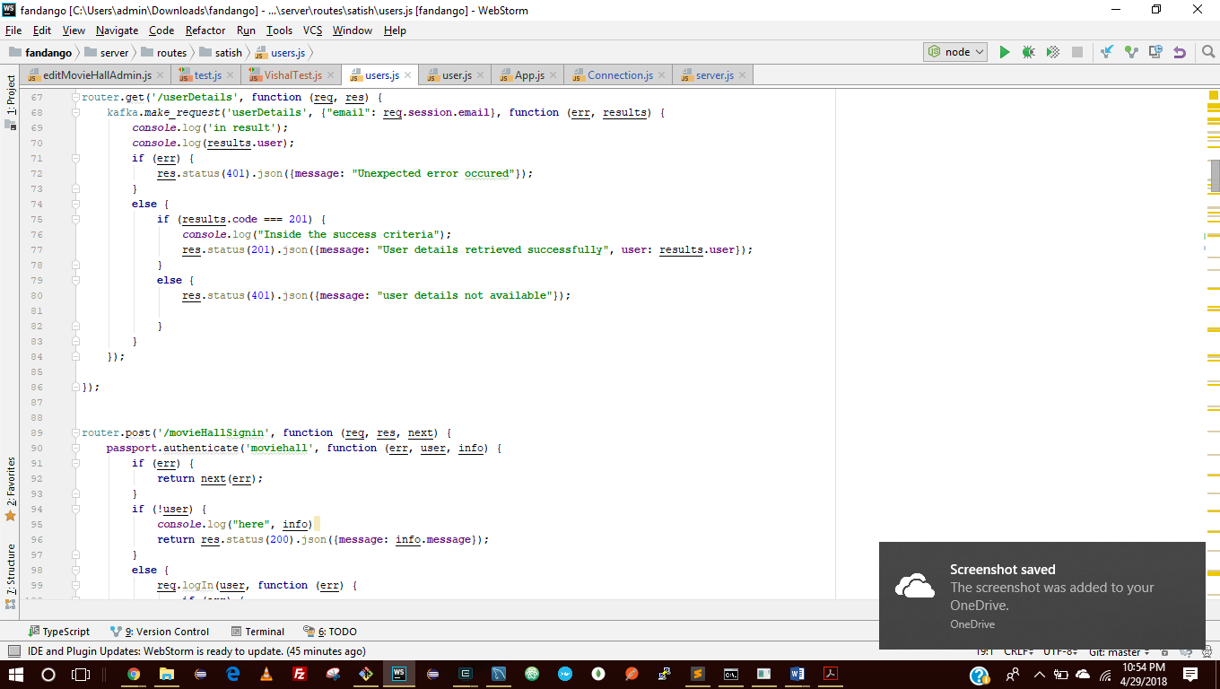

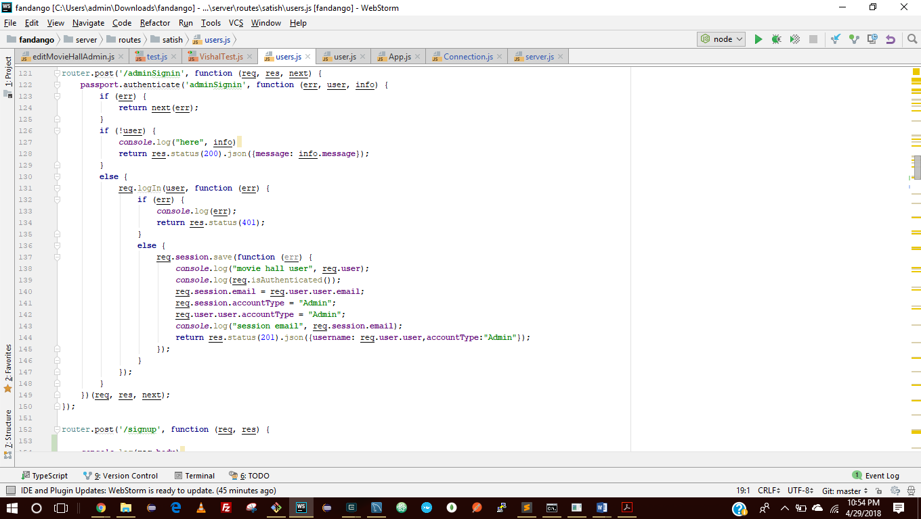

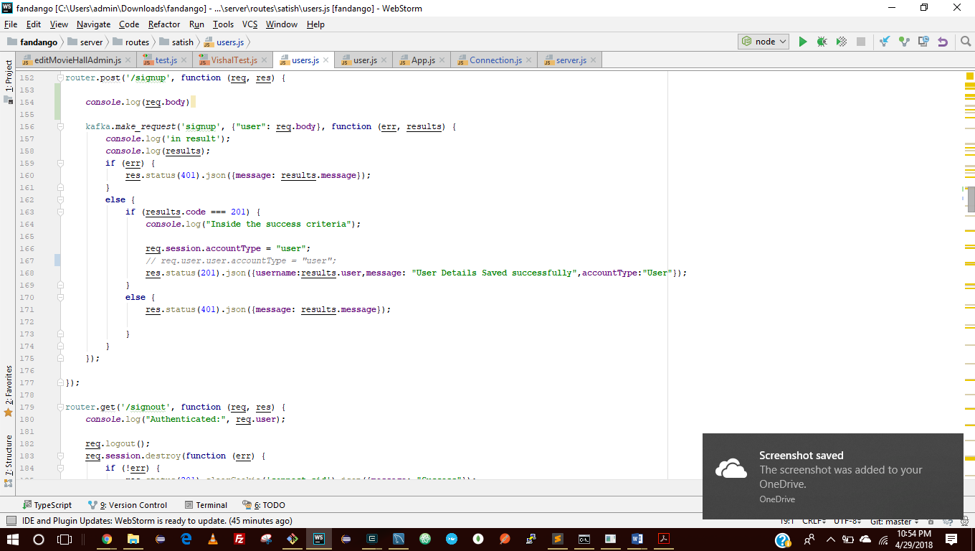

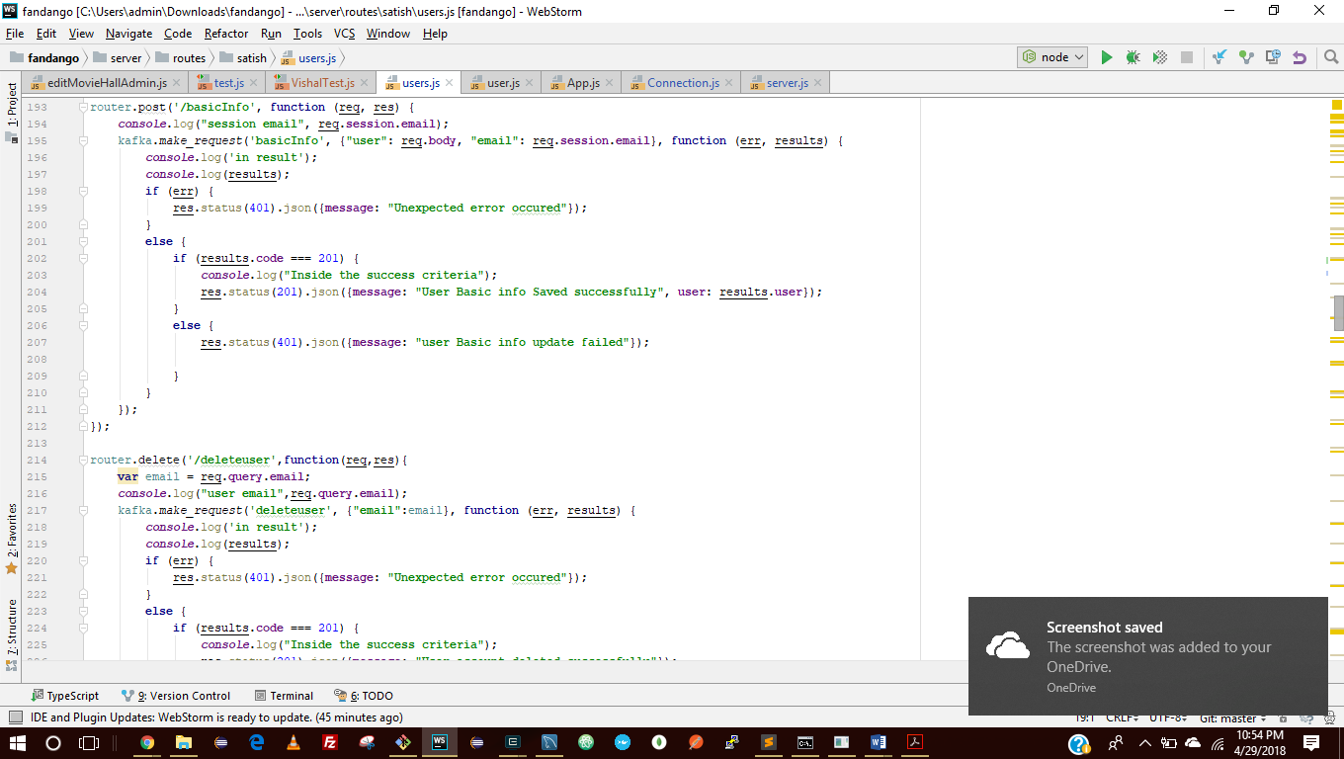

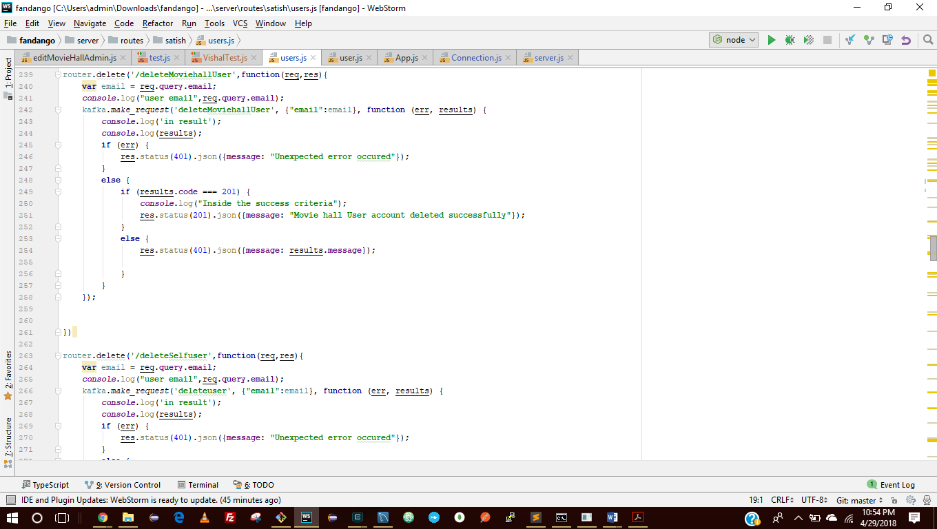

**Client Structure**

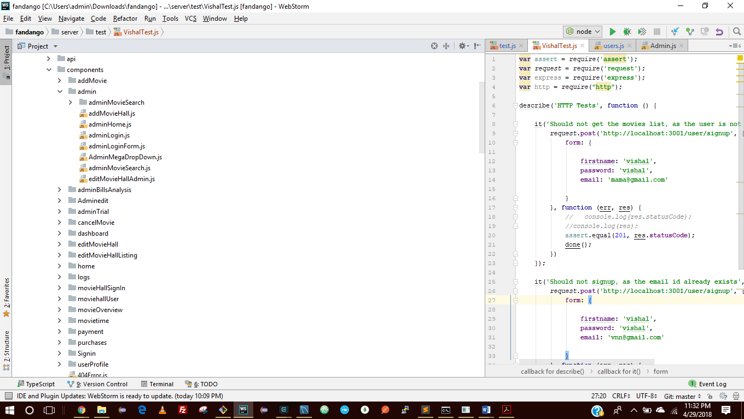

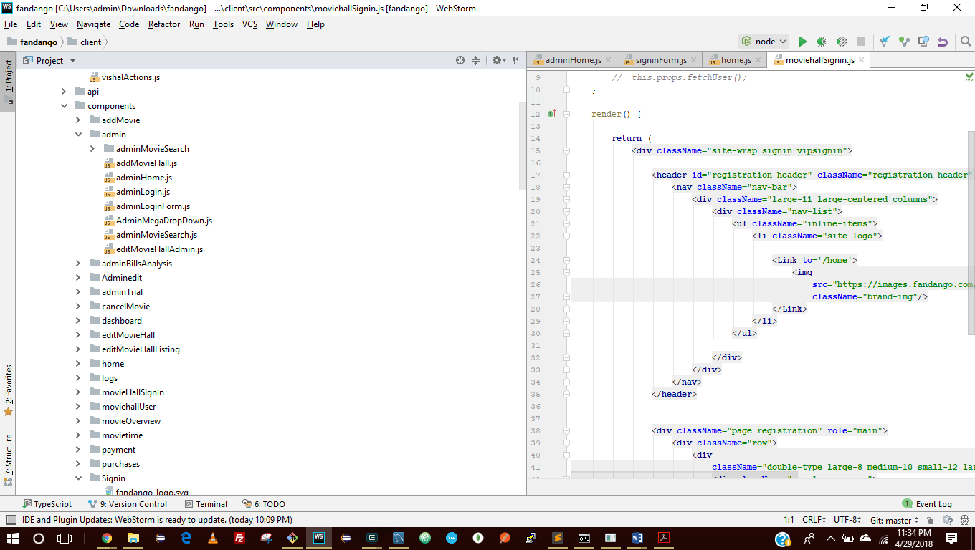

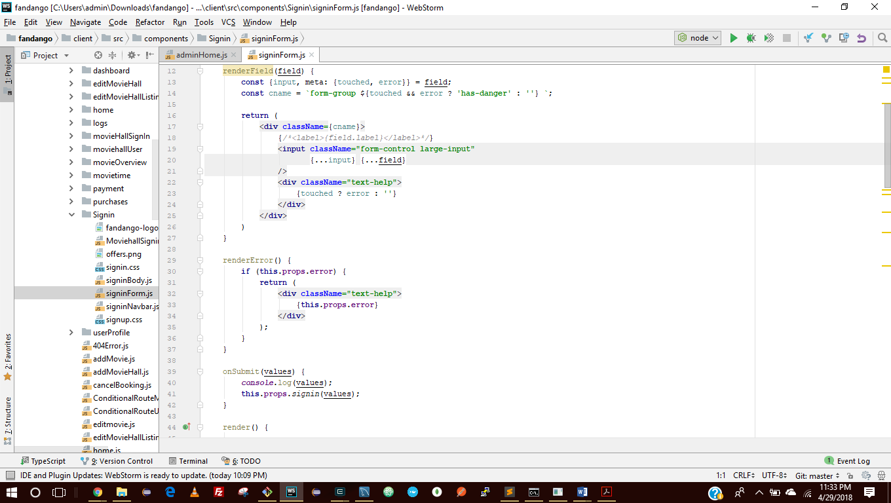

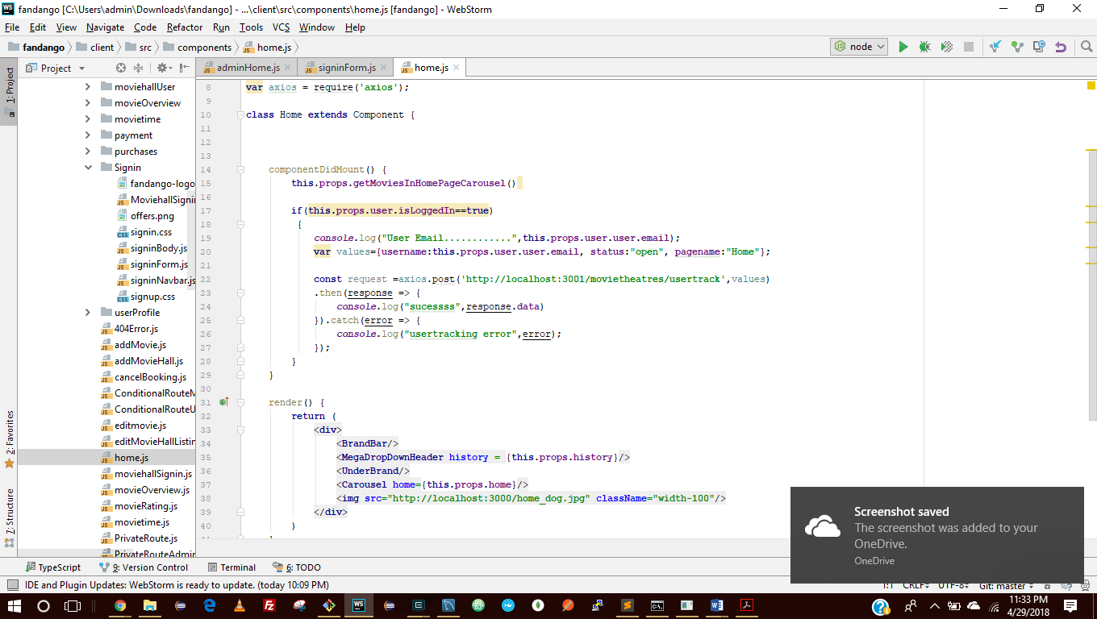

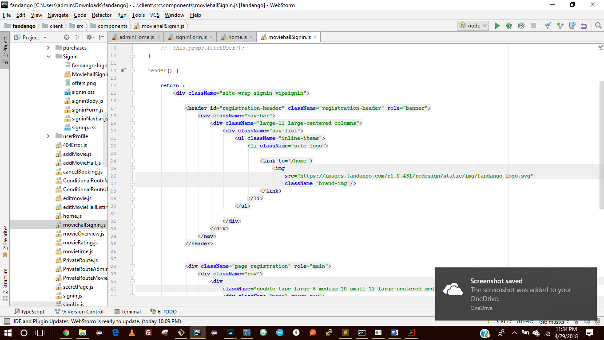

**Models of SQL**

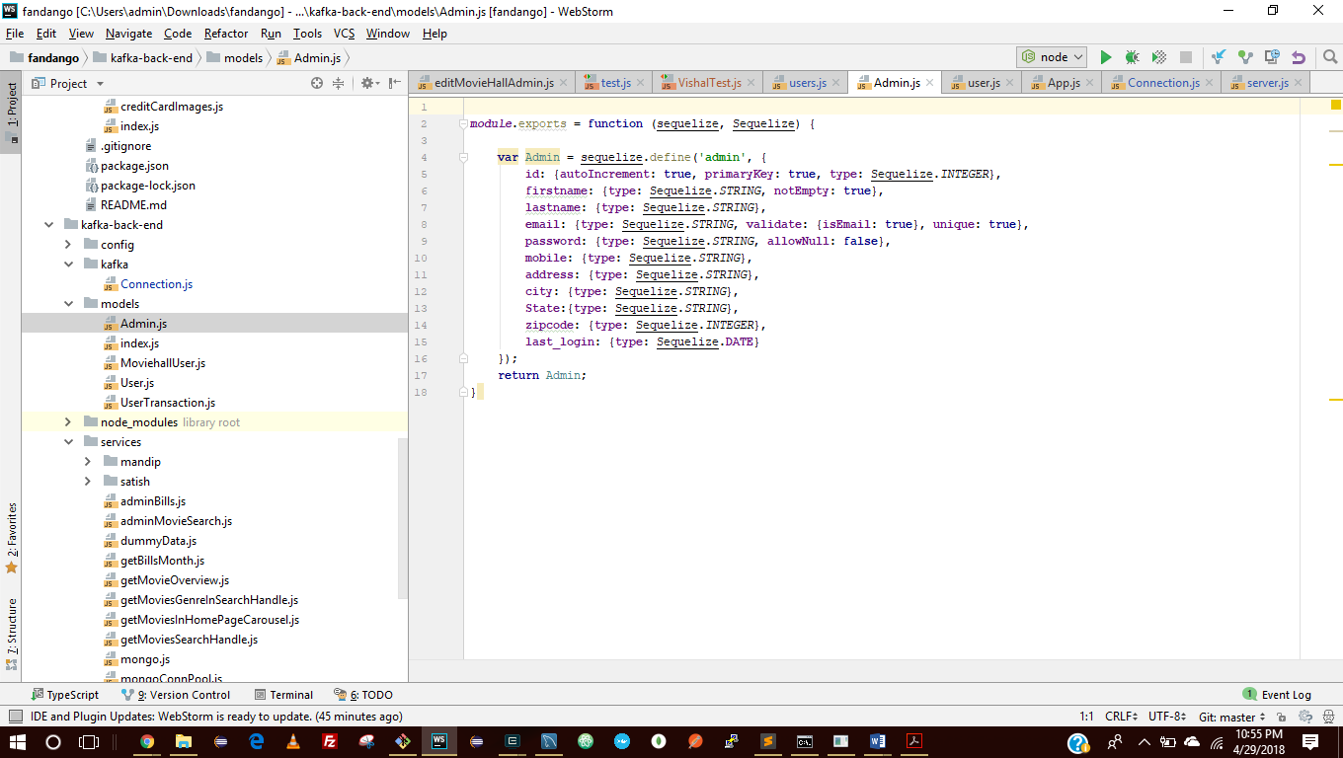

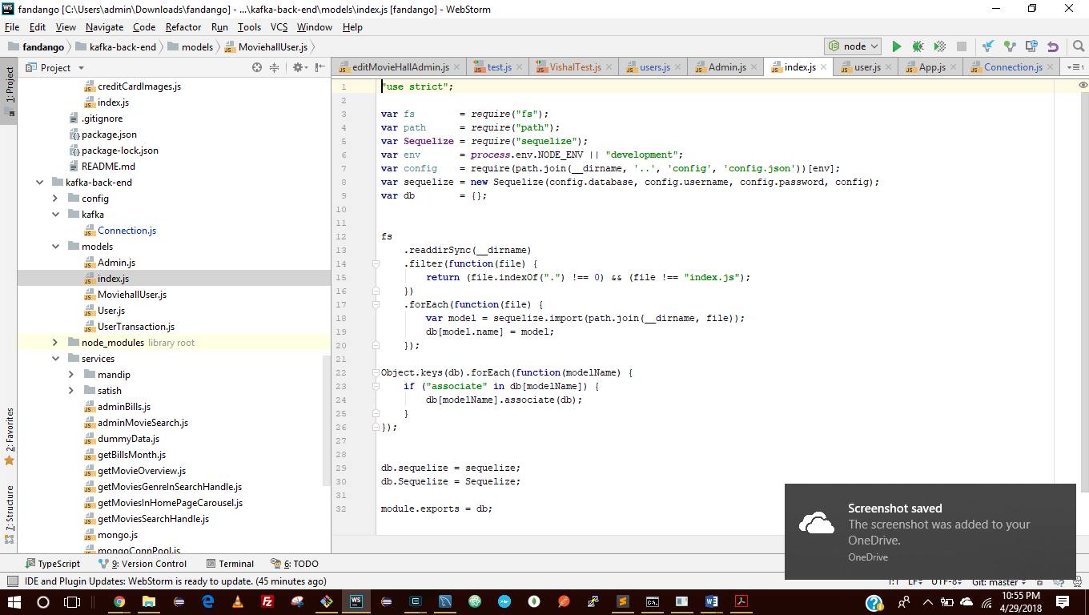

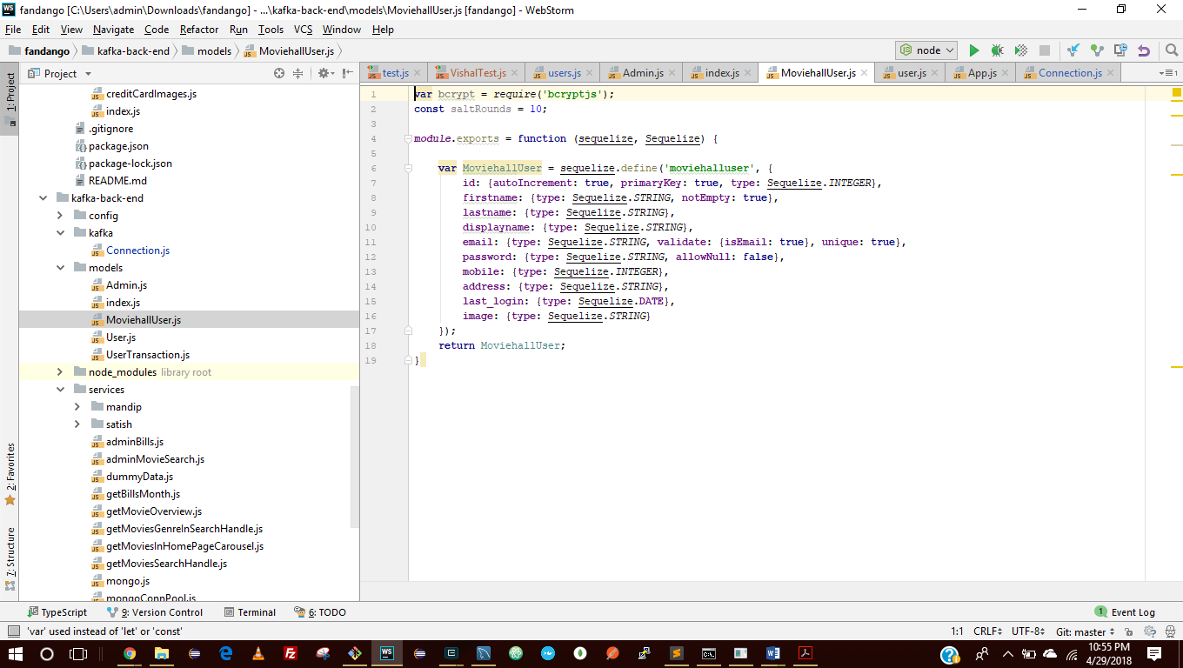

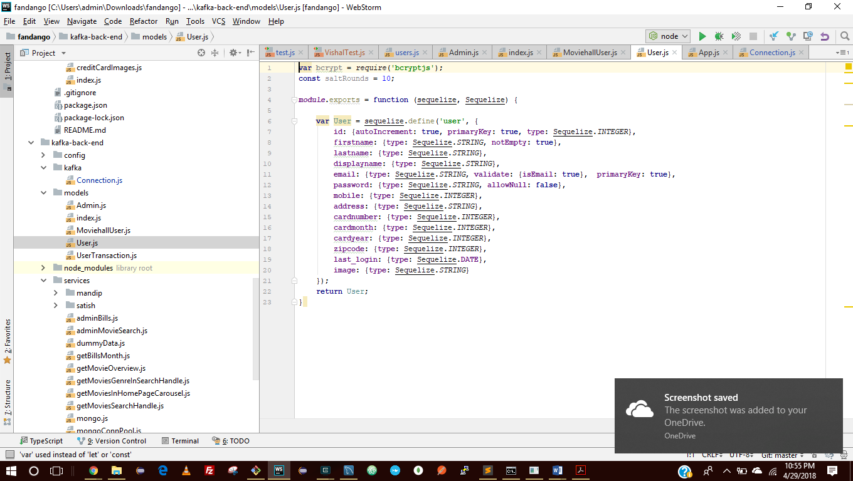

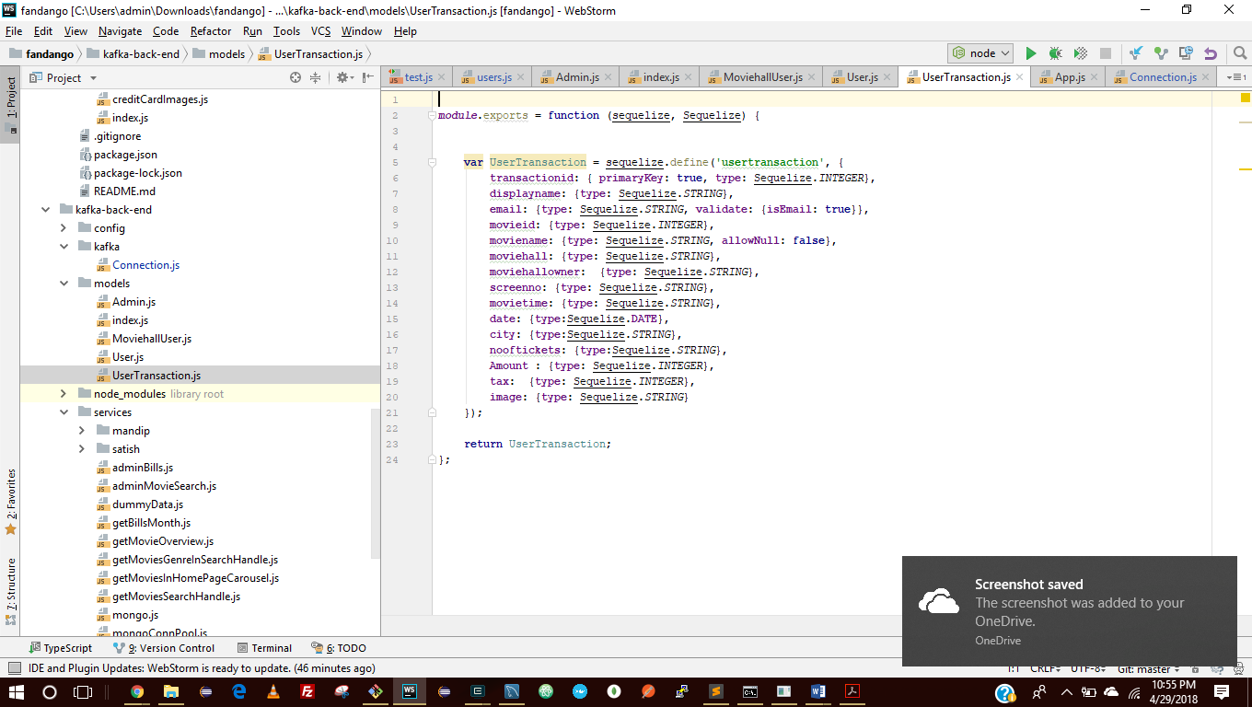

**Database Schema**

CREATE TABLE IF NOT EXISTS `users` (`id` INTEGER auto_increment , `firstname` VARCHAR(255), `lastname` VARCHAR(255), `displayname` VARCHAR(255), `email` VARCHAR(255

) , `password` VARCHAR(255) NOT NULL, `mobile` INTEGER, `address` VARCHAR(255), `cardnumber` INTEGER, `cardmonth` INTEGER, `cardyear` INTEGER, `zipcode` INTEGER, `last_login` DATETIME,

`image` VARCHAR(255), `createdAt` DATETIME NOT NULL, `updatedAt` DATETIME NOT NULL, PRIMARY KEY (`id`, `email`)) ENGINE=InnoDB;

CREATE TABLE IF NOT EXISTS `moviehallusers` (`id` INTEGER auto_increment , `firstname` VARCHAR(255), `lastname` VARCHAR(255), `displayname` VARCHAR(255), `email` VA

RCHAR(255) UNIQUE, `password` VARCHAR(255) NOT NULL, `mobile` INTEGER, `address` VARCHAR(255), `last_login` DATETIME, `image` VARCHAR(255), `createdAt` DATETIME NOT NULL, `updatedAt` DA

TETIME NOT NULL, PRIMARY KEY (`id`)) ENGINE=InnoDB;

CREATE TABLE IF NOT EXISTS `admins` (`id` INTEGER auto_increment , `firstname` VARCHAR(255), `lastname` VARCHAR(255), `email` VARCHAR(255) UNIQUE, `password` VARCHA

R(255) NOT NULL, `mobile` VARCHAR(255), `address` VARCHAR(255), `city` VARCHAR(255), `State` VARCHAR(255), `zipcode` INTEGER, `last_login` DATETIME, `createdAt` DATETIME NOT NULL, `upda

tedAt` DATETIME NOT NULL, PRIMARY KEY (`id`)) ENGINE=InnoDB;

CREATE TABLE IF NOT EXISTS `usertransactions` (`transactionid` INTEGER , `displayname` VARCHAR(255), `email` VARCHAR(255), `movieid` INTEGER, `moviename` VARCHAR(255)NOT NULL, `moviehall` VARCHAR(255), `moviehallowner` VARCHAR(255), `screenno` VARCHAR(255), `movietime` VARCHAR(255), `date` DATETIME, `city` VARCHAR(255), `nooftickets` VARCHAR(255)

, `Amount` INTEGER, `tax` INTEGER, `image` VARCHAR(255), `createdAt` DATETIME NOT NULL, `updatedAt` DATETIME NOT NULL, PRIMARY KEY (`transactionid`)) ENGINE=InnoDB;

## **MongoDB:**

MongoDB is a document-oriented database. Instead of storing your data in tables made from individual rows, like a relational database does, it stores your data in collections made of individual documents. In MongoDB, a document is a big JSON blob with no format or schema.

MongoDB should be used in the following cases:

* **High Write Load**: MongoDB by default prefers high insert rate over transaction safety. If you need to load tons of data lines with a low business value for each one, MongoDB should fit.
* **High Availability** in an Unreliable Environment
* **Data is Location Based:** MongoDB has built in special functions, so finding relevant data from specific locations is fast and accurate.

In our application, MongoDB can be used to store files and user activity log data on the database.

## **MySQL:**

MySQL is a free, open-source database management system. A DBMS is a system that manages databases and connects them to software. MySQL is a powerful, free open-source database management system that has been around for years. It is very stable and has a big community that helps maintain, debug and upgrade it.

MySQL should be used in the following cases:

* When we need to define relations between data present in different tables.
* Data to be stored is not large.
* Large Scalability is not required.
* Security is essential. Fast Query processing and complex query implementation.

MONGO DB SAMPLE DBS

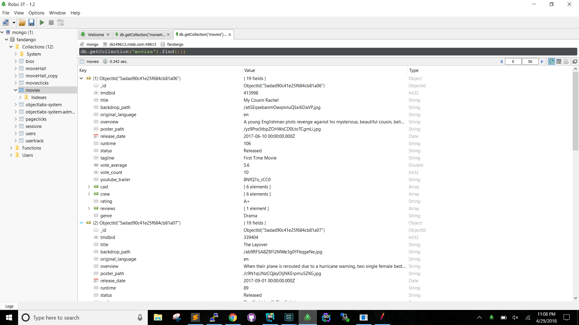

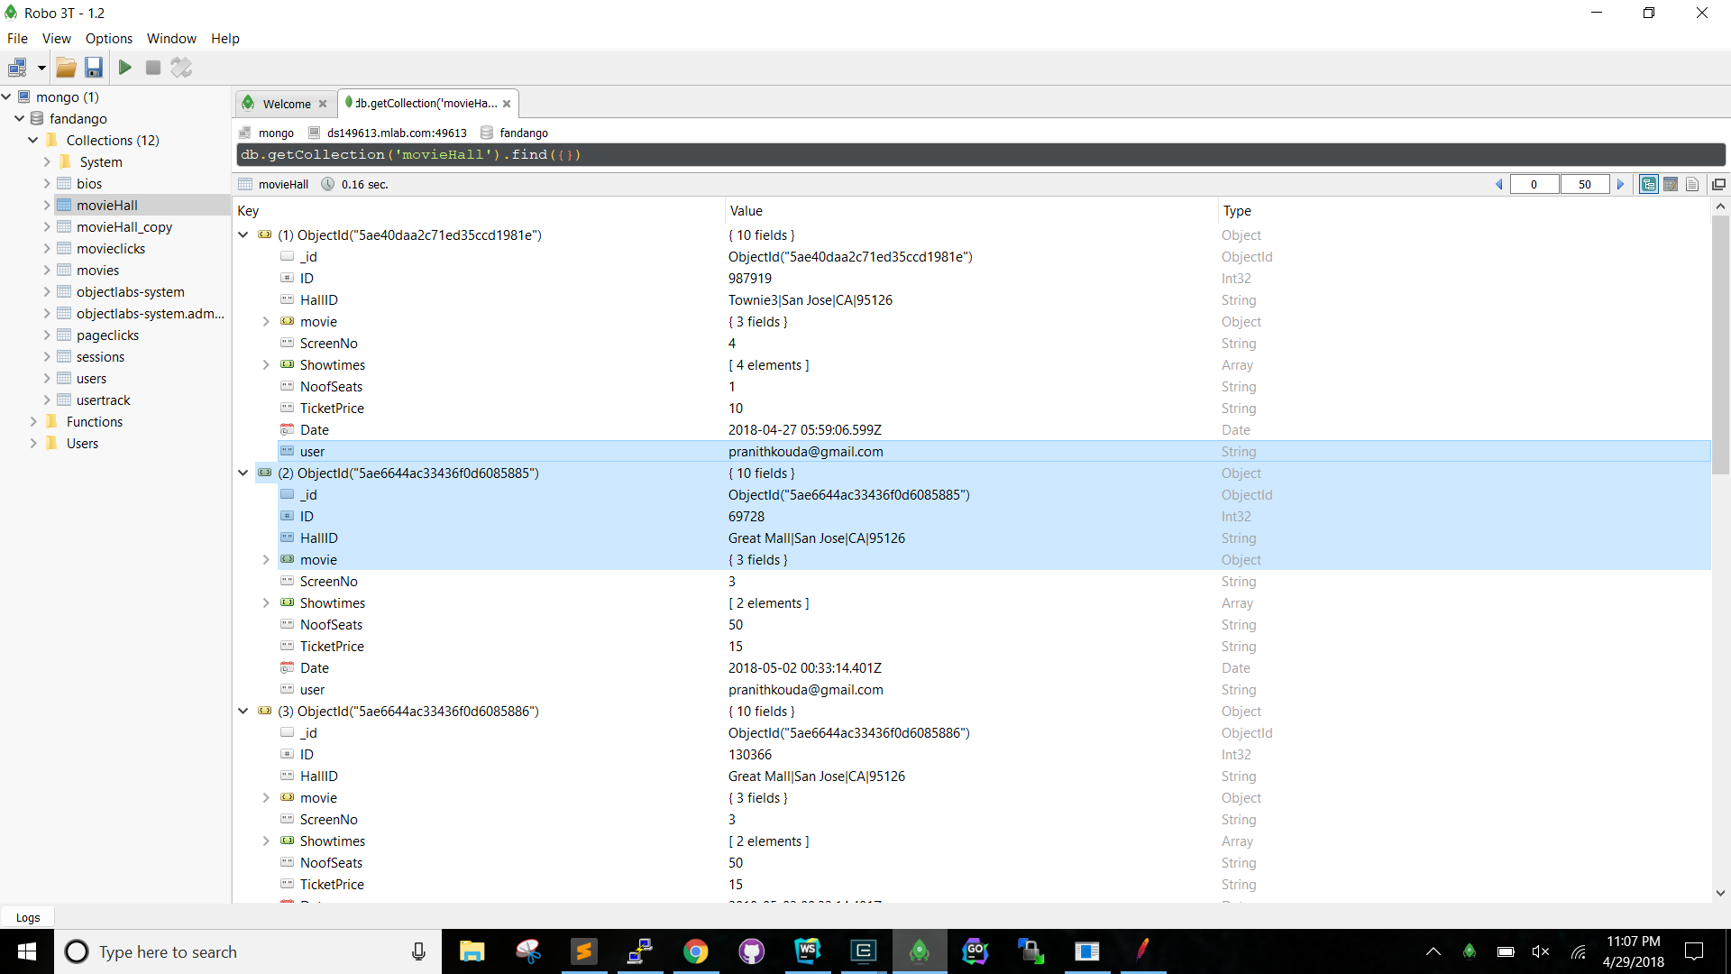

JMETER TESTS WITH KAFKA WITH REDIS

For 100 Concurrent Users sending requests

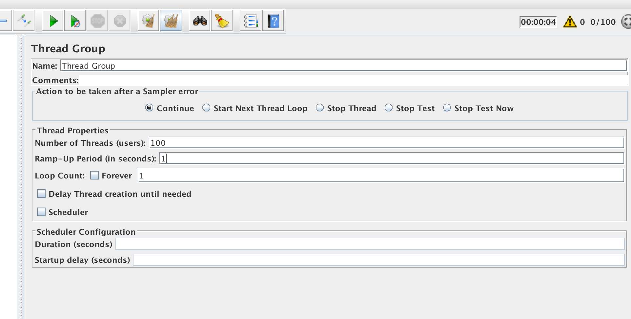

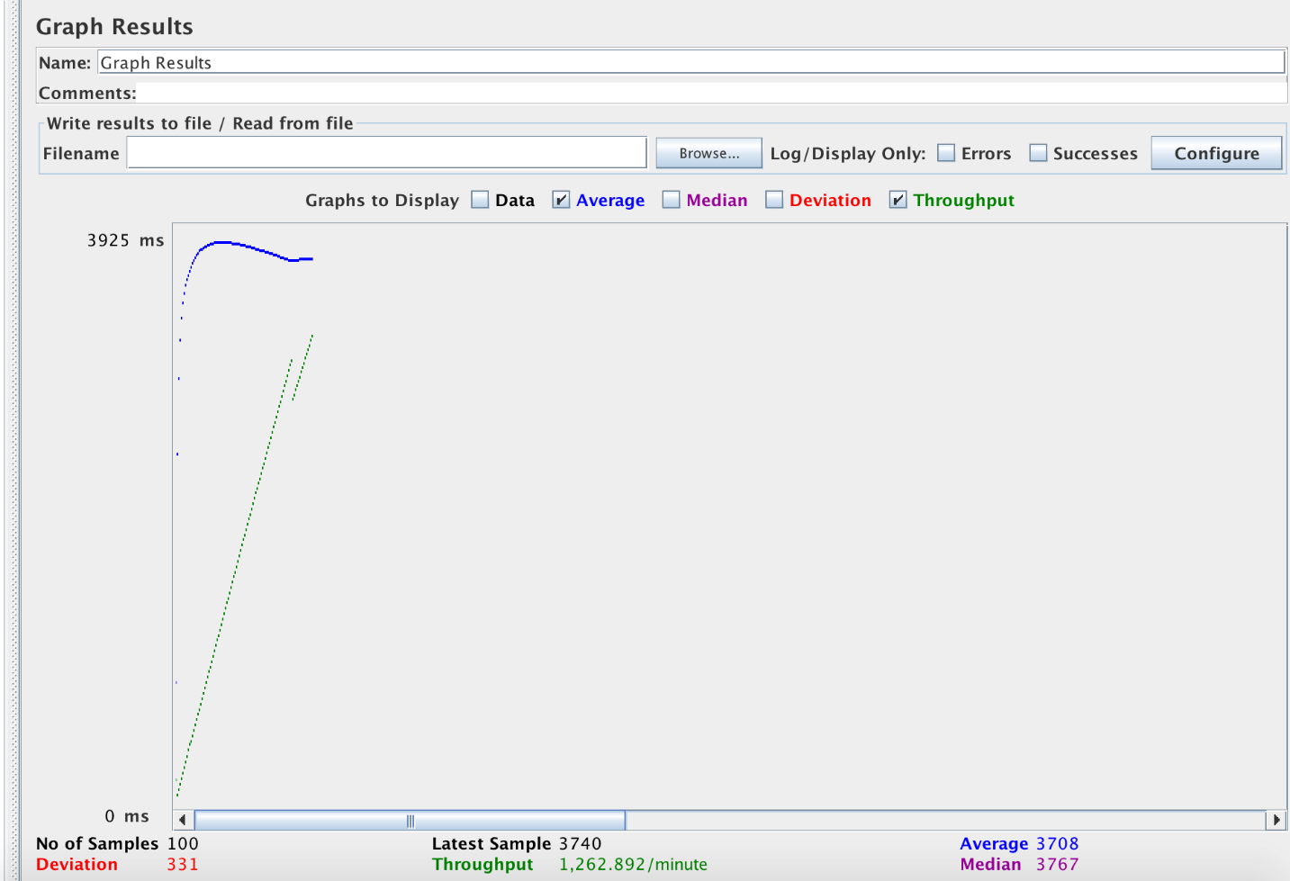

For 200 Concurrent Users sending requests

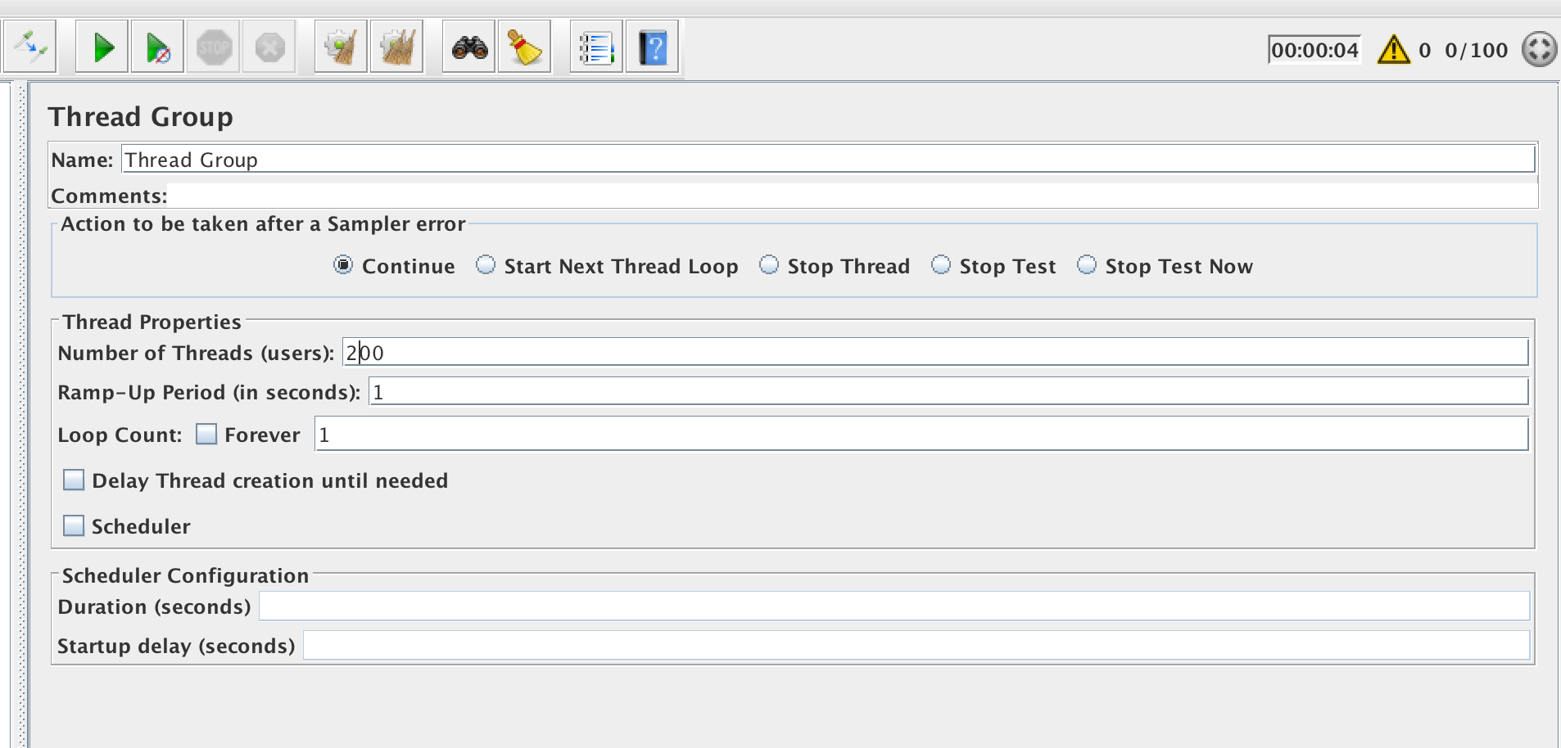

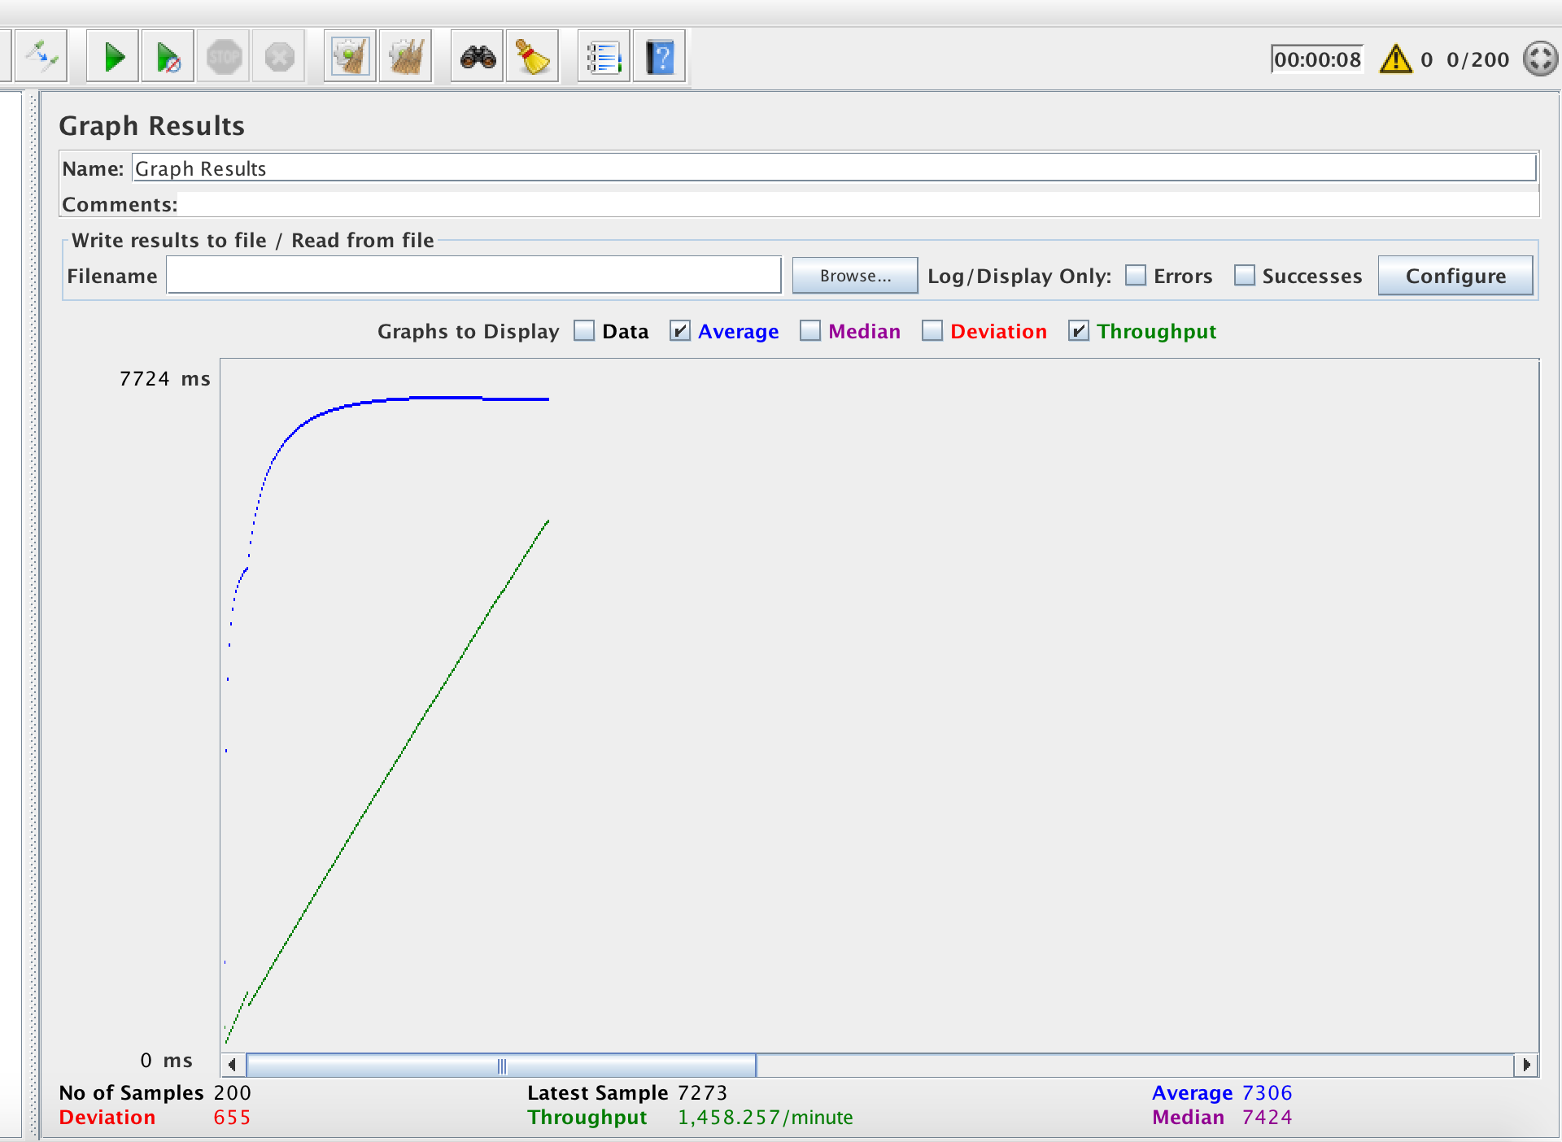

For 300 Concurrent Users sending requests

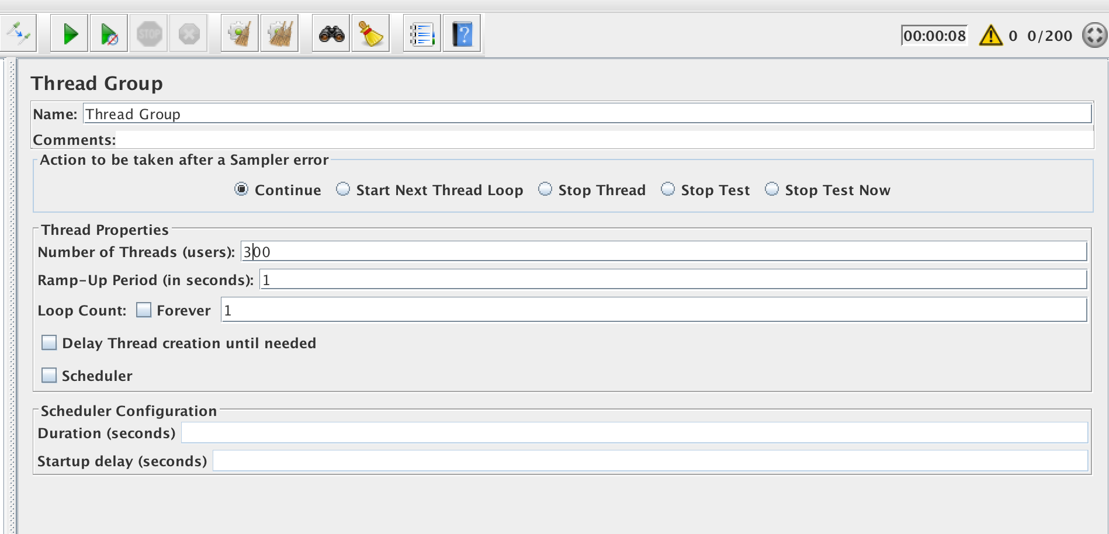

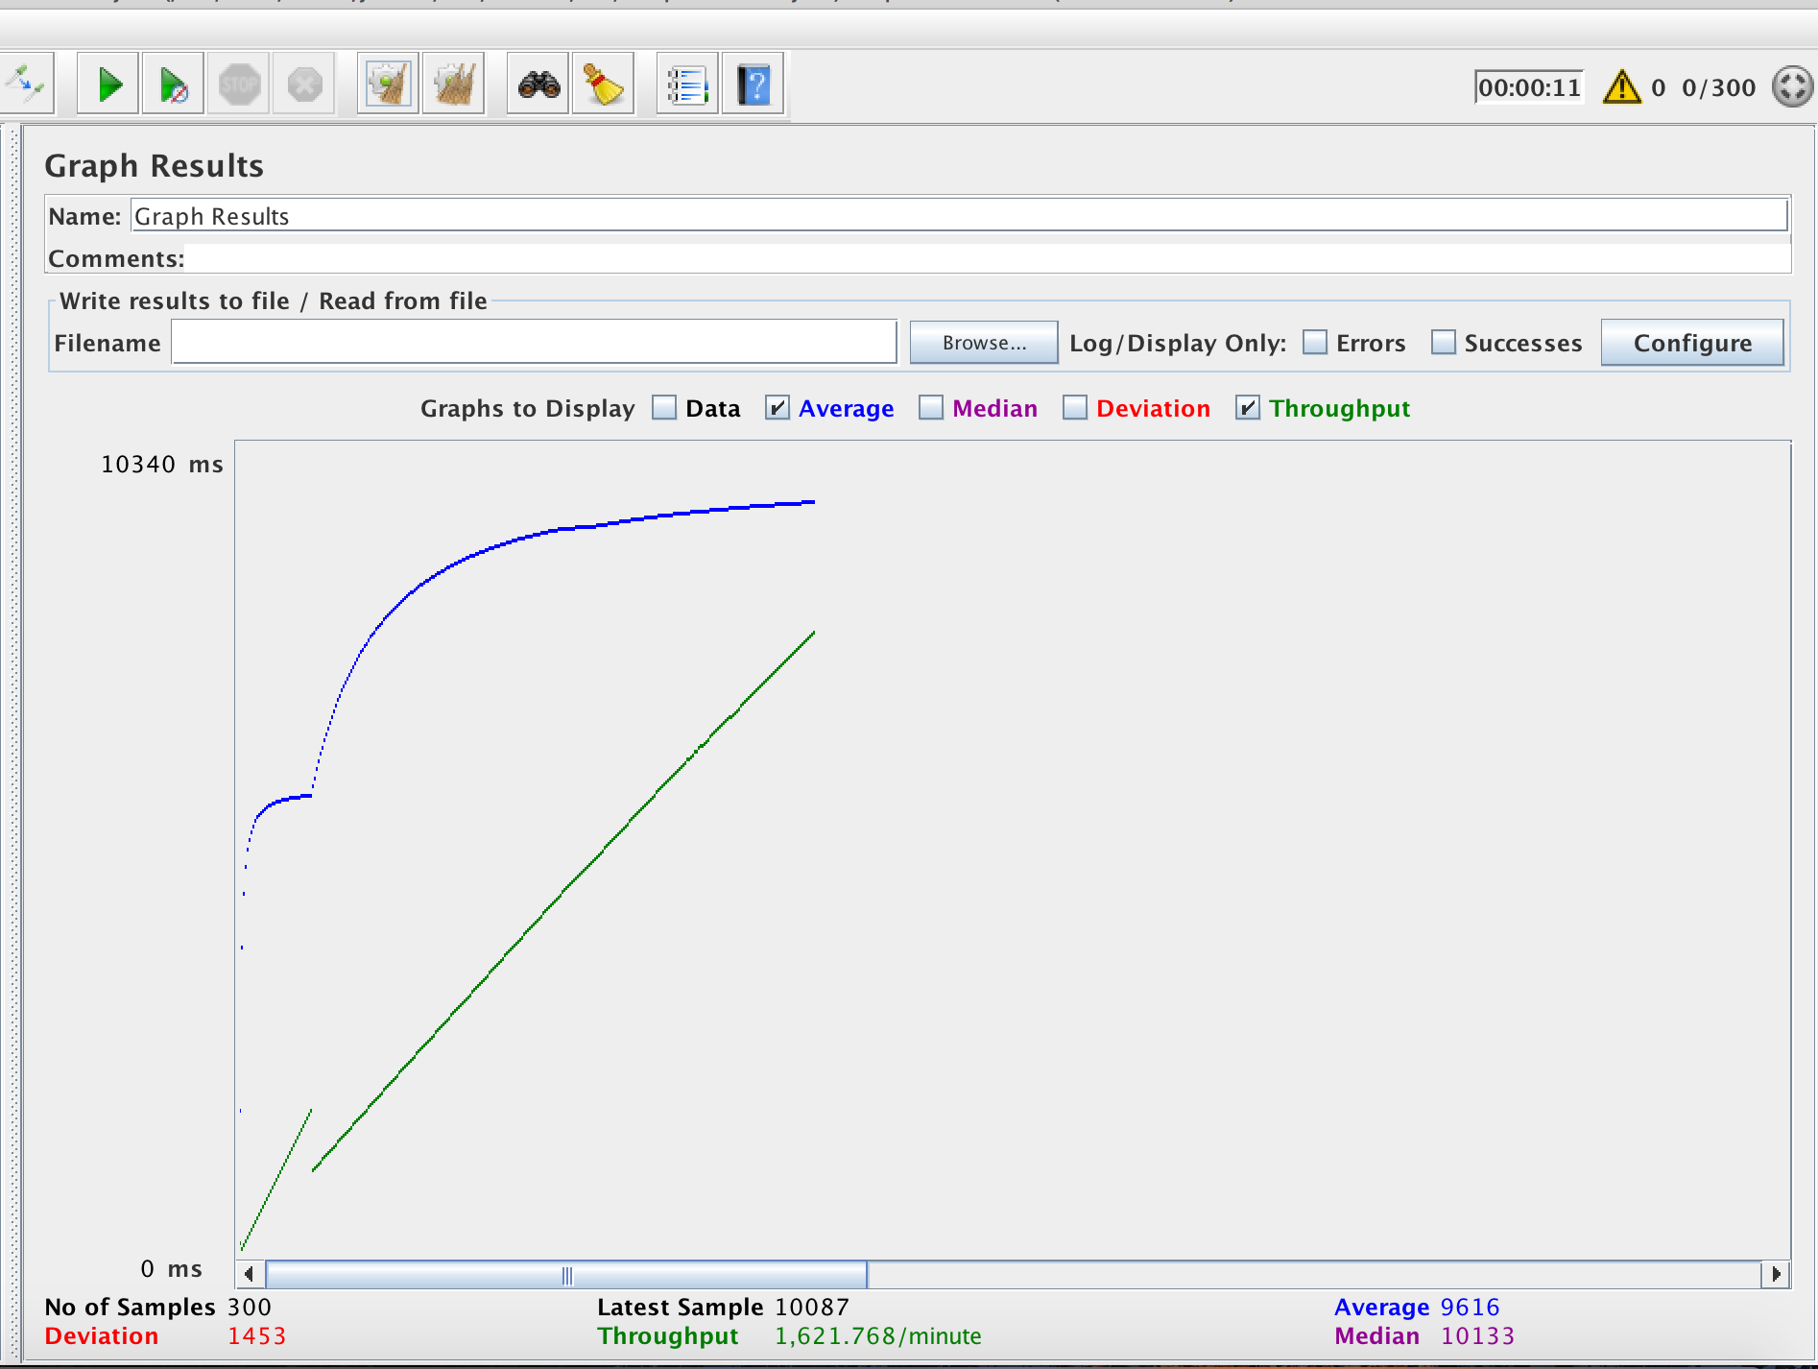

For 400 Concurrent Users sending requests

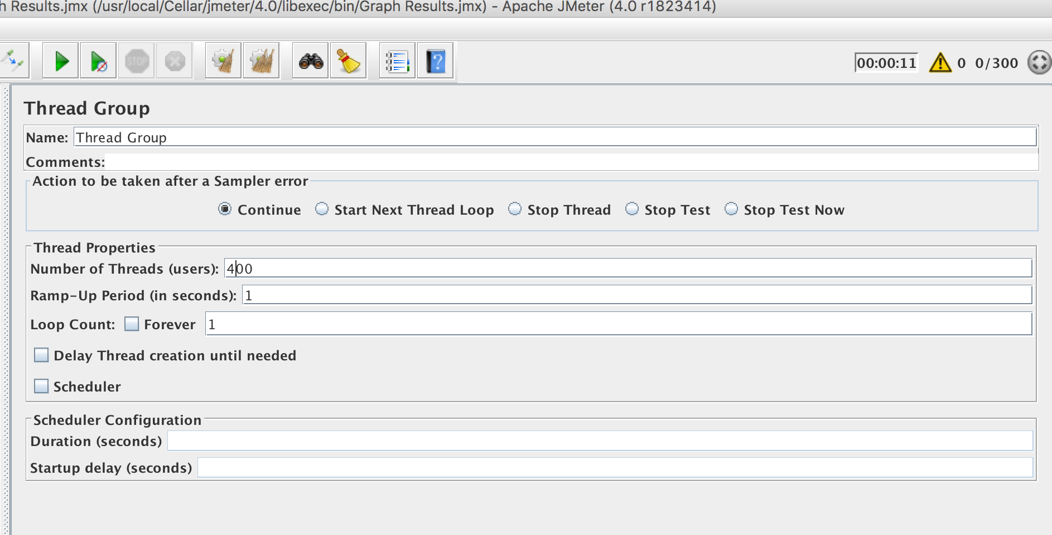

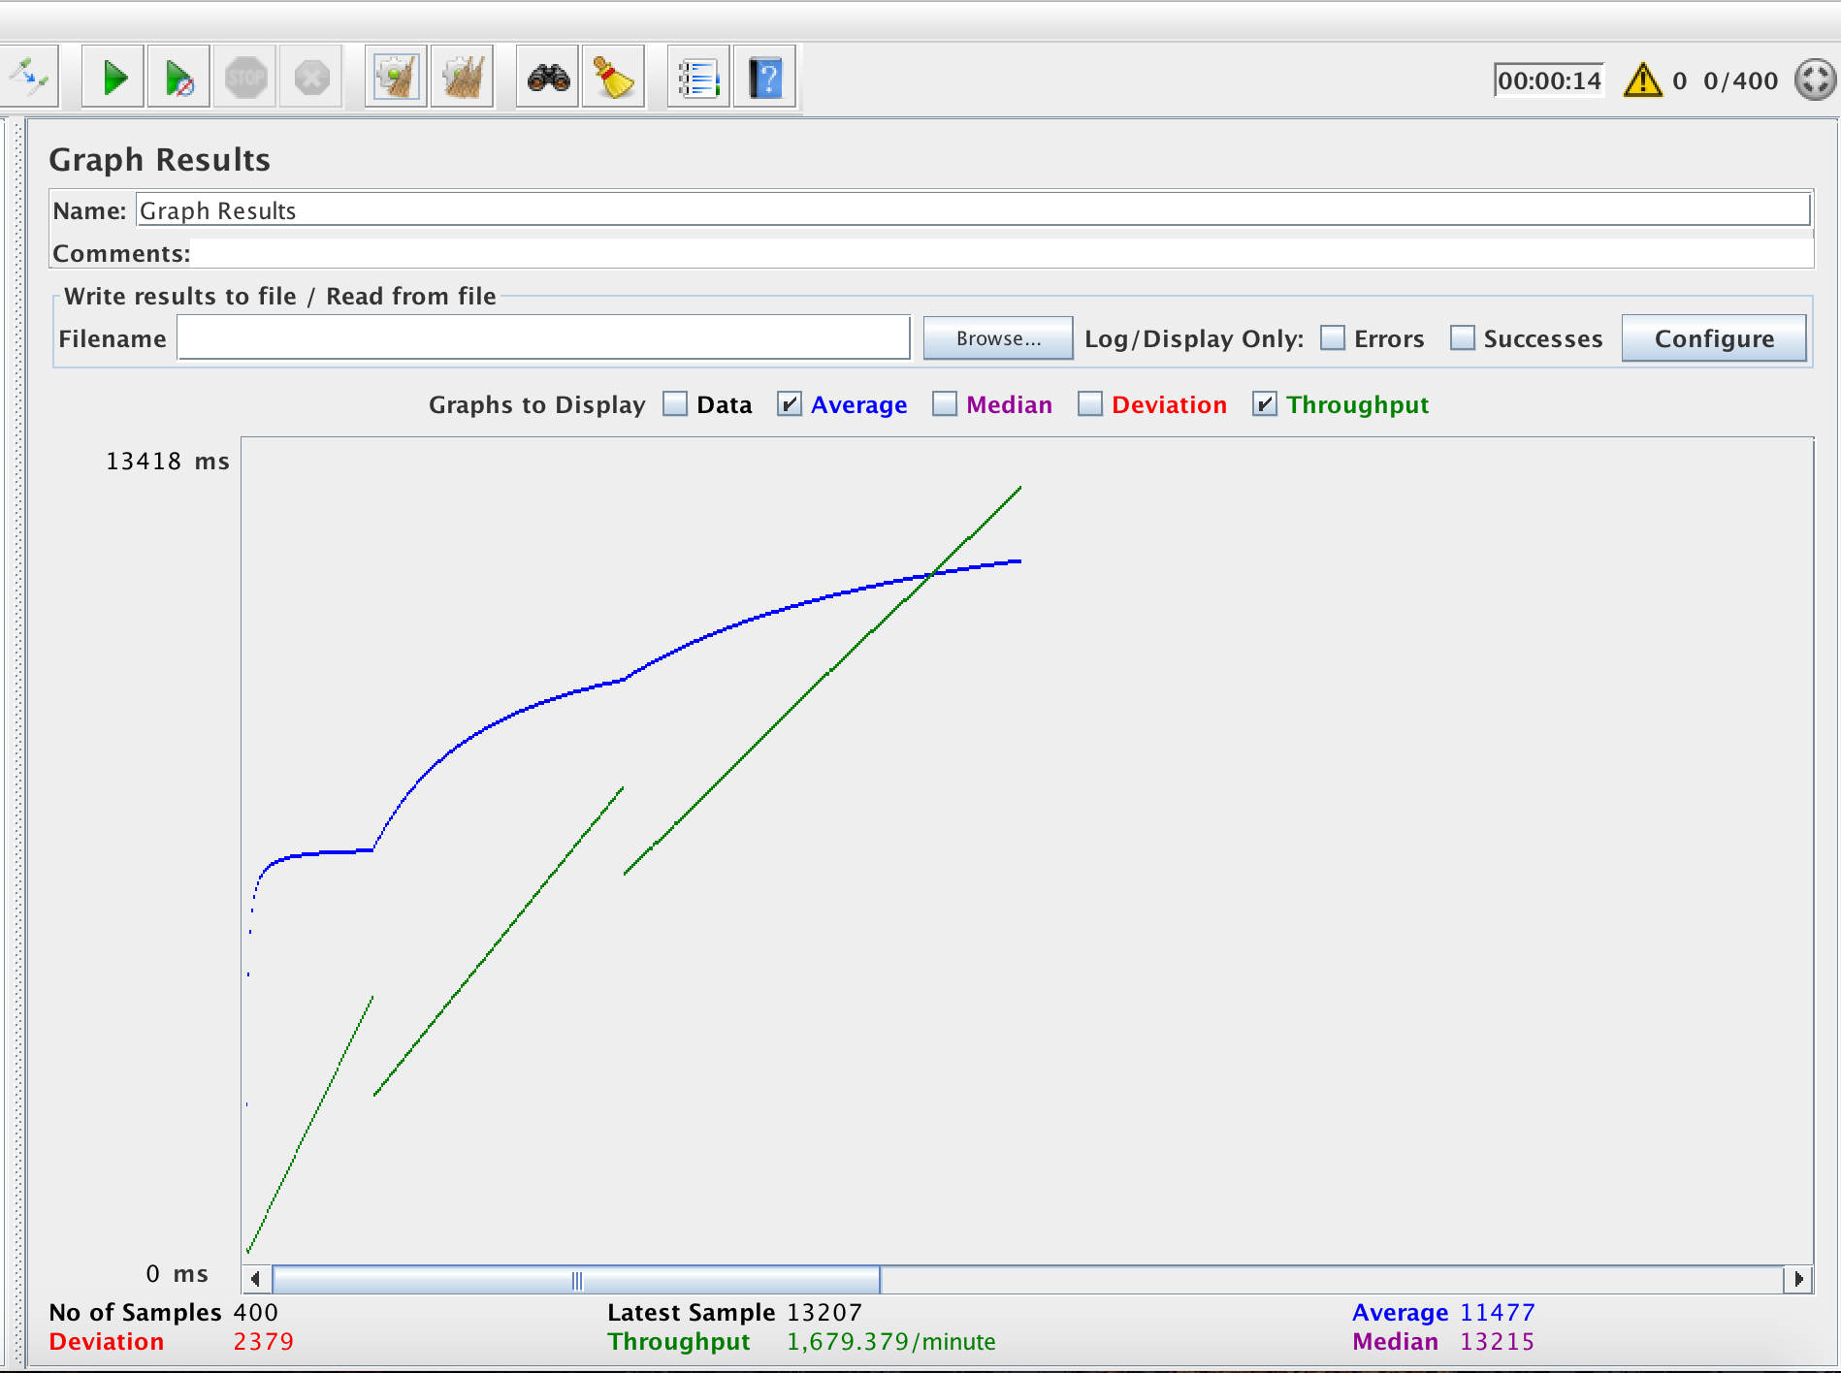

For 500 Concurrent Users sending requests

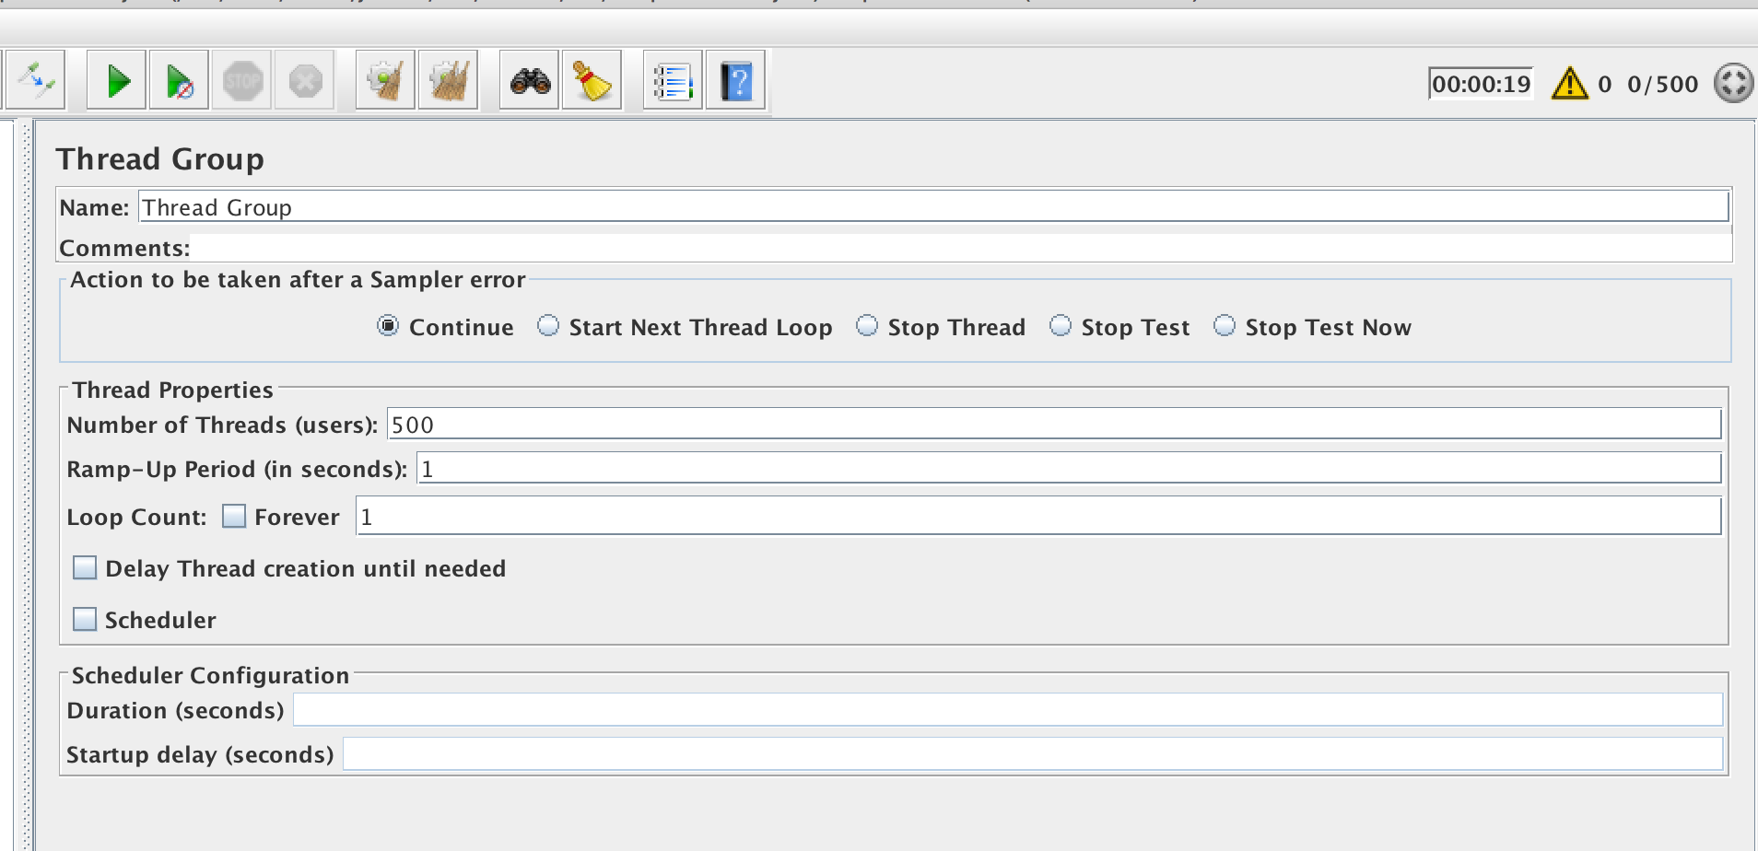

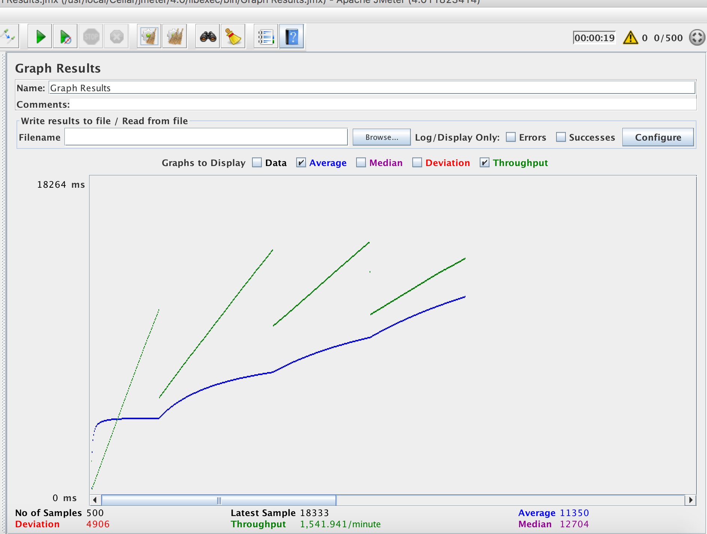

JMETER TESTS WITH OUT KAFKA

For 100 Concurrent Users sending requests without Redis cache with kafka

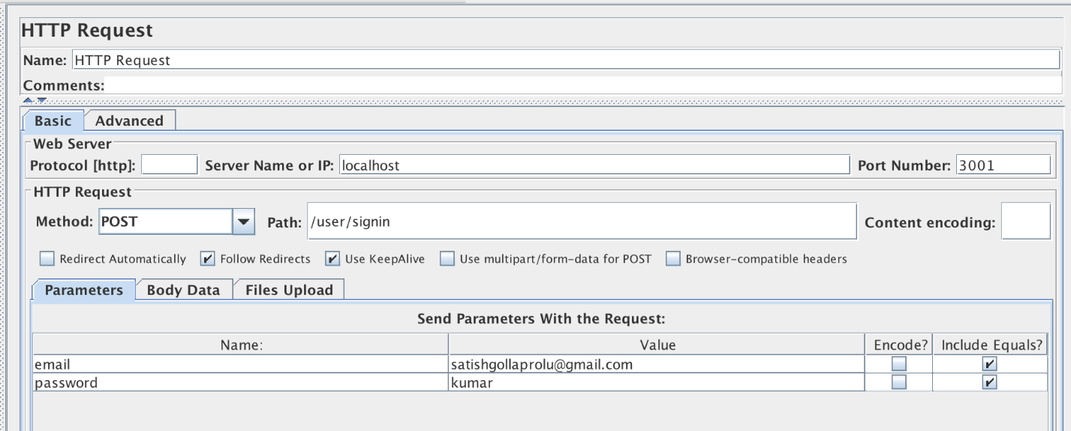

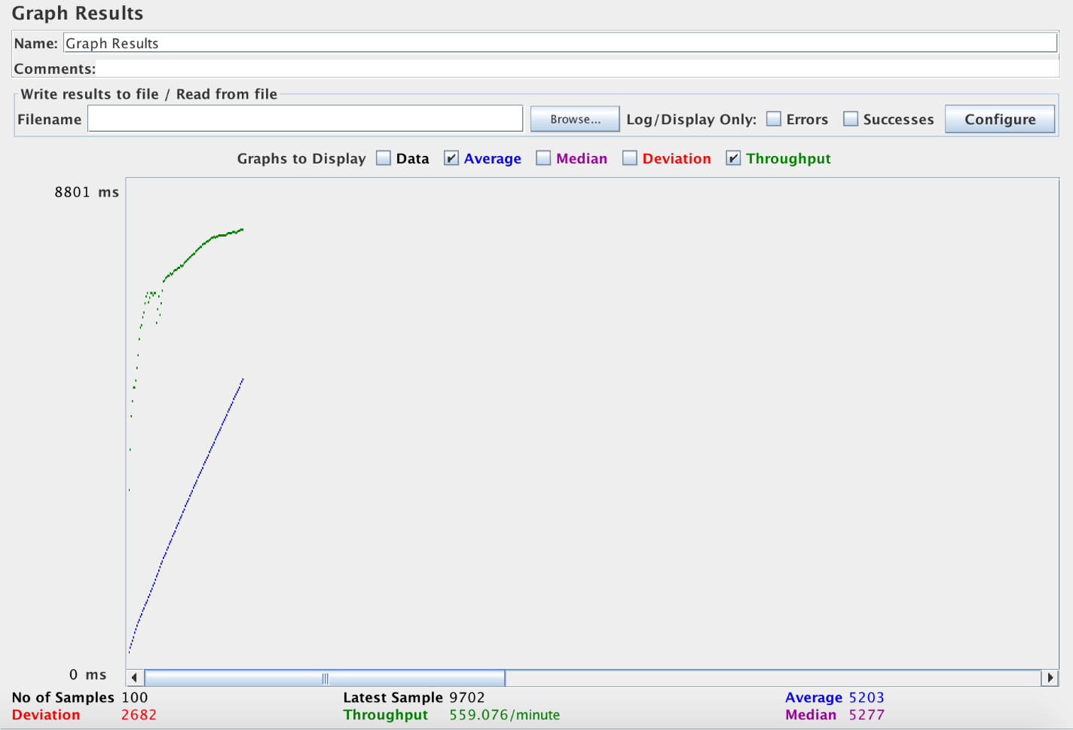

For 200 Concurrent Users sending requests without Redis cache with kafka

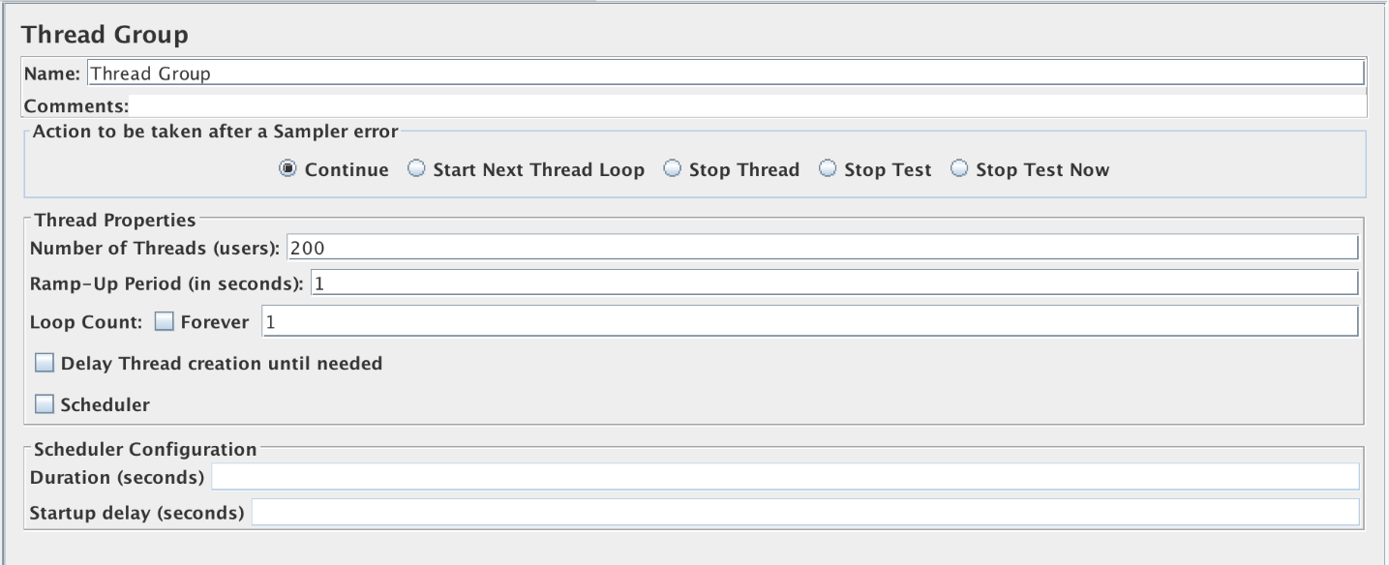

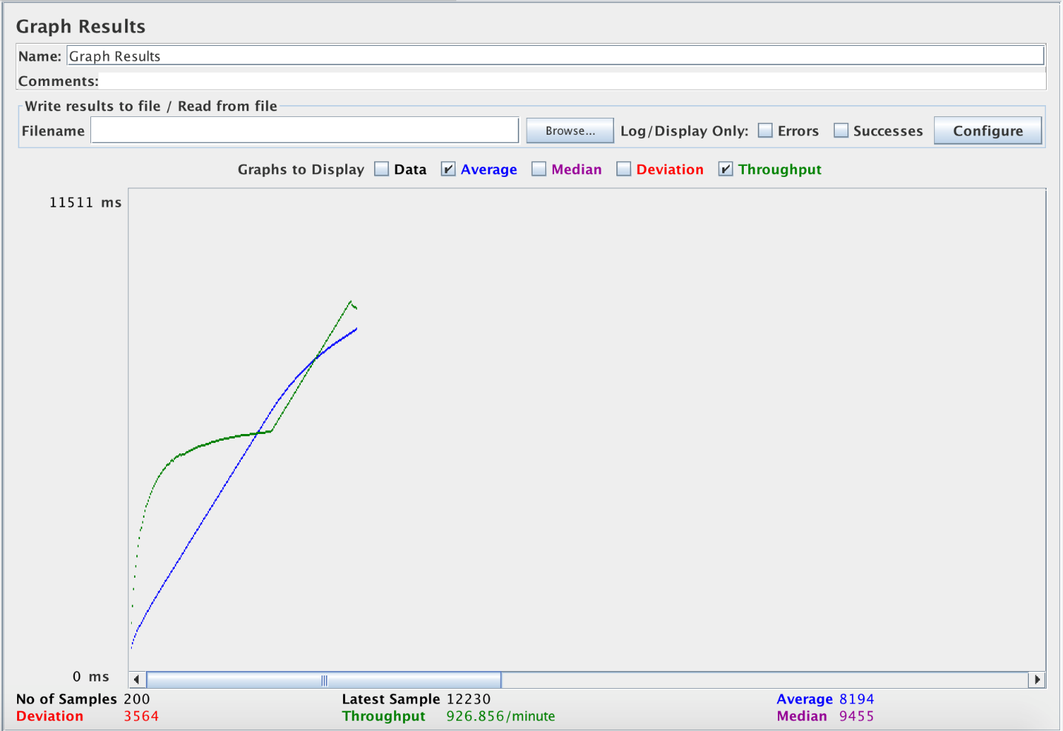

For 300 Concurrent Users sending requests without Redis cache with kafka

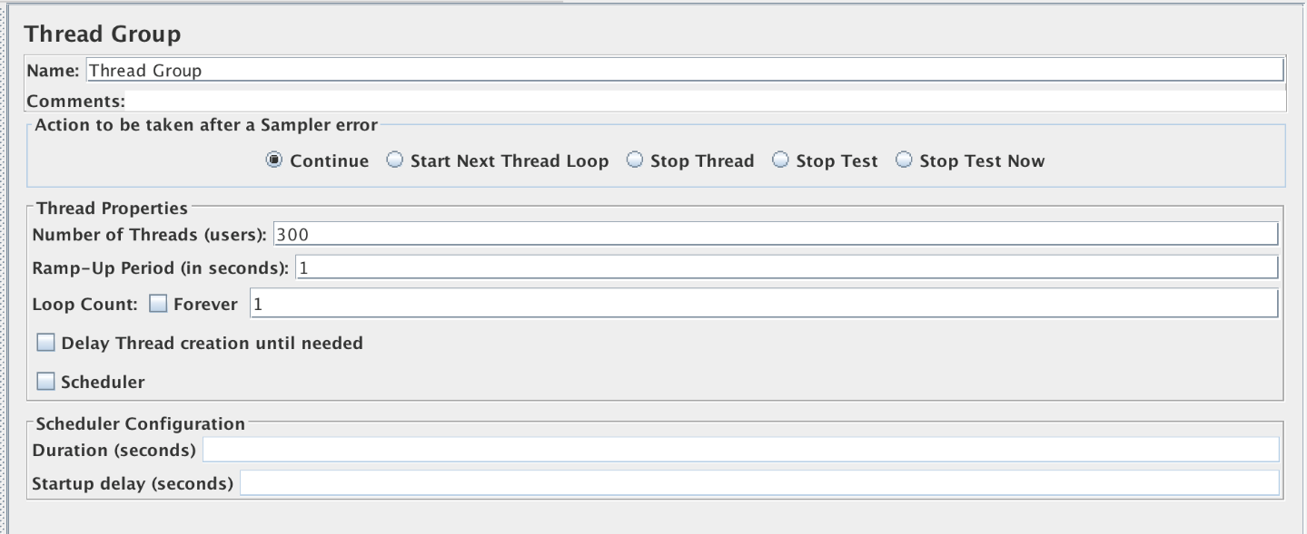

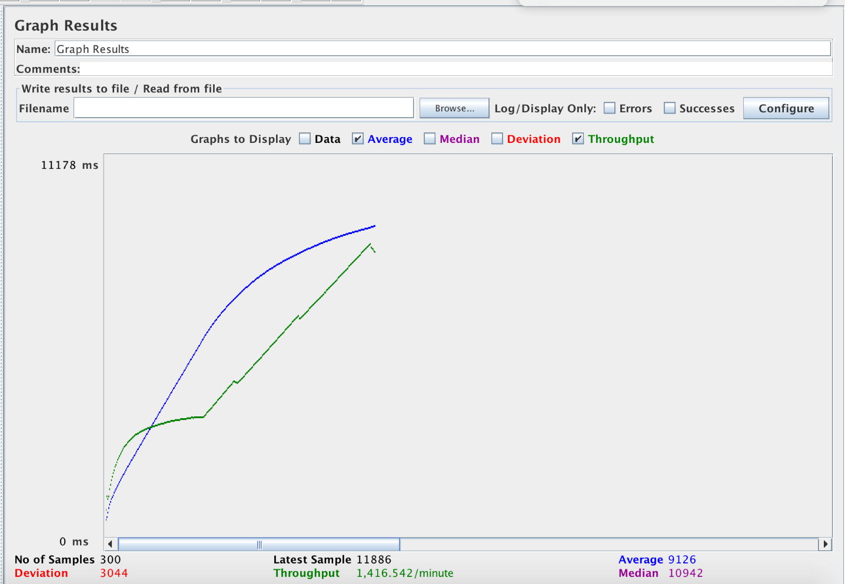

For 400 Concurrent Users sending requests without Redis cache with kafka

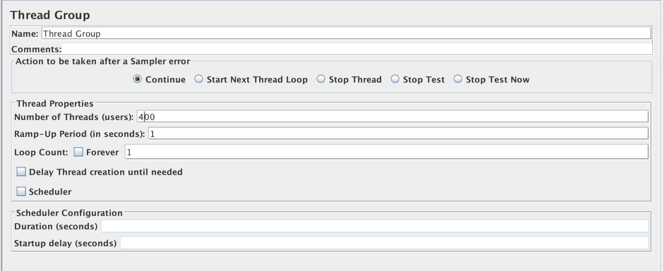

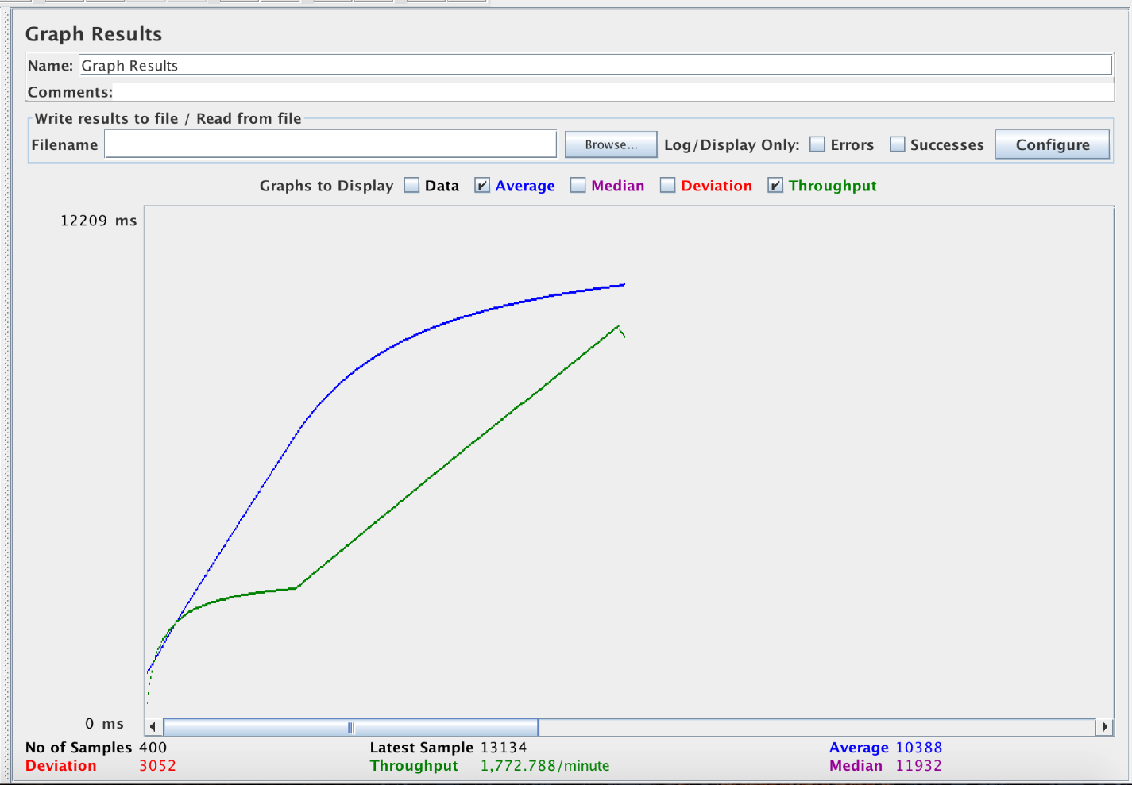

For 500 Concurrent Users sending requests without Redis cache with kafka

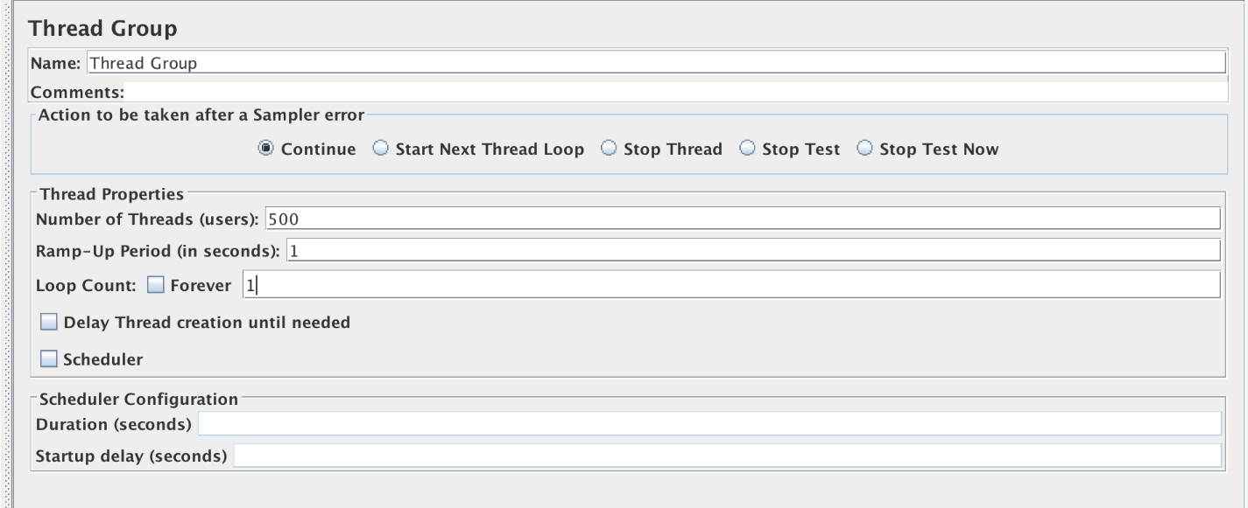

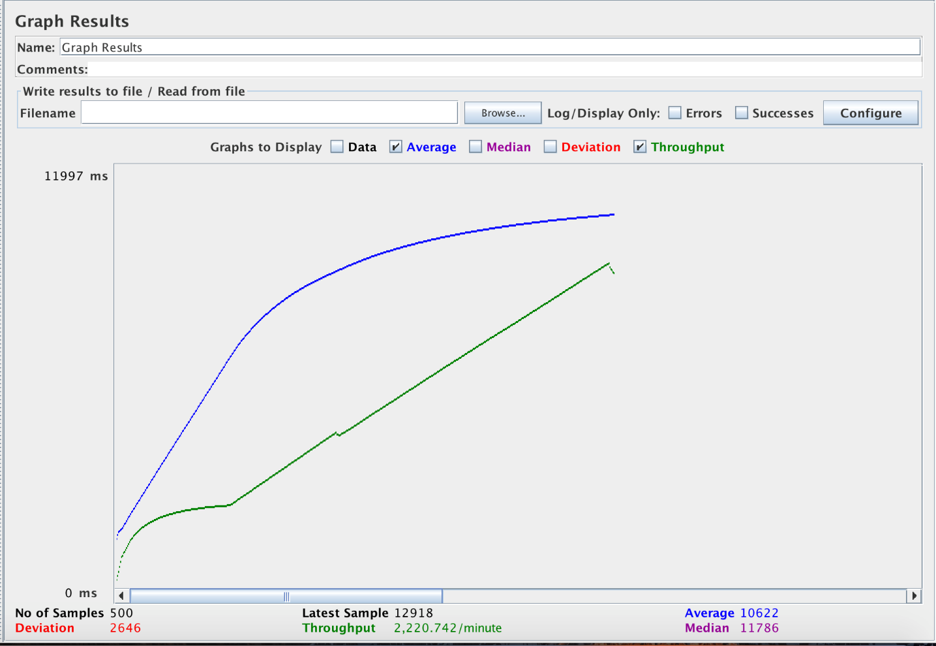

## **Mocha Tests**

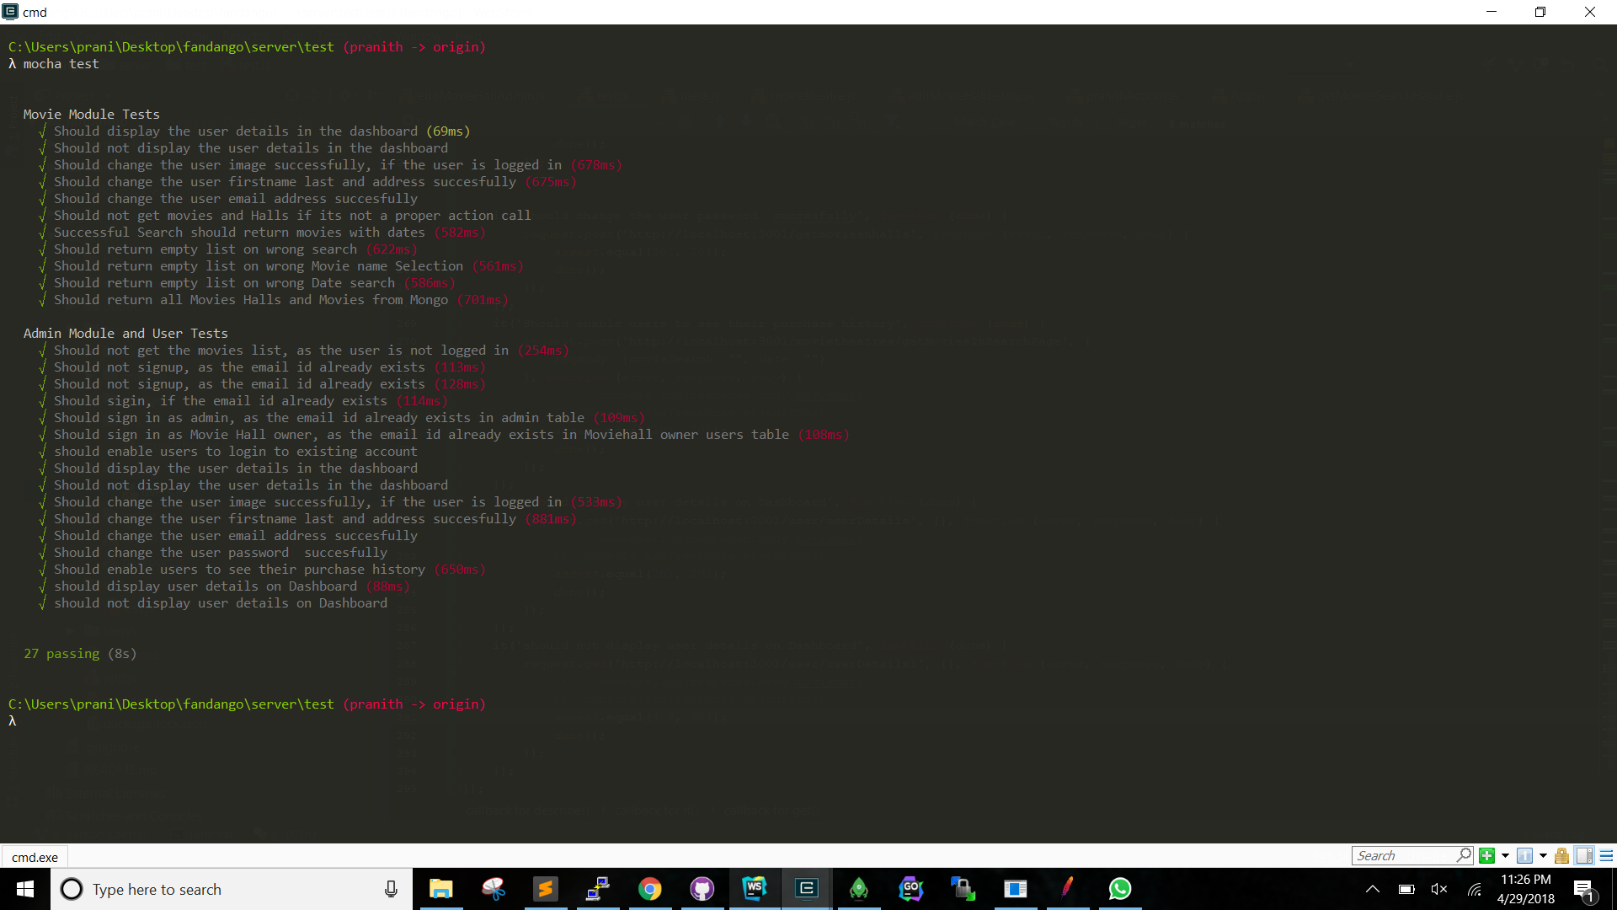

Test Classes

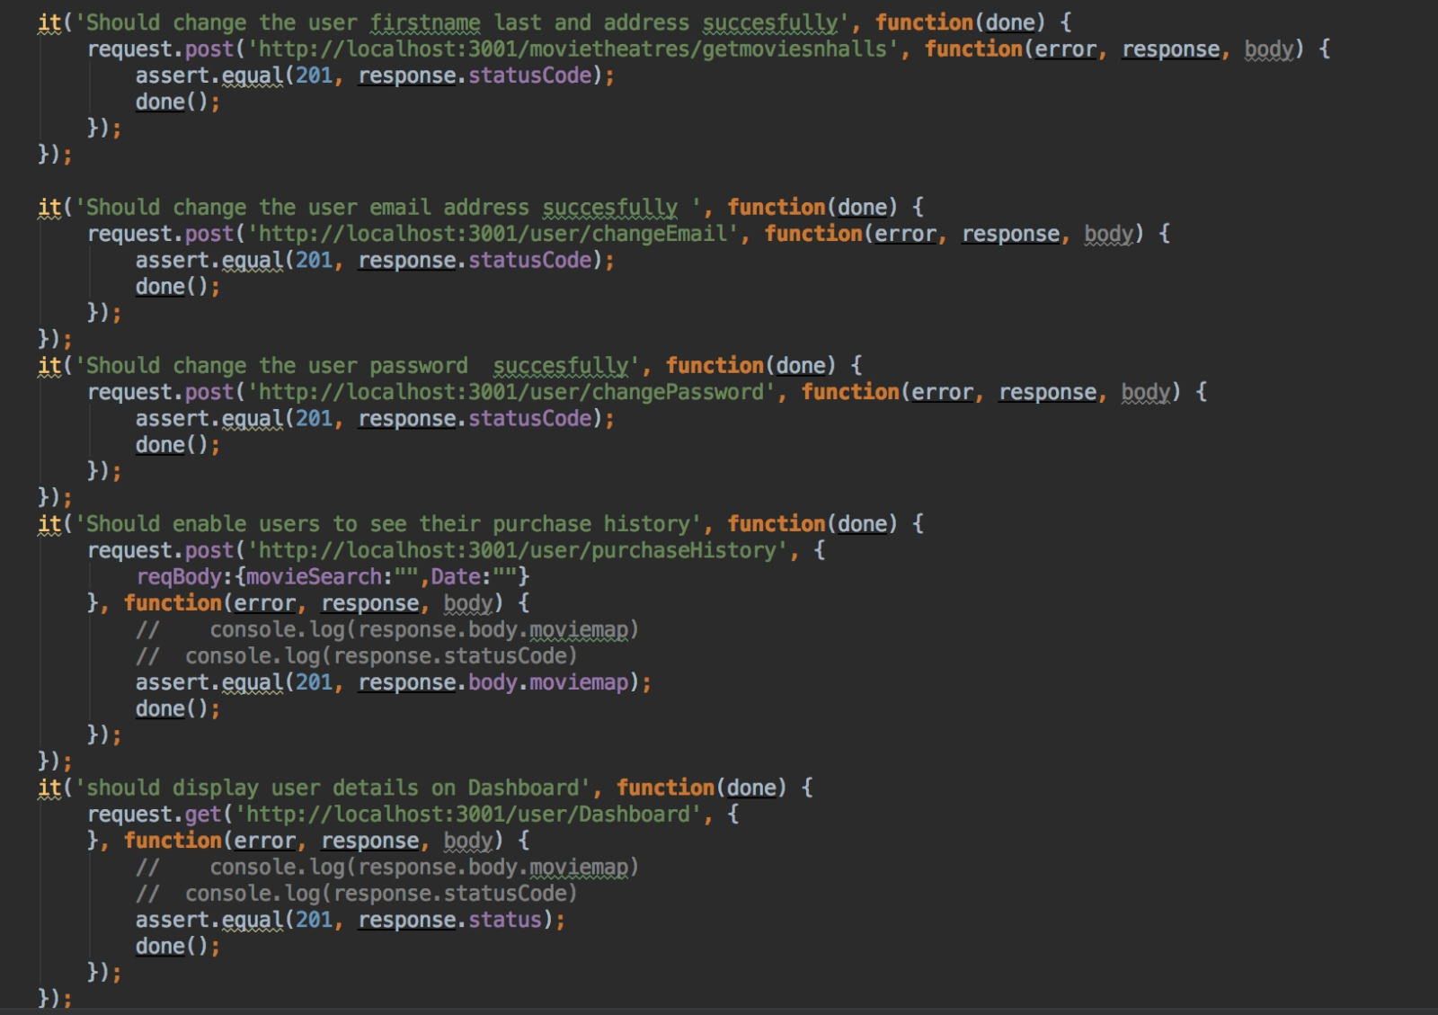

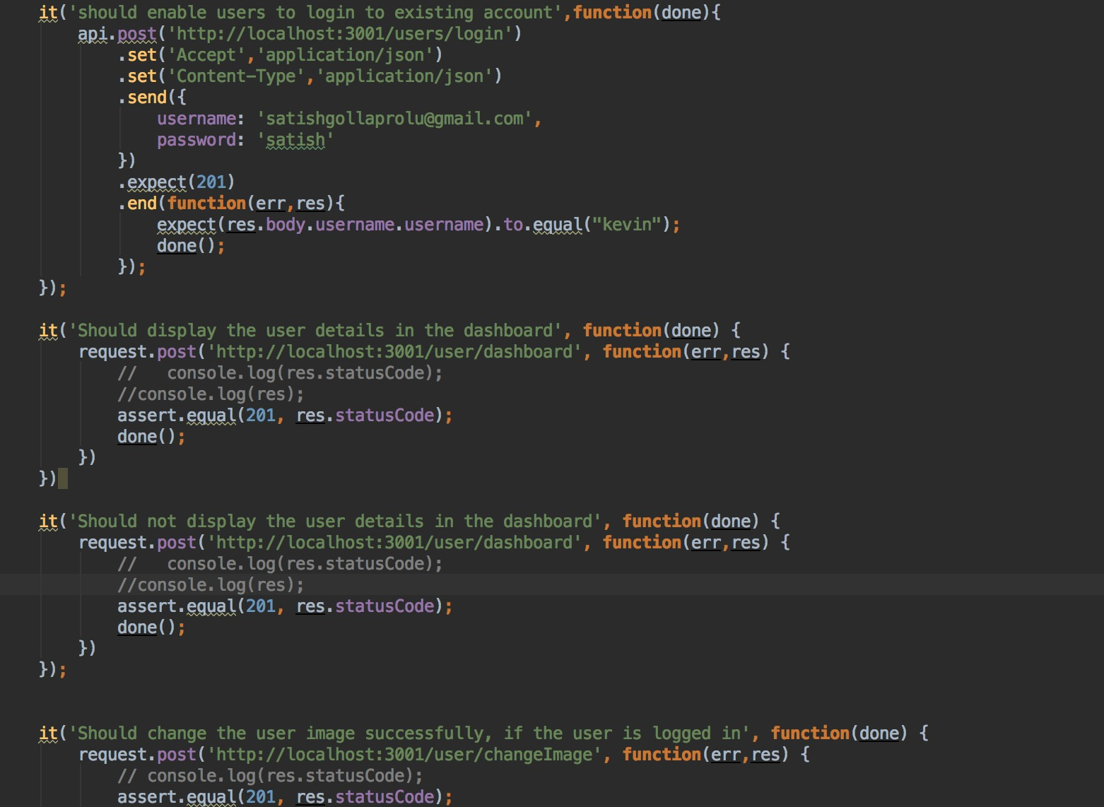

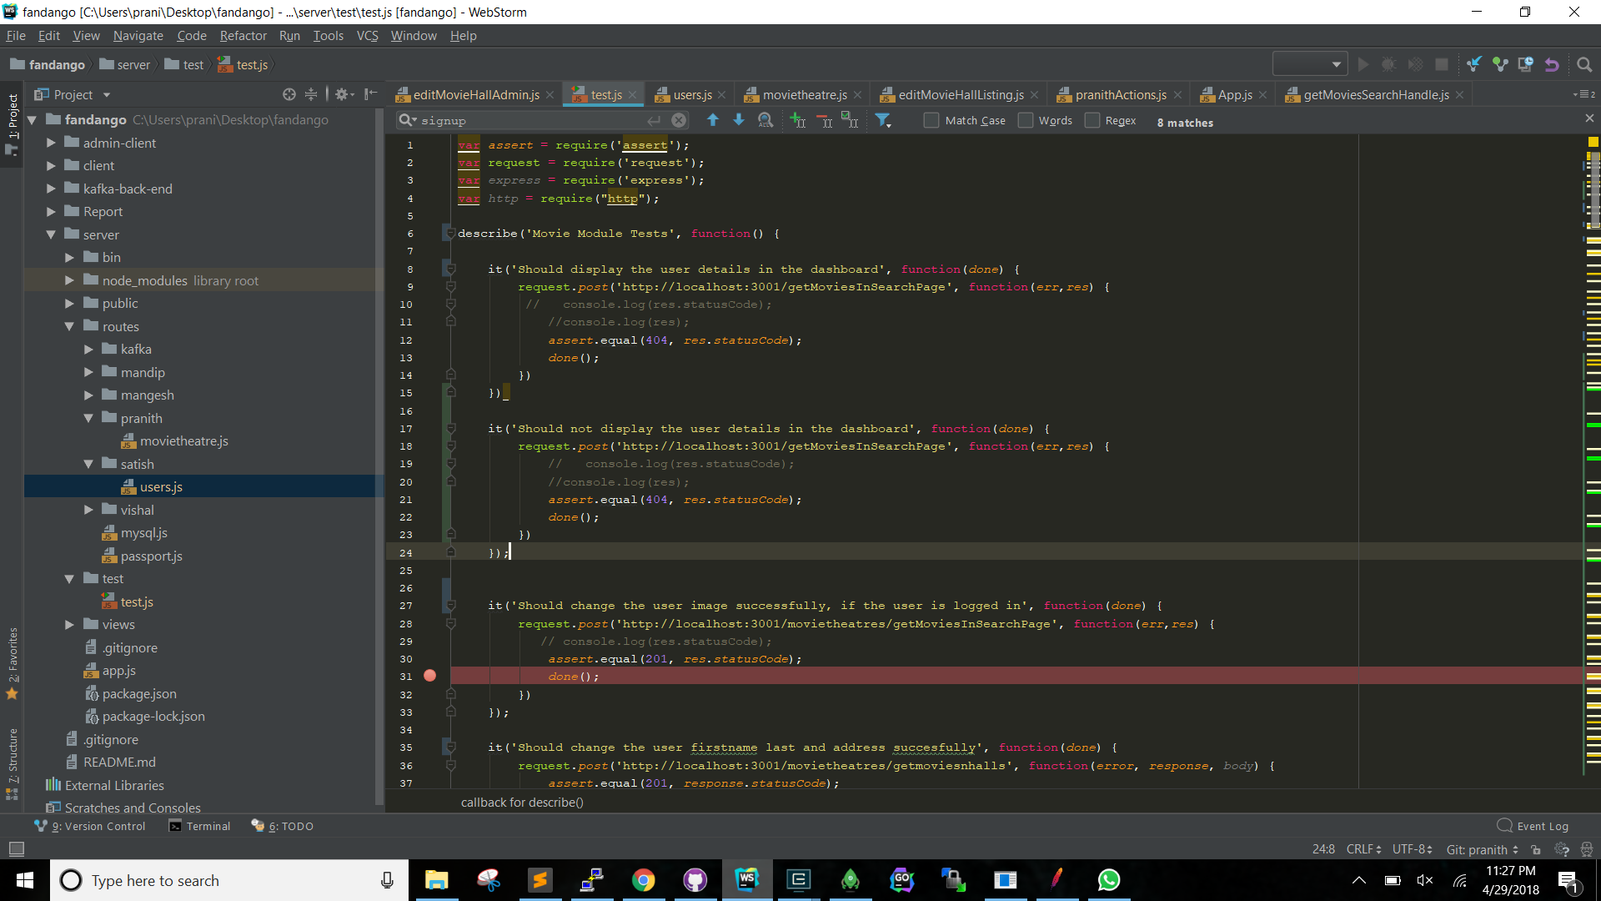

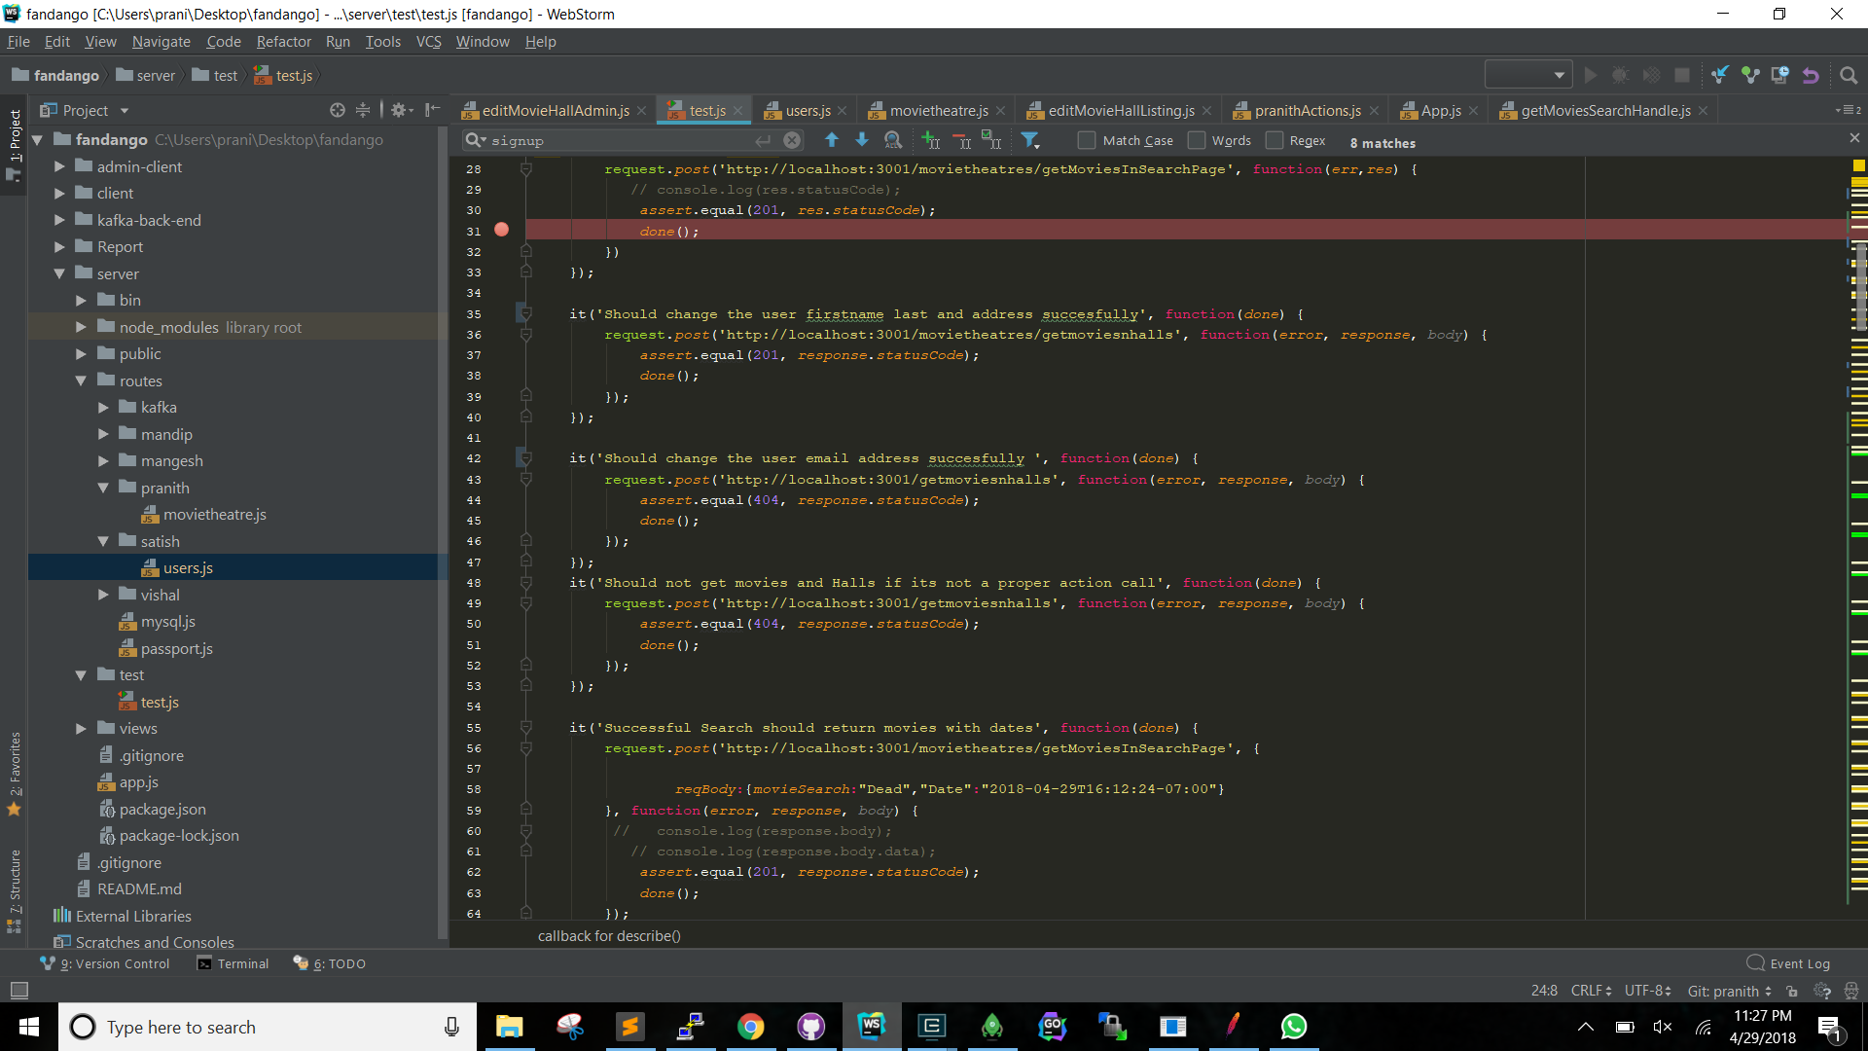

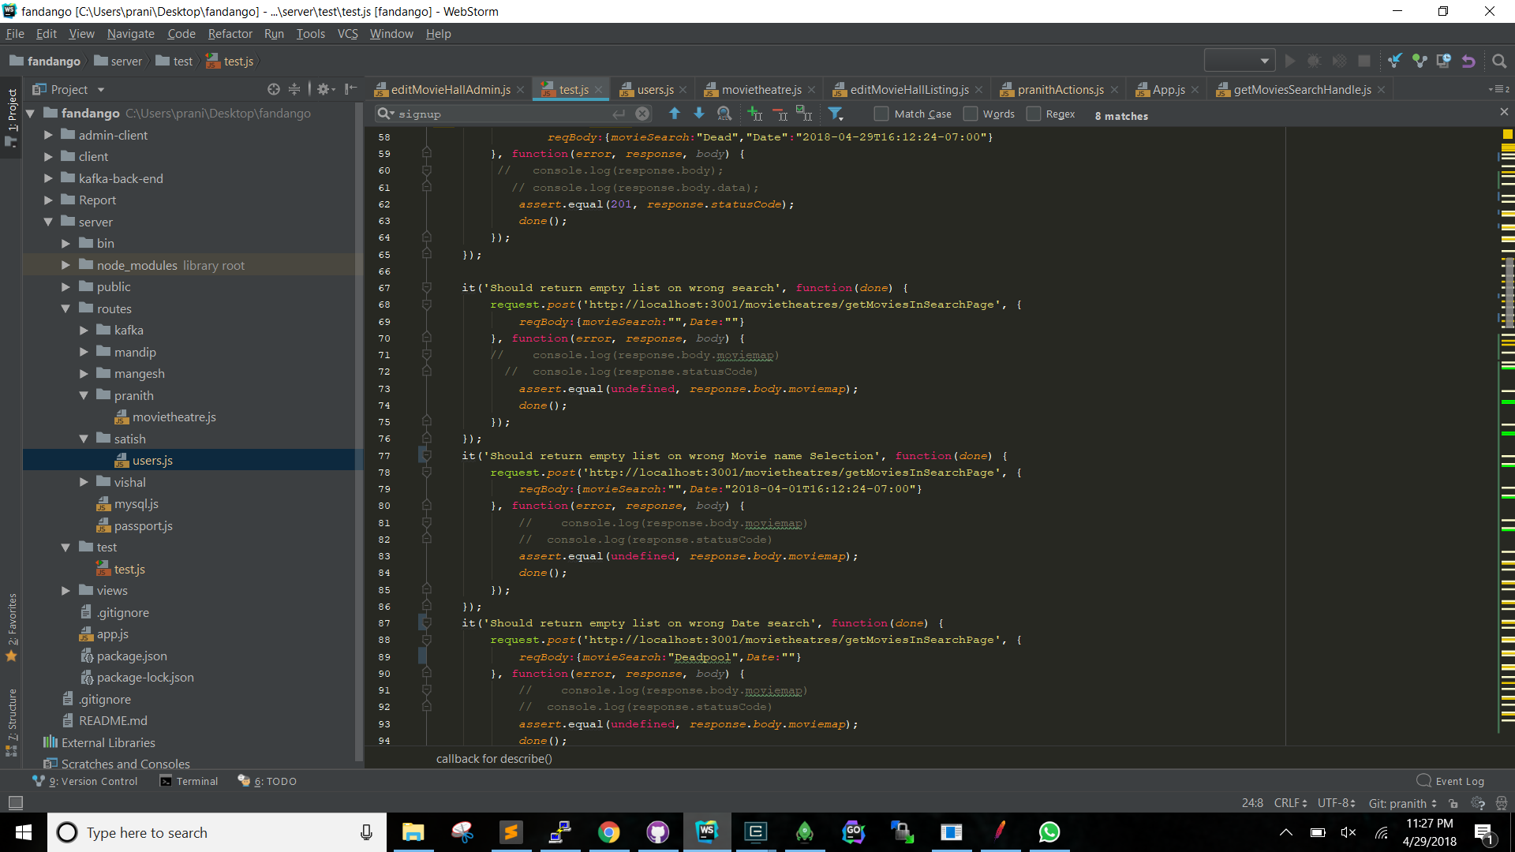

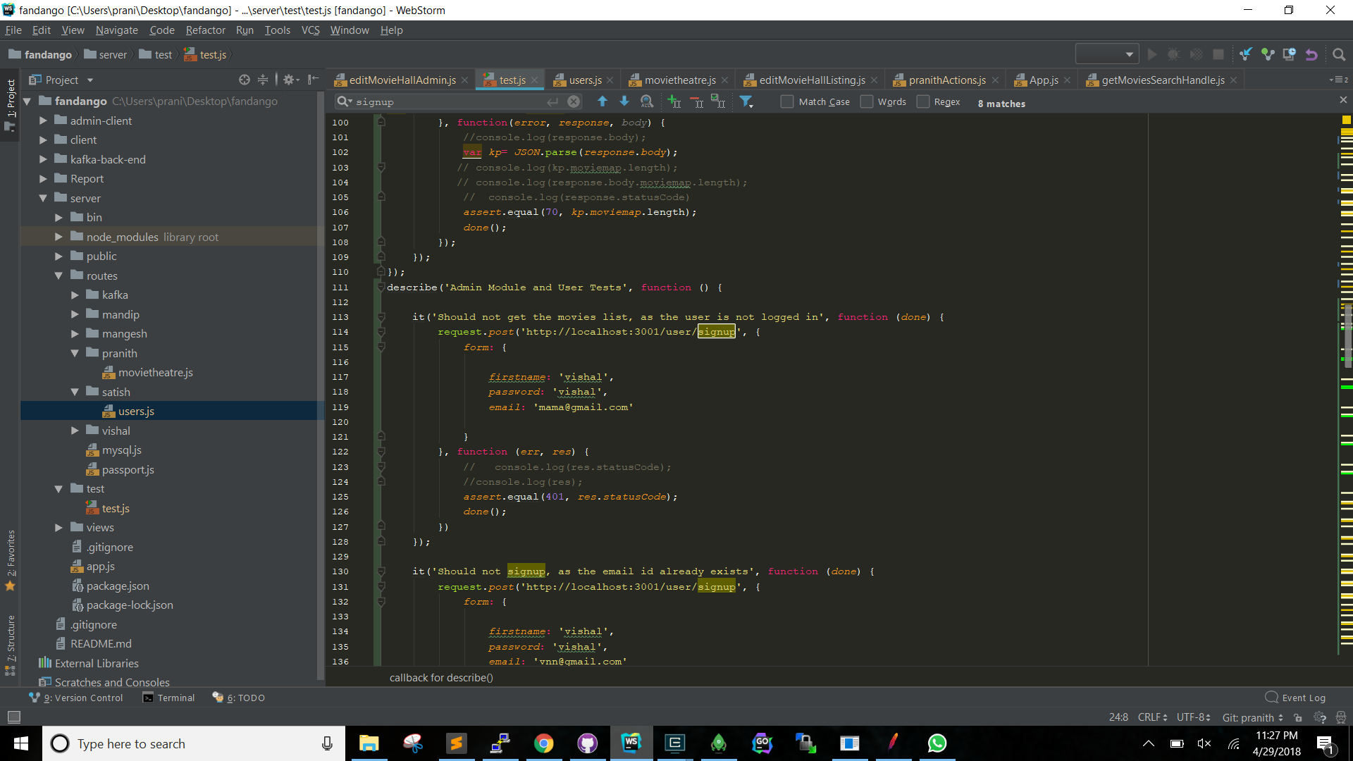

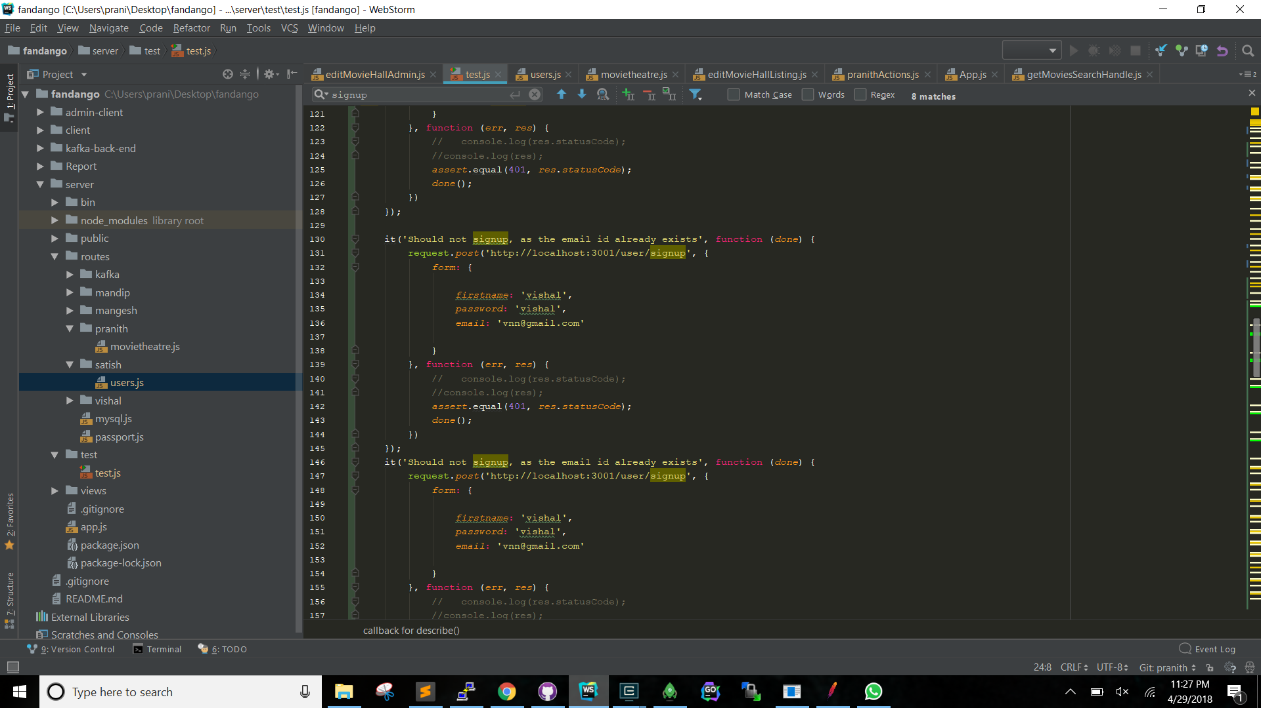

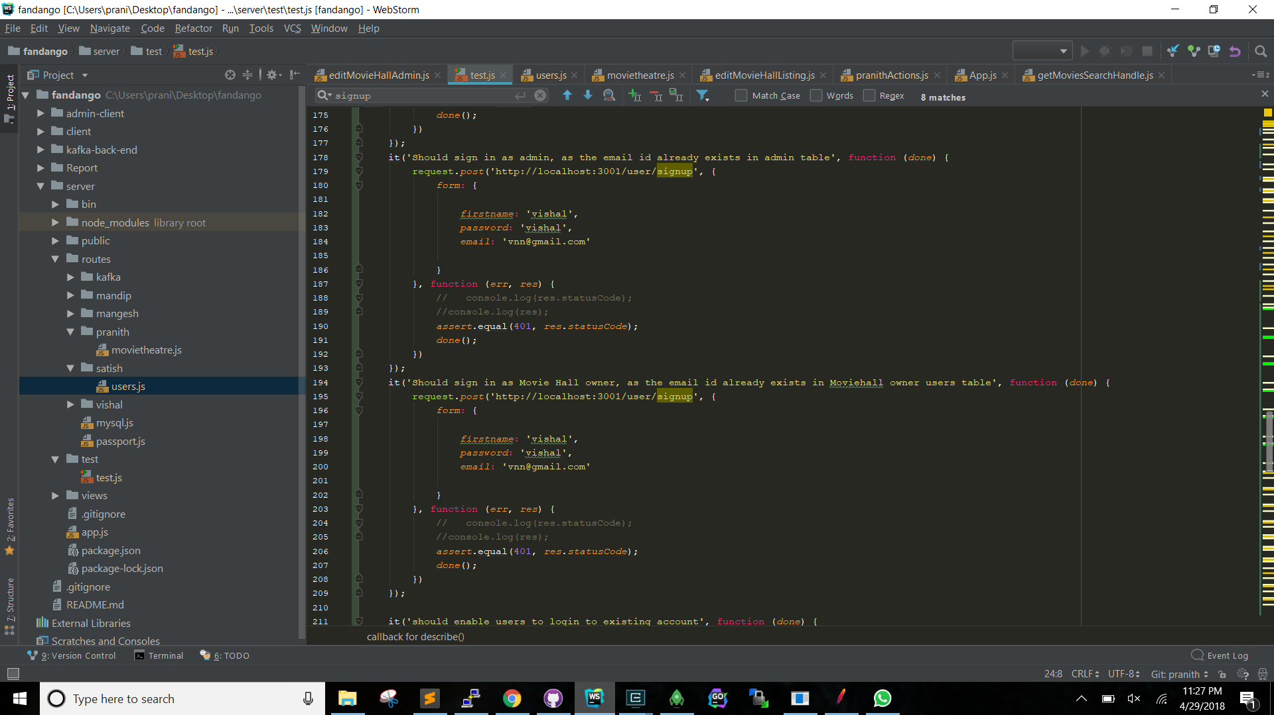

# **OBSERVATIONS & LESSONS LEARNED**

## **Observations**

The implementation of the whole Fandango Prototype website along with the analytics part was a large-scale project which needed proper planning and coordination. Few of the points which we observed are as follows:

* Defining all the APIs before starting the project helped us in understanding the whole skeleton of the project.
* We divided the project into different modules internally which helped us to develop different sections in parallel manner. This resulted in a lot of time saving because one module did not affect the others.
* While developing the UI, we made various components like sidebars which was reused in various web pages that is one of the reason we use React in frontend so that we can make component that can be reuse. This reduced the number of lines of code we had to write.
* The analytics page helped us gaining data from end user, which can be later used to improve the services.
* We used MongoDB client for managing data in MongoDB. It helped in reducing the code to perform CRUD operations.
* We followed Agile methodology in our project development phase. The daily standup meeting benefited us with keeping track of everyone’s tasks and planning for the remaining tasks. We use Scrum for that. So everyday Scrum Meeting and work on sprint helps us to complete the whole project in time and we also put 1-2 sprint for finding bugs and improve the services.

## **Lessons Learned**

Below are few of the points we think could have been improved.

* Develop code keeping the analytics page in mind. This would have helped in developing the analytics page faster.
* The most import thing is we manages the code on GitHub that help us a lot in integration the code and manages the commits. Help to get the previous commit code for recovery.
* JMeter helped us in testing of scalability and load balancing. After testing, we improved our code to make our website more stable.
* Feedback is an important part of project development. While deciding solutions to various functionalities, we kept a brainstorming session where everyone came up with suggestions and inputs.
* Agile Scrum help us to get new idea and road map as we had short meeting every day.